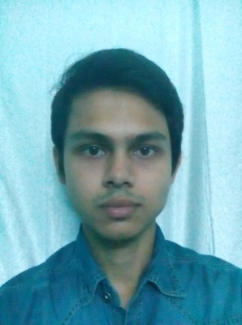

**TAPAS BHATTACHARJEE**

**CAREER OBJECTIVE:**

To gain experience in the professional arena to master myself in the knowledge and attaining job satisfaction and fulfilling Organization goal.

**ACADEMIC BACKGROUND:**

|  |  |  |  |  |
| --- | --- | --- | --- | --- |
| **COURSE** | **YEAR** | **BOARD/ UNIVERSITY** | **SUBJECTS/**  **SPECIALISATION** | **PERCENT/**  **CGPA/GPA** |
| Bachelor in Business Administration (Hons.) | 2017 | West Bengal University of Technology  [College: NSHM College of Management &Technology, Kolkata,234] | English, Maths, Statistics, Economics, ISC, Computer Applications, Psychology, POM, Business Environment, BRF, Business Communication, Financial Accounting, Production, Materials, Marketing, HRM, MIS | 1stSem : 5.33  2ndSem: 6.50  3rdSem: 5.00  4thSem: 5.17  5thsem : 5.17  6thsem : 5.83  DGPA : 5.89 |
| XII | 2013 | Assam Higher Secondary Education Council  [College: Tilak Singha Junior College, Silchar] | English, Alt. English, Political Science, Economics, Logic & Philosophy, Education | 45% |
| X | 2011 | Central Board of Secondary Education  [School: Maharishi Vidya Mandir, Silchar] | English, Hindi, Maths, Science, Social Science | 5.0 |

**TECHNICAL SKILLS:**

* Advanced Excel-lance
* Know how of technical writing
* Good communication skill
* Basic knowledge of computer handling, Ms-Office

**EXTRA-CURRICULAR ACTIVITIES & ACHIEVEMENTS:**

* Global Employability Program 2014. (Certificate of Completion)
* MS-excel (3 days program). (Certificate of Completion)
* Workshop of Business Analytics with Excel. (Certificate of Completion)
* Workshop done at Renaissance. (10 days). (Certificate of Completion)
* Training programme on Excel & Sales Distribution. (Certificate of Completion)
* Basic Computer Awareness Course in Ms-Office. (Certificate of Completion

**EXPERIENCE:**

Worked for 1 year in Network Marketing Business (AMWAY India Pvt Ltd)

Worked in an International BPO for 3 months (Kolkata)

Working as an Insurance Agent for Aditya Birla Sun Life Insurance Comp. Ltd. (7th May, 2018)

**ABILITIES:** Loyal with my job, honest, quick learner, hardworking and enthusiastic

**PERSONAL INFORMATION:**

Date of Birth : 27.08.1993

Gender : Male

Marital Status : Unmarried

Father’s Name : Tushar Baran Bhattacharjee

Father’s Occupation : Govt. Service (Retired)

Contact No. : 7044167748

Email- ID : sunny6764@gmail.com

Permanent Address : C/o Mr. Tushar Baran Bhattacharjee, House No.12, Lane-6,

Azad Hind Road, Silchar- 788007 (ASSAM).

**DECLARATION:**

The above information is true to the best of my knowledge and belief.

**Place**: **Silchar (Assam)**

**Date:** **Tapas Bhattacharjee**