Curriculum Vitae
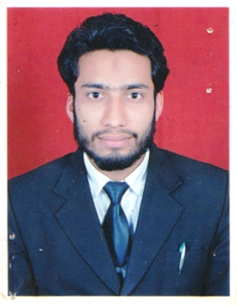

Personal Particulars:

Name : Mohammad Shahzeb
Fathers Name : Mr. Zameer Ahmad
Gender : Male
Date of Birth : 18 Aug 1992
Marital Status : Single
Languages Known : English, Hindi & Urdu
Permanent Address : Jama Masjid Mangal Bazar Umri Kalan distt- Moradabad [244501] UP
E-mail ID : shahzebbca@gmail.com
Contact No. : +91- 7065942656 / 9756612526
Passport : Yes (N3244167)

Objective:|
To hold a position of responsibility for growth of organization along with having long term
Relationship and to conduct myself in such a manner to hold the dignity of the profession

Work Experience:|
GULF ASSOCIATES –System Administrative (18 Aug 2015 to present)
Working within advanced in Excel (PivotTables, nested IFs, VLOOKUP, INDEX/MATCH, etc.); Proficient in Word, Photoshop, Power Point, CorelDraw and Dreamweaver, offering support to other team members as required during projects.

Academic Qualification:
Exam | Board/University | Year | Marks Obtained (%)
High School | U.P. Board | 2007 | 57%
Intermediate | U.P. Board | 2009 | 61.8%

Professional Qualification:
Course : BCA (64.3%)
College : College of Computing and College of application
University : Teerthanker Mahaveer University Moradabad
Batch : July 2009-June 2012
Course : MCA (68%)
College : College of Computing and College of application
University : Teerthanker Mahaveer University Moradabad
Batch : July 2012-June 2015

Certificate Courses:
- Certificate in C# with ASP.Net from Microsoft IT Academy
- Certificate in English Communication 360 Competition
- Certificate in Athletics Event (400 meters Race) at Invertis University Bareilly
- Certificate in PHP Technology (Tech Mentro) TMU Moradabad
- Certificate in JAVA Technology (CMC Limited) TMU Moradabad
- DTP (Desktop Publishing ) from IIST Moradabad

Skills & Capabilities:

- Good Command over working domain
- Can work under pressure
- Can effectively work as team or as an individual

Technical Skills:
- Programming Languages : MVC, ASP.NET, C#, linq, Json and Entity Framework
- Scripting Languages : Html, CSS, Jquery, java script & Ajax
- Database Technology : MS SQL Server
- GUI Tools : Visual Studio 2010, 2012.
- Operating system : Windows

Professional Interest:
- Web Application development.
- State Management in ASP.NET
- Web Services and WCF
- ADO.NET.
- Agile Software development life cycle
- Unit Testing,Smoke Testing Sanity Testing and Regression Testing
- Software development life cycle and Software testing life cycle.

Interpersonal Skills:

- Confident and Determined
- Good team working ability
- Ability to adapt as per changing environment

I hereby declare that the above information is true to the best of my knowledge.

Date: 03/06/2018
Sign:
Place: Delhi (Mohammad Shahzeb)

