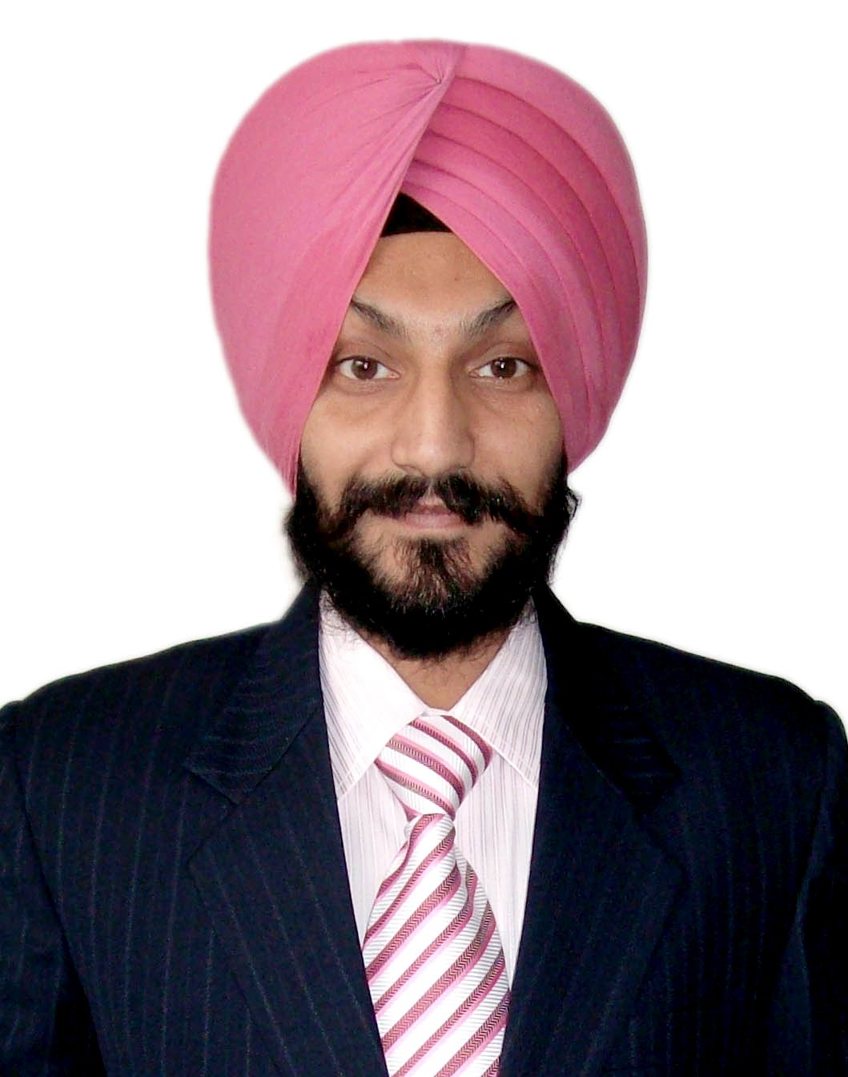
BALJINDER SINGH
E-mail: baljindersingh557056@gmail.com
YouTube Channel: https://www.youtube.com/watch?v=5X2Vg9xU_ts&t=3s

OBJECTIVE
- To become a successful professional in the field of Computer Science and to work in an innovative and competitive world.

JOB EXPERIENCE
- I worked as Assistant Professor in the P.G. Department of Computer Science & Information Technology in D.A.V College, Amritsar for last Six years (2020-2019, 2018-2019, 2017-2018, 2016-2017, 2015-2016 and 2014-2015).
- I worked as Assistant Professor in the Department of Computer Applications (MCA) in Sri Sai College of Engineering & Technology, Manawala Campus, Amritsar for the period of more than two years (Jan. 2012 to Feb. 2014).
- I worked as Assistant Professor in the Subject of Computer Science in Trai Shatabdi Guru Gobind Singh Khalsa College, Amritsar for one session (2011-2012).
- I worked as Ad-hoc lecturer in P. G. Dept. of Computer Science & Applications at Khalsa College, Amritsar for the period of Three Sessions (2008-09, 2009-10 and 2010-2011).
- I worked as Computer Faculty under ICT Project in Govt. High School, Gehri Mandi, Amritsar from (1-4-2005 to 22-7-2008), Director General School Education, Punjab ICT Education Society (PICTES), Department of School Education, GOVT. OF PUNJAB.

ACADEMIC QUALIFICATIONS
Class | Year | Board/University | Institute | %age
MCA | 2007 | Kurukshetra university, Kurukshetra | Kurukshetra university, Kurukshetra | 67%
B.I.T | 2002 | G.N.D.U, Amritsar | Hindu College, Amritsar | 67%

PROFESSIONAL QUALIFICATION: Professional Diploma in Computer Hardware, Networking and Telecommunication Engineering From IIHT, Regional Office (Punjab Zone), Amritsar.

AREA OF SPECIALIZATION
- C / C++/ JAVA /VB/3D Max/3D Maya/3D Mudbox/After Effect
- Data Structure, Computer Graphics, Artificial Intelligence, Oracle, Python, MOODLE, MOOC, WordPress, GNOMIO.
- Linux / UNIX, Mobile Computing, Network Operating System.

AREA OF INTEREST
- Computer Networks, Digital Electronics, PHP, ASP.Net, Computer Graphics (Animation & Multimedia), Diagnosis of Computer Hardware & Networking.

PAPER PUBLISHED IN JOURNAL
- Published Paper “Dynamic Learning Approach to Artificial Intelligence Based Generated Combat Game Tactics” in International Journal of Emerging Technology & Advanced Engineering (ISSN 2250-2459, ISO 9001:2008 Certified Journal), Volume 4, Issue 4, April 2014.
- Paper “Literature Review on Android Based Mobile Application Developed on Eclipse Software” in International Journal of Interactive Computer Communication May 2017.

REFRESHER COURSE
Two week Refresher Course on Recent Trends in Information, Computing, Communication and Teaching Methodology Competency Organised, by Sri Sai Ram Engineering College, West Tambaram, Chennai, Department of CSE, ECE & IT from 4th to 17th May 2020.

FACULTY DEVELOPMENT PROGRAMME
- Five Day’s Faculty Development Programme sponsored by National Institute of Technical Teacher Training and Research (NITTTR) Chandigarh, Ministry of Human Resources Development, Government of India Participated in AICTE Recognized Short Term Course on “Induction Training Programme through ICT” held at Sri Sai College of Engineering & Technology, Manawala, Amritsar 31-12-2013 to 05-1-2014.
- Microsoft Certificate of Participation Partners in Learning Teacher Training Program May 2008.
- One Week online FDP on “Educational Video Creation i.e E-content Development for Teachers” conducted by Department of Mathematics, statistics and Internal Quality Assurance Cell (IQAC) of Rajarshi Chhatrapati Shahu College, Kolhapur from 22nd July – 27th July 2020 (Contact session (18hrs) + Practice Session (18hrs) = Total 36 Hrs)
- Two Weeks Online FDP (MOOC) on “Effective Use of ICT Tools in Online Teaching” from 22nd July to 4th June, 2020 Organised by “IQAC & Department of Electronics and Telecommunication Engineering Department” of Maharashtra Institute of Technology, Aurangabad.
- Two Weeks FDP on “R-Language & R-Studio” Organised by Department of Computer Science and Engineering, Cambridge Institute of Technology, Bengaluru and comes under PMMMNMTT, MHRD, Govt. of India, through IIT Bombay Spoken Tutorial.
- Ten Days FDP on “PYTHON 3.4.3” from 20-5-2020 to 29-5-2020 Organized by SRM Institute of Science and Technology, Ramapuram Campus, Chennai in ssociation with Spoken Tutorial IIT-Bombay.
- Two weeks National Level FDP on “ICT Tools for Technology Infused Learning V2.0” contents covered (Google Docs / Forms / google classroom, Edmodo, Testmoz, Kahoot, certify’em, form limiter, Renderforest, Mind master / AM chart, OBS, Open shot, google site, creative commons, youtube and Microsoft utilities, MOODLE Cloud, MOOC) from 22nd June to 4th July, 2020 Organised by Department of Electronics and Communication Engineering, Saveetha autonomous Engineering College, Anna University.
- Two Week Online “LIVE Training on PYTHON” 20th July to 2nd Aug, 2020 Conducted by Apptronix Technologies-NOIDA.
- One Week National Faculty Enrichment Programme on “Digital Technology for Teaching of Life Sciences and Humanities” Organized by Dr. Ambedkar Government Arts College, Vysarpadi, Chennai, in collaboration with the Indian Science Congress Association from 21-7-2020 to 25-7-2020.
- One week FDP on “PHP & MySQL” from 18-5-2020 to 23-5-2020 Organized by Department of Computer Science and Engineering, JNTUH College of Engineering, Jagtial in association with Spoken Tutorial IIT-Bombay.
- One week FDP on “RUBY & PERL PROGRAMMING” from 3rd June to 8th June, 2020 Organized by Department of Computer Science and Engineering, St. Peter’s Engineering College, Hyderabad in association with Spoken Tutorial IIT-Bombay.
- One week FDP on “LaTeX, R-Programming & PYTHON” from 25-5-2020 to 30-5-2020 Organized by Department of Computer Science and Engineering, Guru Nanak Institute of Technology, Hyderabad in association with Spoken Tutorial IIT-Bombay.
- One week FDP on “PHP & MySQL” from 18th June to 24th June, 2020 Organized by Department of Computer Science and Engineering, V.K.R, V.N.B & A.G.K College of Engineering, Gudivada in association with Spoken Tutorial IIT-Bombay funded by National Mission of Education through ICT, MHRD, Govt. of India.
- One week FDP on “Artificial Intelligence” Organized by All India Council for Technical Education (AICTE) Training and Learning (ATAL) Academy from 11-5-2020 to 15-5-2020 at MSME-Technology Development Centre (PPDC), Meerut.
- One Week online FDP on “LATEX” Organised by Department of Mathematics, Vinayakrao Patil Mahavidyalaya, Vaijapur, Dist. Aurangabad from 15-21 June 2020.
- One week national Level online FDP on “Ethical Hacking and Cyber Security” Organized by Department of Information Technology, Institution of Aeronautical Engineering, Hyderabad in association with SUPRAJA Technologies during 23-27 May, 2020.
- One Week Hands on FDP “DATA SCIENCE USING PYTHON” held from 18-5-2020 to 22-5-2020 Organized by Department of Information Technology of Jeppiaar Institute of Technology, Kunnam, Sunguvarchatram, Sriperumbudur.
- One Week online FDP on “Online Class Management Tools and Techniques” 23rd Jul – 29th July 2020, Organised by Department of Economics, Hamidia Girls Degree College, University of Allahabad, Prayagraj, UP, India.
- One week National level online FDP on “ICT Tools for Effective Teaching Learning” from 11th to 16th May, 2020, organized by School of Mathematical Sciences, Swami Ramanand Teeerth Marathwada University, Nanded.
- One Week FDP on “Modern Teaching, Evaluation and Research Methods” under UGC scheme, STRIDE Component-I (Research Capacity Building) Organized by Vinayakrao Patil Mahavidyalaya, Vaijapur, Dist. Auangabad, from 2nd – 7th June, 2020.
- One Week FDP on “ICT based tools and its applications in teaching learning process” Organized by BSVS Educational Learning Centre, Nagpur held during 27th May – 02nd June, 2020.
- One Week Virtual FDP on “E-Learning Tools for MOOC and Creation of Own MOOC Courses” Organized by BSVS Educational Learning Centre, Nagpur held during 11th June – 16th June, 2020.
- Five Days online FDP on “Cyber Security Techniques and Tools” Organized by Department of Information Technology, Sri Sai Ram Engineering College, Chennai, in association with Indian Society for Technical Education held by 15-6-2020 to 19-6-2020.
- Five Days online FDP on “Evolution form offline to online Teaching” Organized by Satish Pradhan Dnyanasadhana College, Thane (IQAC) and FDP committee in Association with Department of Info. Tech. University of Mumbai, Yashwantrao Chavan Maharashtra Open University, Mumbai Regional Centre and MICROSOFT held during 30th May – 3rd June 2020.
- One Week FDP on “Problem Based Learning” Organized by Department of Electronics and Telecommunication Engineering, JSPM’s Rajarshi Shahu College of Engineering, Pune from 1st June to 5th June, 2020.
- One Week Online National FDP on “E-contents and ICT Tools for Innovative and Effective Teaching” Organized by Ks Jain Institution of Engineering and Technology, Modinagar, Ghaziabad from 15th July – 21th July 2020.
- One Week FDP under SAGE SUMMER SCHOOL on “Machine Learning and Applications” Organized by Department of Computer Science and Engineering, Sagar Institute of Research & Technology, Bhopal from 18th – 23th May, 2020.
- Five Days National Level online FDP on “Artificial Intelligence” Organized by Department of computer Science & Engineering, G. Narayanamma Institute of Technology and Science, Hyderabad, in Collaboration with Brain O Vision and National Youth Council of India, from 22-5-2020 to 26-5-2020.
- One Week FDP on “Industrial Automation and Robotics” Organized by Department of Mechanical Engineering, DIT University , Dehradun, Uttarakhand, from 3rd Aug to 7th Aug, 2020.

PROFESSIONAL SOCIETY MEMBERSHIP
- Member, IAENG (International Association of Engineers)
- Member, ISOC (Internet Society)
- Member of Organization (2020-2021) National Teacher Organization in Life Sciences (NTOILS)

NUMBER OF INTER-NATIONAL / NATIONAL CONFERENCES
- Paper Presented on “Probability Based Approach to Recognize E-mail Spam” in the National Conference Sponsored by Punjab Technical University, Kapurthala on “Latest Development in Science, Engineering and Management (LDSEM - 2014)” held at Amritsar College of Engineering & Technology, Amritsar on March 2014.
- Paper Presented on “An Approach Based On Automatically Generated Game Tactics” Organizes 1st National e-Conference on “FUTUREURISTIC TRENDS IN INTERDISCIPLINARY RESEARCH” International Scientific & Engineering Serials, December 2013.
- Paper Presented on “Face Identification Approach Using Hybrid Computing: PCA and Neural Networks” in the Inter-National Conference on History and Development of Mathematical Sciences and Symposium on Non-Linear Analysis (ICHDMS- Nov. 21-24, 2012), Maharshi Dayanand University, ROHTAK, HARYANA.
- Paper Presented on “Autonomic Computing Wireless Sensor Networks” in the National Conference on Spectrum of Information Technology Development at India’s Perspective (17-18 February, 2012), International Scientific & Engineering Serials, Baba Budha College, Bir Sahib (Thatta), Distt. Taran-Taran, Amritsar.
- Paper Presented on “Mobile Ad-Hoc Networks (Applications and Challenges)” in the National Conference on Spectrum of Information Technology Development at India’s Perspective (17-18 February, 2012), International Scientific & Engineering Serials, Baba Budha College, Bir Sahib (Thatta), Distt. Taran-Taran, Amritsar.
- Paper Presented on “Service-Oriented Software Architecture for Sensor Networks” in the National Conference on Spectrum of Information Technology Development at India’s Perspective (17-18 February, 2012), International Scientific & Engineering Serials, Baba Budha College, Bir Sahib (Thatta), Distt. Taran-Taran, Amritsar.
- Paper Presented on “I.T. Vision” 4th BI-ENNIAL Conference of Indian Association for Medical Informatics at Sri Guru Ramdas Institute of Medical Sciences & Research, Amritsar (Oct. 2005)
- Participated in the UGC sponsored National Conference organized by P.G. Deptt. of Comp Sc. & IT, Guru Gobind Singh Khalsa College ,Sarhali.

NUMBER OF PUBLICATIONS
  - TOTAL PUBLISHED BOOKS -6 (Khanna Book Publishing Co. (P) Ltd., Delhi)
  - NUMBER OF BOOKS (IN PRESS)- 4

ISBN | Author Name | Title | Pages
9789381068359 | Ikvinderpal Singh  Baljinder Singh | Windows Based Computer Courses–A Visual Approach | 1100
9789381068199 | Ikvinderpal Singh  Baljinder Singh  Harmandeep Singh | Network Operating System | 450
9789381068311 | Ikvinderpal Singh  Baljinder Singh | Computer Organization and Architecture | 750
9789380016214 | Ikvinderpal Singh  Baljinder Singh | Digital Image Processing | 530
9789380016955 | R Singh, I Singh, B Singh | Electronics Analog and Digital | 639
9789381068175 | Ikvinderpal Singh  Baljinder Singh  Opinder Singh | Mobile Computing | 456

HONOURS
- Best Paper Presented Award in Inter-National Conference on History and Development of Mathematical Sciences and Symposium on Non-Linear Analysis (ICHDMS-2012), Events to commemorate 125th Birth Anniversary of Srinivasa Ramanujan, Maharshi Dayanand University, ROHTAK, HARYANA.
- International Scientific & Engineering Serials Presents this “Certificate of Appreciation” for his contribution to National Conference Spectrum of Information Technology Developments at India’s Perspective SIT@IP-2012. at Baba Budha College, Bir Sahib, Tarn-Taran.
- I performed the duty as a Judge at Sri Guru Teg Bahadur College for Women, Amritsar, for the Event of Quiz Competion & Software Development in JUDGE I.T. Boom January 2010.
- Appreciation Award “Wheat Allergy Awareness Camp” held at 7th April, 2019 Organised by Department of Bio-Technology, DAV College Amritsar.

NATIONAL WORKSHOP LIVE TRAINING
- Two Days online workshop on “Fuzzy Logic and Neural Network Approaches for Engineering solutions” Organized by Journal of Advanced Engineering Research & powered by Hexacube India on 01th & 02nd May, 2020.
- Two Days online workshop on “Patent Drafting and processing with importance of trademark and copyright” Organized by Journal of Advanced Engineering Research & powered by Hexacube India on 08th & 09th May, 2020.
- One week online Workshop on “Best Practices of ICT Tools in Teaching and Learning”, Organized by Department of Computer and Information Science, Jagadguru Rambhadracharya Divyang University, Chitrakoot, from 3rd to 8th Aug, 2020.
- One Week online Lecture Series on “Trends in Artificial Intelligence & Machine Learning” Organized by Department of Computer Application, North Orissa university, from 16th – 21st July 2020.
- One Week “Pedagogical Training for Teachers on Tools for online Teaching Learning and Evaluation” from 1st July – 6th July 2020, organized by School of Mathematical Sciences, Swami Ramanand Teeerth Marathwada University, Nanded.
- One week online Workshop on “Tech-Tools for Teaching”, Organized by the Internal Quality Assurance Cell of Peet Memorial Training College, Mavelikara, Kerala, from 3rd to 7th Aug, 2020.
- One Week Short Term LIVE Online Training on “Internet of Things” conducted by Apptronix Technologies in collaboration with A.G Patil Institute of Technology, Solapur from 01th June to 7th June, 2020.
- One Week Short Term LIVE Online Training on “Deep Learning Using Python” conducted by Apptronix Technologies in collaboration with Mahatma Gandhi Institute of Technology - Hyderabad from 03rd Aug. to 7th Aug, 2020.
- One Week Short Term Training Program on “Learning Management System: MOODLE” conducted by the department of Mechanical Engineering, National Institute of Technology Warangal, Centre for Educational Technology from 10th to 14th Aug, 2020.

INTERNATIONAL SYMPOSIUM
- International Technical Symposium on “Opportunities & challenges in industry 4.0” 15th to 17th June, 2020 Organised by “Industry Cell & Electronics and Telecommunication engineering department of MIT, Aurangabad, supported by “GIZ MSME INNO Project”.
- Ten Days Online International Symposium on “Thought - Experimentation in Humanities, Science and Science Fiction” Organized by Shri Muktanand college, Gangapur, special mission to inculcate scientific, democratic, humane and literary values among the students, Teachers and society on the occasion of the Golden Jubilee Ceremony Year during 21-30 July, 2020.

SEMINAR/WORKSHOP ATTENDED
- One Day Workshop Lecture Delivered On “Fly-IT (Imagine the possibilities)” (06-Oct-2016) by PG Department of Computer Science & IT, DAV College, Amritsar.
- Seminar attend on “Financial Assistance / Incentives available under various schemes of Government of India, Ministry of Micro, small and Medium Enterprises (MSMEs) Development Institute” www.msmedildh.gov.in (30-Sept.-2016) Organized by Federation of Indian Export Organisation (FIEO), Amritsar.
- Participated Certificate “Multiple Choice Questions Competition, Theme: Legal Right of women, Cyber-Crime against women, Equal right, responsibilities and opportunities to women” Organized by DAV College Amritsar, held 19th Dec, 2018, Women Empowerment cum Grievance Redressal & Complaint Cell under the aegis of National Commission for Women, Govt. of India,
- Paper Presented on “Relevance of Mahatma Gandhi’s Philosophy in 21st Century” Organizes ONE DAY INTERNATIONAL SEMINAR held at D.A.V. College, Amritsar on 2nd Feb. 2015.
- Paper Presented on “Wireless Sensor Network (Architectural Design issues and Challenges)” Organizes ONE DAY NATIONAL SEMINAR On Emerging Trends In Computer Industry held at SANATAN DHARMA COLLEGE, Ambala Cantt (Haryana) on 10th Mar. 2012.
- Attended on 2nd Annual Workshop on Safer Internet Day on Feb 10, 2015 for under graduate and post graduate students. Workshop included activities such as Debate, Clipart Creation, Poster Drawing, Presentation Making, Short Movie Making, etc.
- Seminar attended on “Big Data: Impact of Future Trends”, (12-02-2015) by Dr. Sandeep Sharma, Associate Professor, Department of Computer Science & Engineering, G.N.D.U, Organized by PG Deptt. of Computer Sc. And I.T, D.A.V College, Amritsar.
- Seminar attended on “Advance Concepts of Relational Database Management”, (27-02-2015) by Dr. Parteek Bhatia, Associate Professor, Department of Computer Science & Engineering, Thapar University, Patiala, Organized by PG Deptt. of Computer Sc. And I.T, D.A.V College, Amritsar.
- Workshop on Intellisence Technology Multinational Web/ Embedded Software company at Sri Sai College of Engineering & Technology, Manawala, Amritsar (11-10-2012)
- Workshop on JANDEC Software Company Anroid and embedded at Sri Sai College of Engineering & Technology, Manawala, Amritsar (15-10-2012)
- Workshop on IBM Introduce Industrial Training with NIIT on Live Projects at Sri Sai College of Engineering & Technology, Manawala, Amritsar (25-10-2012)
- Workshop On “Internet and its Applications”, (2010) Under Faculty development program sponsored by UGC-CPE on 25-11-2010, 26-11-2010, PG Deptt. Of Computer Sc. And Applications, Khalsa College, Amritsar.
- Seminar on “Software Measurement”, (12-11-2010) by Dr. Hardeep Singh, Dean & Prof. G.N.D.U, Organized by PG Deptt. Of Computer Sc. And Applications, Khalsa College, Amritsar.
- Seminar on “Basics of Electronics”, (24-9-2010) presented by R.K Popli by P.G. Deptt. Of Computer Sc. And Applications, Khalsa College, Amritsar.
- Seminar on “Parallel and Distributed Computing”, (2009) by PG Deptt. Of Computer Sc. And Applications, Khalsa College, Amritsar.
- National Seminar on “Ad-Hoc Networks”, (2008) Under Faculty development program sponsored by University Grants Commission, New Delhi held on Sept. 29, 2008, Khalsa College for Women, Amritsar.
- Workshop On “Internet and its Applications”, (2008) Under Faculty development program sponsored by UGC-CPE on 25-11-2008, Khalsa College, Amritsar.

EXTRACURRICULAR ACTIVITIES
- Placement Cell Activities in DAV College Amritsar.
- Participated in AAGAAZ - 2012, 2013 in Sri Sai College of Engineering & Technology, Amritsar.
- Participated in Admission Cell 2012, 2013 in Sri Sai College of Engineering & Technology, Amritsar.
- Participated in Placement Activities in Sri Sai Institute of Engineering & Technology, Amritsar.
- Participated in TECH-ERA Computer Society, (2011) held by P.G. Dept. of Computer Science & Applications, Khalsa College, Amritsar.
- Participated in TECH FEST 2009 held by P.G. Dept. of Computer Science & Applications, Khalsa College, Amritsar.
- Participated in TECH FEST 2010 held by P.G. Dept. of Computer Science & Applications, Khalsa College, Amritsar.

HOBBIES
- Reading Books

LANGUAGE KNOWN (Speaking, Reading, Writing)
- English, Punjabi, Hindi

