CURRICULUM VITAE

NAME: HANUMT PRASAD
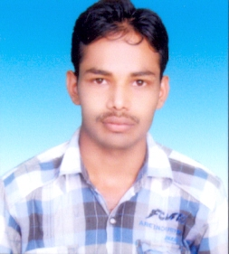
Contact no. : 9721039970, 9918657210
Correspondence & Permanent Address:
- E-mail : sajjan5monti@gmail.com
- Village : Bramhano Ka Nadoura
- Post : Laxmi Ganj
- Distt. : Raebareli
- Pin code : 229401

Academic Qualification:

- Graduate with Art group from Dr. Ambedkar Rajkiya Mahavidyala, Unchahar, Raibareli (C.S.J.M. University Kanpur).

- Intermediate with Science group from Dr. Bhim rao Ambedkar Intermediate College, Sawai Dhani, Distt. Raibareli.

- High School with Science group from S.N. Shiksha Niketan Intermediate College, Babuganj, Distt. Raibareli.

Professional Qualification:

- Pursuing NCVT -ITI 4th (Industrial Training Institute) semester with Fitter Trade from Dipanjali ITI Unchahar, Raebareli
- DCA (Diploma in Computer Application) from Simtach Computer Institute Unchahar, Raibareli

- Diploma in Industrial Safety management from National Institute of Labour Education & Management.(Nilem)

- CCC (Course on Computer Concept) from Nation Institute of Electronics and Information Technology.

Experience:
- Six months experience in Tehsil Unchahar on software of Bhu-Lekh as a computer operator.

- Seven years experience in NTPC-Unchahar on software of MS-Office (World, Excel, Power Point, Access, SAP, and CMS & Internet) as a computer operator.

Language Known:
- English & Hindi as native

Personal Details:
- Father’s Name : Shri Deep Chandra
- Date of Birth : 30th Sep. 1989
- Sex : Male
- Marital Status : Married
- Religion : Hindu
- Nationality : Indian

Dated: …………………………
Place: ………………………….. ( Hanumat Prasad )

