**RESUME**

NAME :-Bijay Kumar Padhi

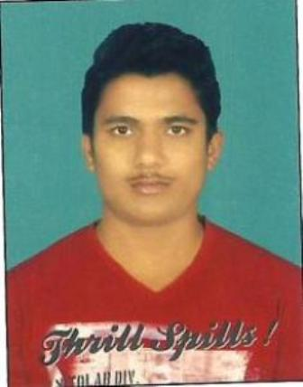

DATE OF BIRTH:- 16/11/1997

AGE:- 20

GENDER:- MALE

PERMANENT ADDRESS:- Plot no_2384,Mancheswar, AT.POST- Mancheswar,Khurdha,Bhubaneswar-751010

E-MAIL:- [bijaykumarpadhi781@gmail.com](mailto:bijaykumarpadhi781@gmail.com)

CONTACT No:- 7504443339/8917552105

EDUCATION QUALIFICATION:-

|  |  |  |  |  |  |
| --- | --- | --- | --- | --- | --- |
| Examination | School/Collage | Board/ Univercity | | Year of Passing | Percentage of Marks |
| 10th | Govt. High school,V.S.S.Nagar | BSE | | 2013 | 62% |
| Diploma  (Electronic and telecommunication | NilachalPolytechnic,  Bhubaneshwar | SCTEVT | | 2018 | 80% |
| B.TECH(ELETRONIC & TELECOMMUNICATION) | COEB,BHUBANESWAR | | BPUT | CONTINUE | 80% |

TRAINING :-Hardware & Networking of one week at CTTC, Bhubaneshwar

TECHNICAL SKILL’S:-

Programing language : C, C++, MS-WORD, MS-EXCEL

STRENGTHS:-

* Team Player and Leader
* Believer in Smart Work
* Self-Motivation
* Optimistic

SPECIAL INTEREST:-

* Playing CRICKET
* Listening music

PERSONAL INFORMATION:-

Father Name:-SudhakarPadhi Mother Name:-PuspanjaliPadhi

Nationality:- Indian

Language:- English, Hindi, Odiya

DECLARATION:-

I do here by declare that all information furnished above is true to the best of knowledge.

DATE:- Bijay Kumar Padhi

PLACE:-Bhubaneshwar