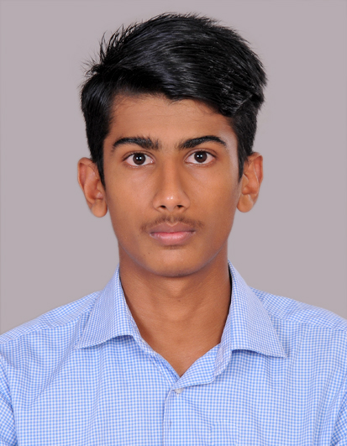 |  |  |  | hentry jose
OBJECTIVE  I want to work with a progressive organization where I could utilize my knowledge and skills for mutual development.  Contact  PHONE:  9061130585  LINKEDIN:  www.linkedin.com/in/hentry-jose  EMAIL:  hentryjose008@gmail.com  PERSONAL INFORMATION  - DOB: 02-12-1999  - Gender: Male  - Nationality: Indian  - Languages known: English,Malayalam  ACHIeVEMENT  Completed internship from Keltron  on PHP programming  activities and interests  Travel  Playing football  Watching movies  Internet surfing |  |  | EDUCATION  2021  Graduation on BCA from Mar.Augustinose College Ramapuram(MGU) with overall CGPA of 6.38.  2018  Higher Secondary Education under Kerela State Board with 69%.  2016  Class 10 under CBSE Board with 90%.  ACADAMIC pROJECTS  Online Hotel Reservation  Enthanced model of Online hotel reservation to automate the existing manual system by the help of computerized equipment and full-fledged computer software, fulfilling their requirements, so that their valuable data or information can be stored for a long period with easy accessing and manipulation of the same.  Languages used : PHP,MySQL  - Virtual University System  The system manages daily works of different public universities.This com-  puterized system helps students fulfill their purpose of tertiary education.  Front end : .NET,Visual Studio  Back end : Microsoft SQL  IT SKILLS  - Programming Languages : C,C++,Java  - Web Technologies: HTML,CSS,PHP  - Database: MySQL  - OS: Windows,Linux,Android

