CURRICULUM VITAE
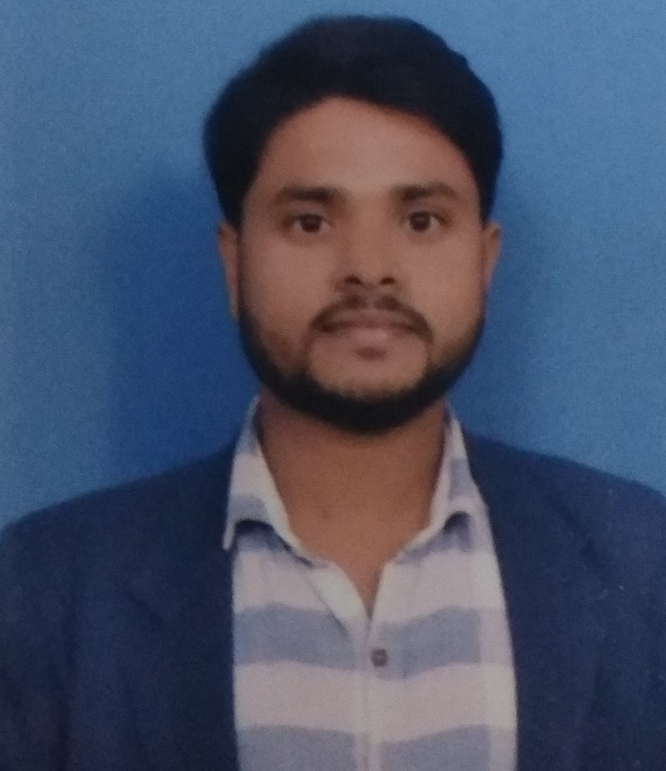
Vikram Kumar
H.No.1046 sec-17 B,
Gurgaon, Haryana 122001. Email: vikram.ee2016@gmail.com
Mob: +971553120624 (UAE), +919990617309 (INDIA)

CAREER OBJECTIVE

- An effective communicator with good leadership, interpersonal, analytical and problem-solving skills. Willingness to walk the extra mile to attain goals and ability to think out of the box.
PROFESSIONAL QUALIFICATION

- B.tech in Electrical and Electronics Engineering from IIME Delhi, with 1st Division in 2017 and 5 years 7 months Experience in different field like Electrification work (Internal & External), BMS, FAS & PA (Fire alarm system & public addressing), Telecom and Data, CCTV, with Quality control.

- VRF (HVAC) Error Trouble Shooting, Import and Export of all VRF Parts including PCBs and compressor through GSFS software.

COMPUTER AWARENESS:

- Knowledge of computer (Ms-Office and AutoCAD).

EMPLOYER:

- I am currently working as an Electrical Site Engineer in (OCUS GROUP) Ocus Hospitality Projects Pvt. Ltd. “B+G+5 MFC Katra, J&K, from April 2019 to till date.

- I was working as an Electrical Site Engineer in (OCUS GROUP) Ocus Skyscrapers Realty Limited.
"2B+G+18", (Retail +Pvr ) from October 2017 to 31
March 2019 .

- I was working as VRF SERVICE HEAD for Dreeshti Airtech Solutions Pvt. Ltd.(LG ELECTRONICS)
Duration : August 2016 to October 2017.

- I was working in Itqan Electromechanical Cont. as an Assistant Electrical Engineer.

The Project at which I have worked, B+G+4,
The Greens, Residential Building, Dubai
( Consultant Mario, Main Contractor: AMBB).
Duration : 15th April 2015 to 16 July 2016.

- Company : Prayag International.
1039/17B, Gurgaon -122001
Duration : 1st April 2014 to 31st March 2015.

Nature of work : Marketing of Programmable digital
Almanac based timers to various corporate like NTPC,
EIL, Power Grid etc.

PROFESSIONAL EXPERIENCE: Total – 5 year. +
- Electrification and Consultant Work of High Rising Residential and Commercial Buildings. (Execution of 11KV &33KV Switchgear, Transformers and DG Sets, LV Panels, SMDB, DB, MV and LV Cabling and Installation of Cable Try, GI and PVC Conduiting, Lighting and Power Wiring. Earthing, Bonding and Lighting arrester Lighting Protection System and Data, CCTV and BMS system.

PERSONAL DETAILS

Father’ Name : Sh. Suresh Singh

Date of Birth : 13th may. 1995

Marital Status : Married

Languages Known : Hindi & English

Citizenship : INDIAN

Permanent Address : H.NO: 1046, Sec-17th B,
Gurgaon, Pin: 122001,
Haryana, INDIA.

Mobile. No. : +971553120624 (UAE)
+919990617309 (INDIA)

PASSPORT DETAILS:

Passport no. : M 3317274

Date of Issue : 17.11.2014

Date of Expiry : 16.11.2024

Place of Issue : Delhi (INDIA)

Current Salary : 40000/. INR

Expected Salary :

Date:-

Place:- (VIKRAM KUMAR)

