Shiwani Sharma

+91-7902031046 | ssssharma59@gmail.com

# Profile

Aspiring for challenging assignments in the field of Quality Assurance of Software, wish to achieve high career growth through a continuous learning process and prove to be an asset for the organization.

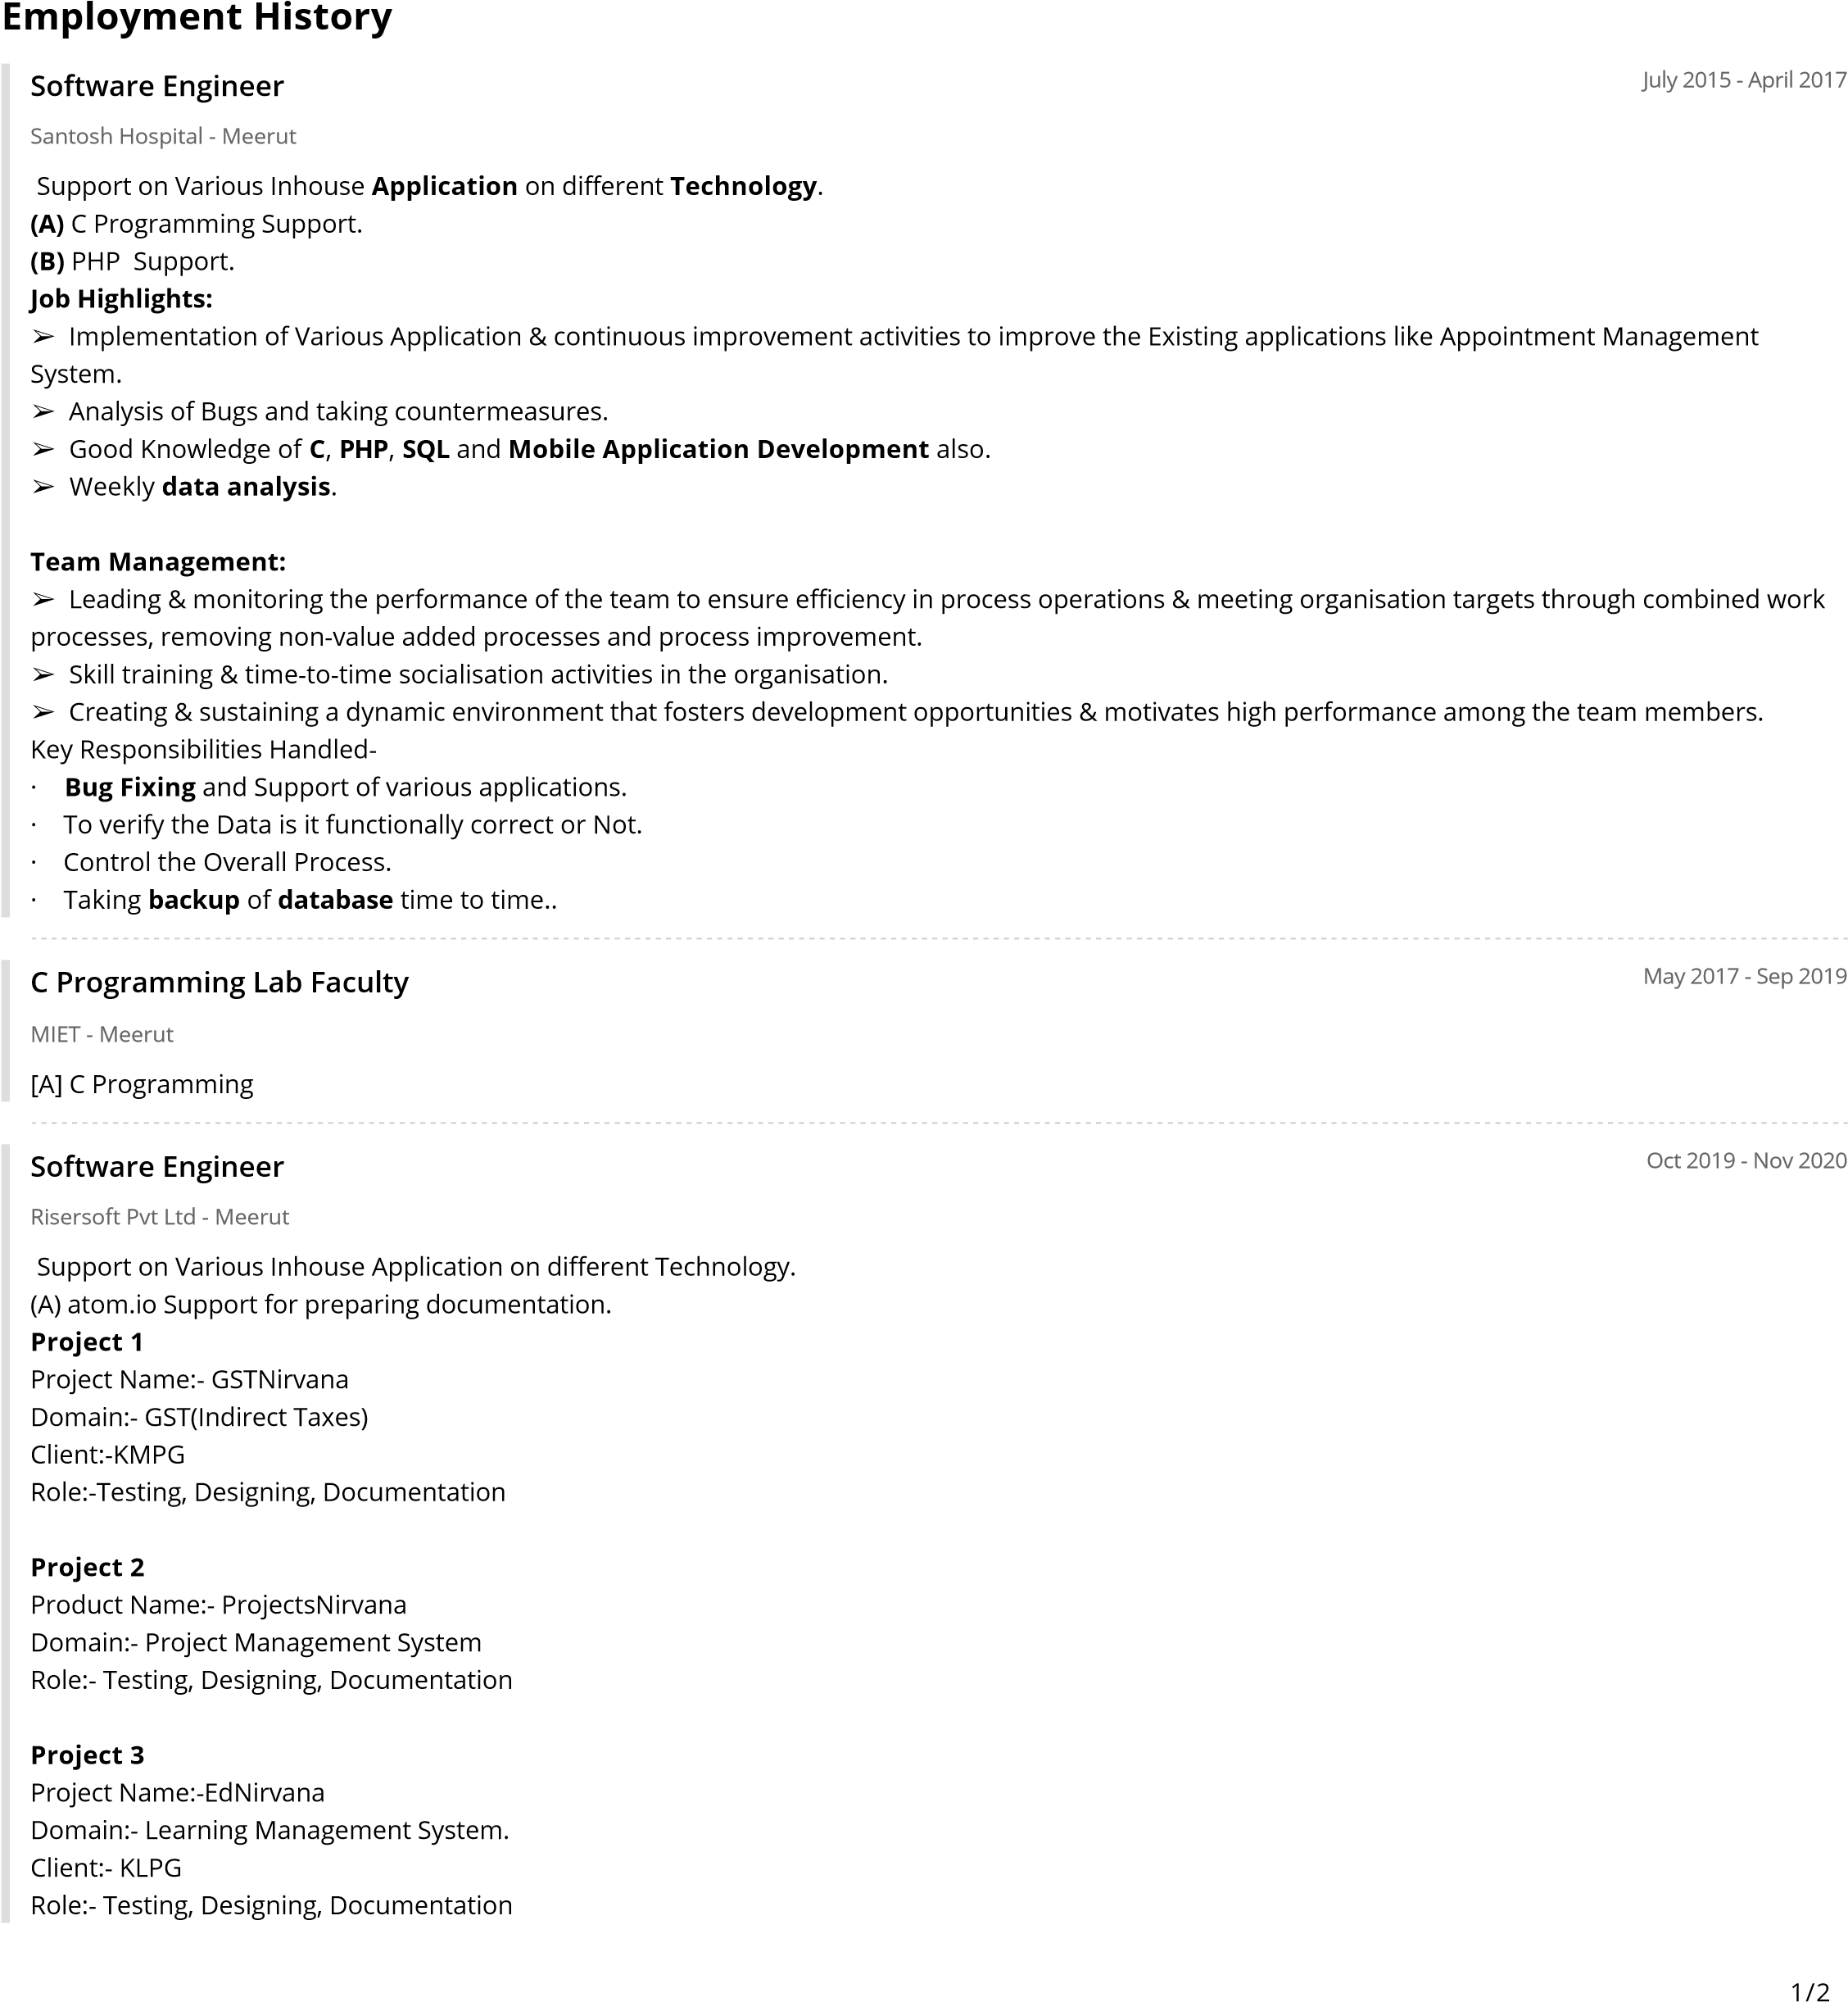

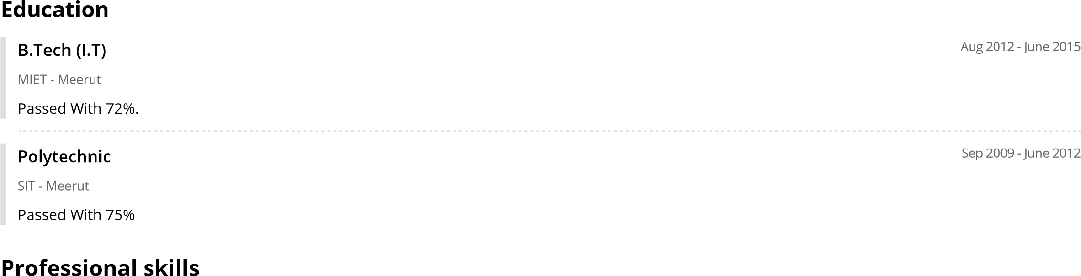

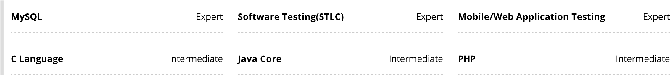

# Languages

English

Fluent

Hindi

Native

Trainings:

· 8 Week PHP Training from Sunrise, Meerut

· Two weeks training in “IBM” with work light on Mobile Application.

· 6 Week SQL Training from Sunrise, Meerut

· 6 Week Training on Java from CMC (TCS Subsidiary).

# Personal Details

Father’s Name : Mr. H.D. Sharma

Date of Birth : 05-10-1994

Gender : Female

Permanent Address : G-574,Govindpuram, Ghaziabad(U.P.)

Hobbies : Reading Newspaper, Internet Surfing

Strength : Ability to work in a team, Optimistic, Self motivated, Good Grasping ability, Honest toward work

Marital Status : Married

# Reference

Mr. Abhishek Goel Team Leader

Risersoft Pvt. Ltd.

+91-8859958997

# Declaration

I hereby assure that all the above mentioned information is absolutely true to the best of my knowledge and belief.

**DATE:**

**PLACE:** Ghaziabad(U.P) **Shiwani Sharma**

2/2