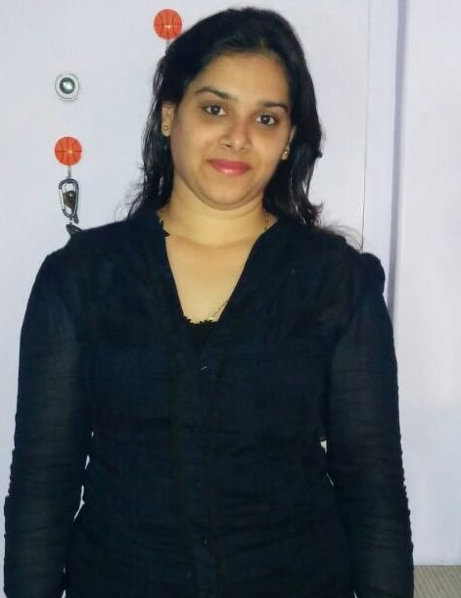

**FARAH KARIM**

**Address** – 3-A/104, Hamara Ghar Society, Model Town, **Email**-farahkarim9@gmail.com

Near R.T.O, Andheri (West), Mumbai - 400053

**Mobile**- 9920471721 **D.O.B**- 5th December 1986

**PERSONAL SUMMARY: -** A pleasant professional and proficient administrator who has a long track record of ensuring things run smoothly behind the scenes of a busy office. I am an effective team member who has the ability to meet deadlines and ensure that the highest standards of Office organization are maintained at all times. Right now I am looking to work for a company that offers excellent opportunities for personal and professional development.

**DESIGNATION:**-

* Personal Secretary (to the Director) cum admin

**CAREER HISTORY: -**

* **Zahara Productions** – 10th April 2013 to 30th May 2015
* **Evangrove Shipping Mumbai Pvt Ltd –** June, 2015 to March, 2016
* **OES International School** - 9th March, 2016 to 30th September, 2017
* **R**.**K. Lighting Pvt Ltd** – 21st March, 2018 – Till Date

**SUMMARY OF SKILLS:-**

* Possess excellent administrative and interpersonal skills
* Knowledge of Personal Secretary's job profile
* Highly skilled in managing time and organizing work priorities
* Ability to perform tasks under minimal supervision
* Possess excellent communication skills and a pleasing personality
* Knowledge of computer applications with good typing speed

**KEY SKILLS AND COMPETENCIES:-**  
  
**Working Experience:**

* Preparing and managing correspondence, documents and reports
* Organizing and coordinating conferences, meetings and making arrangements for travels
* Preparation of staff payroll and entry.
* Calculations of staff overtime allowances and any other benefits due them
* Preparation of LC (Letter of Credit)
* Maintaining filing systems under the instruction of the superior officer
* Supervising and maintaining financial transactions of the organization
* Maintaining calendars for the boss and scheduling appointments with clients
* Maintained and updated files, mails, inventory and database
* Reviewed files, records and documents to obtain necessary information
* Responded to calls and passed on important and necessary messages
* Screened telephone calls, took appointments, ordering gifts and flowers
* Recorded appropriate notes, attending meetings and events as necessary
* Prepared daily agendas, scheduled meetings, and confirmed appointments
* Performed other secretarial and administrative tasks as assigned

**Personal:**

* Calm and composed under pressure and able to work to tight deadlines
* Ability to work within a busy and demanding team environment
* Able to work with minimum amount of supervision and on own initiative

**AREAS OF EXPERTISE:**

* Office Administration & Personal Secretary

**ACADEMIC QUALIFICATIONS:-**

|  |  |  |  |
| --- | --- | --- | --- |
| **Degree** | **Institute** | **University / Board** | **Year** |
| TYB.Com | Mumbai University | Mumbai University | 2015 |
| SYB.Com | Mumbai University | Mumbai University | 2014 |
| HSC | Kamla Mehta College Of Commerce | Maharashtra Board | Feb 2004 |
| SSC | St. Louis Convent High School | Maharashtra Board | March 2002 |

**IT SKILLS:**-

* Proficient in MS Office, Excel and Internet

**Language proficiency**:-

* **Written:-**English, Hindi and Marathi
* **Spoken:-**English, Hindi and Marathi

**References:-**

Available on request

I certify that the above information is true to the best of knowledge

**Farah Karim**