**RESUME**

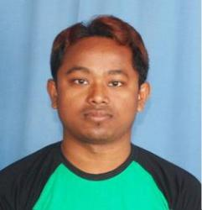

**NAME : BIKASH ROY**

**PERMANENT ADDRESS:**

Rajib Nagar, Darjeeling More,

P.O/P.S- Pradhan Nagar,

Dist: Darjeeling – 734003

Ph. 8972072045 / 8250055145

E-mail: bikash.roy2919@gmail.com

**PERSONAL DETAILS:**

|  |  |  |
| --- | --- | --- |
| • | Father’s Name | : Rajkumar Roy |
| • | Date of Birth | : 6th-Nov-1990 |
| • | Marital Status | : Unmarried |
| • | Gender | : Male |
| • | Nationality | : Indian |
| • | Religion | : Hindu |
| • | Languages Known | : Bengali, Hindi, English & Nepali |

**EDUCATION QUALIFICATION:**

1. Class 10th Passed in 2007
2. Class 12th Passed in 2009

**EXTRA QUALIFICATION:**

1. Computer Basic Knowledge, Tally – ERP 9.
2. Diploma in Excel .

**MANAGERIAL SKILLS:**

1. Strong Communication and interpersonal skills.
2. Ability to work independently as well as in Team Environment.
3. Ability to tackle new challenges.
4. Strong leadership qualities.

**WORKING EXPERIENCE:**

1. Worked as a senior Associate in First Source Pvt. Ltd. for 24th Months.
2. Experience as an Electrician (Domestic).
3. Now working as a Data Operator & Accountants Management in Goswami Optics.

**STRENGTHS:**

1. Sincerity, Honesty and remarkable Patience.
2. Adaptability to work at different environment.
3. Quick learner and pleasing personality.

**DECLARATION:**

I do hereby declare that all the statement made in the above application are true and correct to the best of my knowledge and belief.

**Date:**

**Place: Siliguri**

**(BIKASH ROY)**