RESUME
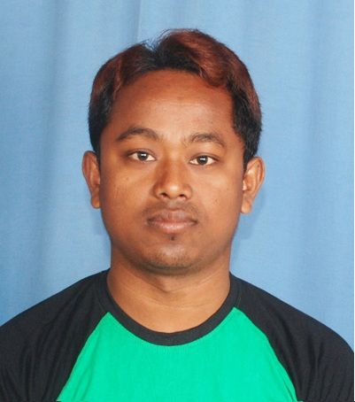
NAME : BIKASH ROY
PERMANENT ADDRESS:
Rajib Nagar, Darjeeling More,
P.O/P.S- Pradhan Nagar,
Dist: Darjeeling – 734003
Ph. 8972072045 / 8250055145
E-mail: bikash.roy2919@gmail.com
PERSONAL DETAILS:
- Father’s Name : Rajkumar Roy
- Date of Birth : 6th-Nov-1990
- Marital Status : Unmarried
- Gender : Male
- Nationality : Indian
- Religion : Hindu
- Languages Known : Bengali, Hindi, English & Nepali
EDUCATION QUALIFICATION:
- Class 10th Passed in 2007
- Class 12th Passed in 2009
EXTRA QUALIFICATION:
- Computer Basic Knowledge, Tally – ERP 9.
- Diploma in Excel .

MANAGERIAL SKILLS:

- Strong Communication and interpersonal skills.
- Ability to work independently as well as in Team Environment.
- Ability to tackle new challenges.
- Strong leadership qualities.
WORKING EXPERIENCE:

- Worked as a senior Associate in First Source Pvt. Ltd. for 24th Months.
- Experience as an Electrician since Five years.
- Now working as an Accountant in Goswami Optics.
STRENGTHS:

- Sincerity, Honesty and remarkable Patience.
- Adaptability to work at different environment.
- Quick learner and pleasing personality.
DECLARATION:
I do hereby declare that all the statement made in the above application are true and correct to the best of my knowledge and belief.

Date:
Place: Siliguri (BIKASH ROY)

