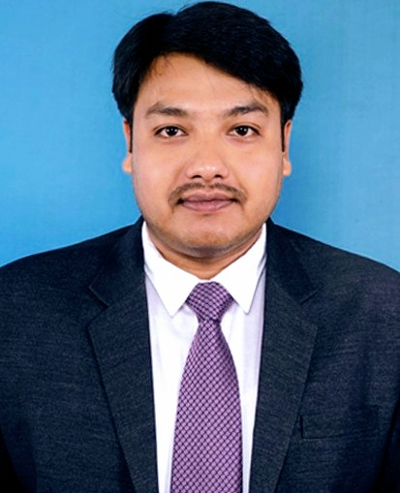
Mr. Subarna Ghosh

2/1. R. B. S. Road.
P. O. & P. S. : Bhadreswar.
Dist. : Hooghly.
Pin Code : 712124.
West Bengal, India.
Mobile : (+91) 9674888123
Email : gsubarna@rocketmail.com

CAREER OBJECTIVES

To succeed in an environment of growth and excellence and earn a job which provides me job satisfaction and self-development and help me achieve personal as well as organizational goals.

SUMMARY

A Proactive and result oriented professional with 8 years of experience.
Highly self-motivated team leader with positive attitude.

WORK EXPERIENCES

Current Organisation

BANDHAN BANK
Position : Senior Officer (Branch Sales Executive)
Duration : August 2019 to till now.

Responsibilities:

- CASA Opening.
- Providing Customer Service.
- Upselling & Cross Selling.
- LI & GI Opening.
- Product Branding to Customer.
- Lead Generation & Conversion.

Previous Organisations

6. GD HOSPITAL & DIABETES INSTITUTE

Position : Floor Coordinator
Duration : October 2018 - December 2018

Responsibilities:

- IPD Patients File Handling.
- File Updation of Patients on Daily Basis.
- Floor Operations Team Handling.

5. INDIAN INSTITUTE OF LIVER & DIGESTIVE SCIENCES (IILDS)
(LIVER FOUNDATION OF WEST BENGAL)

Position : IPD Executive
Duration : February 2018 - October 2018

Responsibilities:

- Patient Counselling.
- Admission Team & Discharge Team Handling.
- Floor Management.
- File Updation of Patients on Daily Basis.
- Floor Managers Team Handling.
- Making Monthly Roster.
- Grievance Handling.

4. B. P. PODDAR HOSPITAL & MEDICAL RESEARCH LTD.

Position : Senior Executive
Duration : November 2017 - February 2018

Responsibilities:

- Patient Counselling.
- Admission Team & Discharge Team Handling.
- Patient File Handling.
- Making Monthly Roster.
3. SANJEEVANI MULTISPECIALITY HOSPITAL

Position : Asst. Coordinator (Administration)
Duration : April 2017 - November 2017

Responsibilities:

- Admission Team & Discharge Team Handling.
- Floor Management.
- Making Monthly Roster.
- Grievance Handling.

2. KOTHARI MEDICAL CENTRE

Position : Jr. Executive
Duration : March 2012 - April 2017.

Responsibilities:

- Gastroenterology Department Operations in Charge.
- Floor Management.
- Roster Making of Doctors, Nurses & Departmental Employees.
- Scheduling of Departmental OPD & IPD Procedures.
- Scheduling of Departmental OT & Therapeutic Procedures.
- Departmental Stock Maintenance.
- Arrangement of Departmental Doctors Conferences.
- Departmental Monthly & Annual Report Arrangement.

- DESUN HOSPITAL & HEART INSTITUTE

Position : Assistant Executive
Duration : November 2011 - February 2012

Responsibilities:

- Admission & Discharge of Patient.
- Making OPD & IPD Bill.
- Cash Counter Handling.

LANGUAGES KNOWN

English : Read, Write, Speak.
Bengali : Read, Write, Speak.
Hindi : Read, Speak.

ACADEMIC QUALIFICATIONS

Year | Examinations | Board / University | Percentages (%)
2011 | B.COM | C.U. | 36.46
2008 | HIGHER SECONDARY | W.B.C.H.S.E. | 65.20
2006 | SECONDARY | W.B.B.S.E. | 49.62

OTHERS QUALIFICATION & TECHNICAL SKILLS

BFSI Course from West Bengal Swarojgar Corporation Limited.
Database Technologies : Basic, MS Office.
Platform Familiar With : All Windows Versions.

PERSONAL PARTICULARS

Father's Name : Mr. Subhash Chandra Ghosh.
Nationality : Indian.
Religion : Hindu.
Marital Status : Married.
Date of Birth : 05.05.1991

Place : Bhadreswar. Signature of the candidate
Date : MR. SUBARNA GHOSH

