SOMESH PATRA  E-Mail : patrasomesh0@gmail.com  Mobile : +918927008993 | 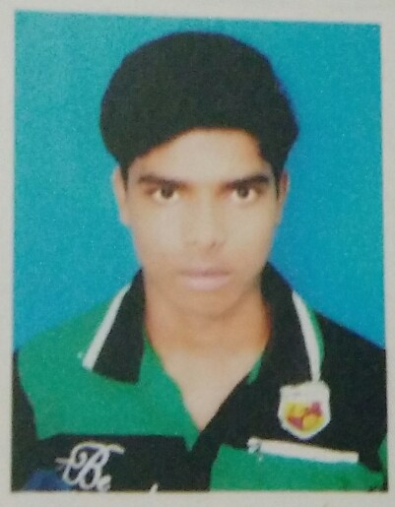
I like to gather a huge knowledge in my field and try to reach at a suitable position , in a field where I can establish myself .
PERMANENT ADDRESS |  | PERSONAL INFORMATION
Somesh Patra S/O : Subhas Patra  - VILL : Nimdasbar  - P.O : Pichhaboni  - P.S : Contai  - DIST : Purba Medinipur  - PIN : 721455  - STATE : West Bengal |  | Date Of Birth | 18/06/1995
 |  | Sex | Male
 |  | Nationality | Indian
 |  | Religion | Hindu
 |  | Caste | SC
 |  | Marital Status | Unmarried
 |  | Hobbies | Reading
 |  | Language Known | Bengali, English, Hindi,Oriya
ACADEMIC QUALIFICATION
EXAMINATION | SCHOOL/COLLEGE | BOARD/ UNIVERSITY | % OF MARKS | YEAR OF PASSING
Madhyamik | Pichhabani Bani Niketan High School(H.S) | W.B.B.S.E. | 48 | 2011
Higher Secondary (Commerce) | Pichhabani Bani Niketan High School(H.S) | W.B.C.H.S.E. | 60 | 2013
Graduation  (Accountancy honours) | P.K College , Contai | Vidyasagar University | 49.87 | 2016

TRAINING EXPROUSER:

Have done a 6th month basic course in computer and business softwares like DOS MS WORD, MS EXCELL, POWER POINn AND 6th month TALLY course from CONTAI WEBEL COMPUTER TRAINING CENTER.

DICLARATION .

I HEREBY DECLARED THAT ALL THE STATEMENT AND DATA ARE TRUE TO THE BEST OF MY KNOWLEDGE AND BELIEF. I PROMISE I CAN PROOF IT ON DEMAND

DATE: ………………………….. Somesh Patra
PLACE: ………………………… Signature

