 | Shambhvi Gupta  shambhvi.gupta21@gmail.com  Ph: +91-7355646581 | 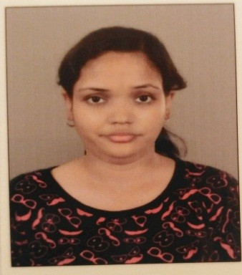
OBJECTIVE

- To work hard with full determination and dedication to achieve organizational as well as personal goals.
- I want to succeed in a stimulating and challenging environment that will provide me with advancement opportunities.
ACADEMIC QUALIFICATION

Name of the Examination | Name of the Institute | Board/University | Year
MBA | School of Management Studies, Varanasi | A.K.T.U. | 2014-16
BBA | Microtek College of Management and Technology, Varanasi | SMU | 2011-2014
12th | NIOS | NIOS | 2011
10th | Bal Vidhyalay Madhyamik School, Varanasi | C.B.S.E | 2008

CERTIFICATE PROGRAMME / WORKSHOPS / CONFERENCES

Organization: Aditya Birla Group (Pantaloons)
Duration: 6 Days
Key takeaways: To understand the working mechanism of retail chain.
To observe the customer behavior and customer psychology.

- Certificate of Participation Industrial Visit at Hewlett-Packwad (HP) India Sales Pvt. Ltd. & Parle Biscuits Pvt. Ltd. in Rudrapur (Uttaranchal) During 2nd October to 5th October 2013.
- Lecture sessions by Prof. B.P. Singh, Former Head and Dean, Delhi School of Economics.
- Lecture session by Prof. P. Venu Gopal, XLRI, Jamshedpur.
- International conference on SPIRITUALITY- the essence of ethical leadership and management , School of management sciences, Varanasi, 22 to 24 November 2014
- Personality Assessment Workshop conducted by ABBSCISSA, New Delhi on September 19, 2014 at School of Management Sciences Varanasi

- Proficient with MS Office and using the internet for research & official communication
Computer knowledge

Organization: Aditya Birla Group (Pantaloons)
Duration: 6 Days
Key takeaways: To understand the working mechanism of retail chain.
To observe the customer behavior and customer psychology.

PERSONAL ATTRIBUTES

- Ability to produce best result in pressure situation
- Persistent
- Punctual
- Willgness to Learn
- Ability to work as individual as well as in group
Work Experience

Organization: Aditya Birla Group (Pantaloons)
Duration: 6 Days
Key takeaways: To understand the working mechanism of retail chain.
To observe the customer behavior and customer psychology.

13 October 2016 – 30 April 2018 - GYANDEEP ACADEMY
POSITION – OFFICE ASSITANT
FRONT OFFICE ASSISTANT OCT 2016- DEC 2017
- Keep front desk tidy and presentable with all necessary material (pens, forms, paper etc.)
- Answer questions and address complaints of customer
- Answer all incoming calls and redirect them or keep messages
- Receive letters, packages etc. and distribute them
- Check, sort and forward emails
- Maintain admission of new student and taken test of these students
- Prepare student records on Excel and Word

CASHIER JAN 2018- APR 2018
- Handle cash, credit or check transactions with customers
- Count money in cash drawers at the beginning and end of shifts to ensure that amounts are correct and that there is adequate change
- Collecting fees of student & prepare daybook
- Pleasantly deal with customers to ensure satisfaction
PERSONAL DETAILS

Date of Birth : 21-12-1992
Father’s Name : Mr. Ajai Kumar Gupta
Gender : Female
Language : English & Hindi
Address : C/22 Vishwakarma Nagar Colony, Kandwa, Varanasi.
DECLARATION

I Shambhvi Gupta hereby declare that the information provided above is true and the best of my knowledge.
Date:
Place: (SHAMBHVI GUPTA)

