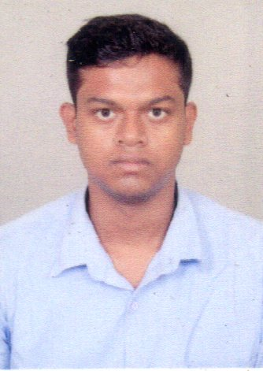
CURRICULUM VITAE

SOUVIK CHATTERJEE
C/O- MANIK CHATTOPADHYAY.
VILL- MUNDUKHOLA. P.O- PATULIGARM.
P.S- BALAGARH. DIST- HOOGHLY.
PIN-712501. STATE- WEST BENGAL.
CONTACT NO. +917980412636.
Email- souvikchatterjee891@gmail.com

OBJECTIVE
Looking for challenging carrer, where there is scope for demonstration, always on a look out for a positive &
bigger outlook, currency are ideas, thrive on imagination & passion, rigorous thinking & bondless curiosity,
sets level & standard that exceed expectations. A learner of life.

TECHNICAL QUALIFICATION
ITI in Electronics Mechanic form Government ITI Pandua under National Council for Vocational Trining.

RESULT
EXAMINATION | COLLEGE | BOARD/  COUNCIL | YEAR OF  PASSING | MARKS  % | AVG  %
ITI IN  ELECTRONICS  MECHANIC | GOVT.ITI  PANDUA | NCVT | 2021 | 80 | 83.7
 |  |  |  | 86.14

ACADEMIC QUALIFICATION
EXAMINATION | SCHOOL | BOARD/  COUNCIL | YEAR OF  PASSING | GRADE
MADHAYMIK | J.C.H.S | W.B.B.S.E | 2013 | B+
H.S-com(Distance) | B.H.S | W.B.C.H.S.E | 2016 | C

OTHER ACTIVITES
- I have certificate of graphics design and web page design for Brainware

HOBBIES
- Listening music
- Playing football
- Net Surfing

PERSONAL DETAILS
Father’s Name : Manik Chattopadhyay.
Date of Birth : 16th Aug.1996.
Sex : Male.
Nationality : Indian.
Religion : Hindu.
Cast : General.
Blood Group : ‘AB’ Positive.
Languages Knows : Bengali,Hindi,English.

DECLARATION
I hereby declare that all above the information made in this curriculum vitae are true, complete and correct, to
the best of my knowledge and belief.

Date:
()

