Curriculam Vitae

PERSONAL INFORMATION 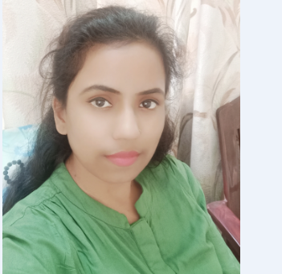
Name : PINKI KUMARI
Address : Siduli colliery, P.S – Andal, (WB)
Dist - Burdhwan (Asansol)
Pin - 713322

Mobile : 9609788216/ 9635463292
E-mail : pinki.suhasini.pks@gmail.com
Nationality : Indian
Date of birth : 02.01.1991
Marital status : Unmarried

AREA OF EXPERTISE

Sourcing–Negotiation-Vendor code development– Material code extend.

WORK EXPERIENCES

Jan’2019 – Till date Executive (Sourcing)
JBM Auto Limited, Chennai, India

• Name of the organization - HYUNDAI (Servicing).
Designation - Service Advisor
Date of joining - 25/04/2014 TO 30/08/2016
• Name of organization -FORD
Designation - Service Advisor
Date of joining - 01-09-2016 to 02-01-2018

OBJECTIVE:
To be associated with a progressive organization that provides an opportunity to apply my knowledge and skills in order to keep myself updated with latest trends and technologies and to constantly strive for the betterment of organization. To Excel among the professionals. Where I can utilize my skills with strong commitment and dedication, for the progressive growth of the company.
CAREER SUMMARY-
1. JBM Auto Ltd. (tier1) Sourcing Executive Purchase (SCM & Procurement) from 18 Jan 2018 till date
This plant is dedicated to manufacture and supply of Sheet Metal parts to Ford India Pvt. Ltd, Isuzu & Ashok Leyland.

RESPONSIBILITIES:
Sourcing:

- Prepare the Approval for L1 Supplier.
- Prepare the packing material paper for the domestic and overseas customer requirement.
- Prepare the provision for scrap and Raw material rate revision and reporting to management.
- Mail handling with Domestic and overseas supplier.(Related to Cost reduction).
- Responsible for FORD and Isuzu Tooling Payment process.
- Prepare and manage program timing plan against customer milestone
- Conduct regular meeting with overseas supplier and Internal CFT to monitor the program status (Related to Negations)
- Drive core team to complete their task and deliverables
- Ensure that the project budget allocated within target value and monitor spend vs actuals.
- Responsible for Global supplier audit and payment closure with customer
- Participate Management review meeting to review on each Program phases
- VAVE ideas and improvement on quality, productivity, implement new things and cost reduction.

EDUCATIONAL Qualification
Be mechanical engineering 2017.
2014: Diploma in Automobile Engineering From Malda Polytechnic Malda (WB) Affiliated 70% with WBSCTE.
2005 10th BSEB, PATNA

PROFESSIONAL SUMMARY:

Consumbal & indirect material source SAP based on the request from the Plant requirement or Customer and Manufacturing for Production.
• Good knowledge in preparing technical documents of SAP
• work knowledge Vendor code development and SAP MM.
• Material code extend.
INTERPERSONAL SKILLLS
Good Analytical and problem solving skill.
Self-confident and hardworking nature ability to work both independently and as a team player.

COMPUTER SKILLS:
    - Basic knowledge in MS Office Tools. MS-Office (Word, Excel, Power Point),
    - SAP, GDMS.
LANGUAGE SKILLS:

    - English, Hindi & Bengali.

PINKI KUMARI

