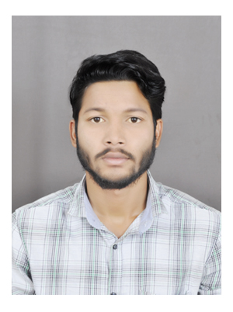

**RESUME**

**SONU Kumbhar**

**E-mail id:bbzsonu5@gmail.com**

**Mobile No:720514398**

**CAREER OBJECTIVE**

To work in a technically challenging environment and serve to the best of my abilities where I can contribute my entire knowledge and skills for the development of the Organization as well as my own growth as an individual in all aspects.

**EDUCATIONAL QUALIFICATIONS**

**TECHNICAL QUALIFICATIONS**

|  |  |  |  |  |
| --- | --- | --- | --- | --- |
| Qualification | Institution & Place | Board/ UIniersity | Year of Passing | Percentage |
| Diploma (CeramicTechnology) | Utkamani Gopabandhu Institute of Engineering, Rourkela | SCTE & VT | 2020 | 62% |

.**WORK EXPERIENCE**

3 months of Working experience in TRL Krosaki Ltd at Gumadera as Supervisor.

**INTERESTS AND HOBBIES**

* Playing Cricket .
* Listening Music.
* Reading Novels.

**PERSONAL DETAILS**

Name : Sonu Kumbhar

Father’s Name : Gouri Shankar Kumbhar

Date of Birth : 01.12.1996

Marital Status : Single

Nationality Indian.

Languages Known : English, Hindi & Odiya

Address : At- Gumadera Gountiapada Po- Belpahar

Dist- Jharsuguda Pin- 768218

State- Odisha

DECLARATION

I hereby declare that the information furnished above is true to the best of my knowledge & belief.

**Place: Belpahar**

**Date: (Sonu Kumbhar)**