GUNJESH

Contact: +91-9972936618;Kumargunjesh@yahoo.co.in

data analyst with 11+ years of experience in interpreting and analyzing data for driving business solutions. proficient knowledge in statistics, mathematics, and analytics. excellent understanding of business operations and analytics tools for effective analysis of data.

- Engineering Graduate and MBA with rich experience of 13 years in Marketing, Account Management, I and Data Analysis, U&R in Telecom Industry.
- Great ability to plan, develop and implement new product development projects.
- Have a rich experience in handling M&A projects along with projects related to smooth transitioning.
- Experience in handling Enterprise, Channel sales, Acquisition & U&R projects in prepaid and post-paid, data for wireless business and also in Wire-line Business.
- Excellent understanding of using Analytical tools like Advanced Excel, SAS,R,SPSS and Python.
- Remarkable ability to understand research principles, and statistical analysis with a good track record of prioritizing task and meeting deadlines.

ORGANISATIONAL EXPERIENCE:

August 2019-Till Date Vodafone India Shared Services Sr Manager-Global Business
July 2015- August 2019 Tata Teleservices Ltd Manager-BI Operations Oct 2013 –June 2015 Vodafone India Limited AM-Post-pay Marketing
Jan 2012- Sept 2013 Quadrant Tele ventures Ltd AM Wireline Marketing
Aug 2008- Dec 2011 Reliance Communications Ltd AM-Marketing Operations

AREA OF EXPERTISE:

Total Experience ~ 12 Years

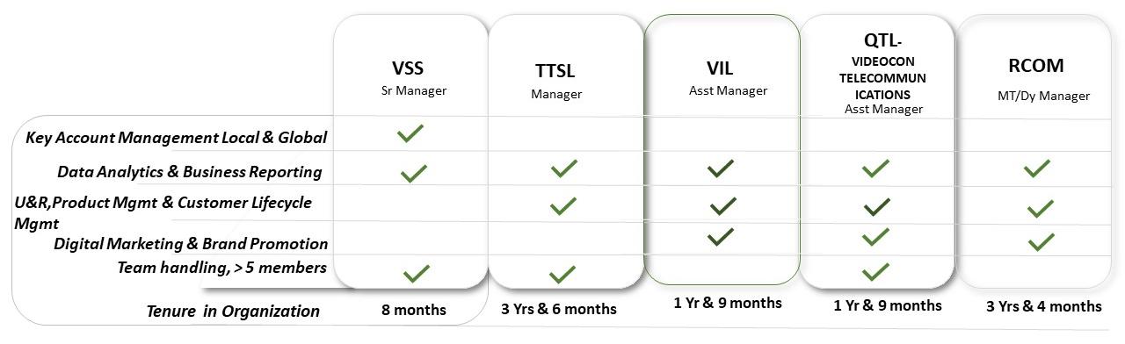

Account Management and Project Conceptualization:
VSS, VIL and Videocon

- Good Exposure of handling global internal clients of Vodafone Shared Services.
- Working with the top-level management Vodafone Local European Markets, Australia and South Africa for any project concept, implementation and financial benefits.
- Requirement gathering, business proposals, financial calculations and get the deliverables through BAs, developers and Solution Architect.
- Act as a Spoc for global clients and pitch them with new BI products used cases.

- Organise and conduct trainings seminars with BAs and developers on new Analytics product and used cases.
- Hands on experience of handling large corporate clients and also nurture additional business through cross selling/Up selling Opportunities.
- Analyzing latest marketing trends, tracking competitors’ activities and providing valuable inputs for fine tuning sales & marketing strategies; identifying streams for revenue growth & developing plans to build consumer preference
- Studying business potential, conceptualizing & executing strategies to drive sales, augmenting turnover and achieving desired targets; identifying and establishing strategic alliances / tie-ups with suitable channel partners, resulting in deeper market penetration and reach for achieving profitability and increased sales growth
- Preparing presentation & proposals for new projects based on site visits, study of client’s requirement to be acquired for negotiation & finalization of contracts

Business Intelligence,Data Analystics and Marketing(U&R)
TTSL,Videocon,RCOM,VIL

- Tracking, analysis, benchmarking and publishing of Business KPIs on Customer loss and retention programs across the circles, apart from tracking and reporting of important/assigned business activities as well as preparation of presentations for various meetings.
- Strengthen decision making process of customer offer proposals and approvals through business analysis, while managing interaction and coordination with various stake holders at corporate office as well as circles.
- Perform market analysis to efficiently achieve objectives, increasing sales.
- Investigate and conducted study on forecasts, demand, and capital for products.
- Product design, customer segmentation & marketing communication based on analysis of customer usage, consumer research, and penetration and market trends.
- Benchmarking competition on product pricing, trade margins, distribution and user experience.
- Coordinating with cross-functional teams in the development and execution of marketing strategies, including strategic selling support & promotions.
- Undertake in-depth data mining and analytics to gain insights into customer purchase and usage behaviour. Access financial impact of existing products & promotions on revenues.
- Benchmarking competition on product pricing, trade margins, distribution and user experience
- Test hypothesis and validate the same using statistical tools and analysis.
- Team handling experience of ten members with full responsibility of their performance metrices.

Digital Marketing and Acquisitions
Videocon,RCOM

- Plan and execute BTL promotions. Provide brief to Marcom team for rolling out ATL campaigns for various products and promotions. Consistently chart out activation strategies for higher engagement.
- Brand Promotional activities and focus on strategies to retain customers.
- Using data mining techniques to identify leads and derive a lead score for conversions via digital campaigns.
- Loyalty promotional campaigns and conduct customer interactions programs to enhance product outreach.
- Managing Outbound CCs for identified lead conversions and also strategise performance incetive programs for CC executives.

Channel Sales and Distribution Management :
RCOM

- Exposure to build a distribution infrastructure consisting a network of distributors, retailers and franchise models.
- Experience in handling a distributor with monthly trade volumes in excess of 5 Cr
- Run performance enhance programs for off roll FOS on quarterly basis.
- Roll out trade schemes, customer schemes and other sales promotion programs to boost incremental sales.

Notable Achievements and milestones:

- 2008-2011 – Was Awarded as the best performer for the year 2009-10 in RCOM
- 2010- Was awarded as champions of Champions for achieving most sales of Data cards in a particular market in RCOM.
- 2011-Was awarded for archiving highest RMS growth in a quarter in RCOM
- 2012 –Was awarded for launching “Project Parivartan” in QTL which focused on upselling activities for DSL users.
- 2014- Was a part of Global team which piloted and launched Post-pay Red Plans in Vodafone.
- 2016-Was a part of core team which launched first cross product loyalty programs and convergent billing system in Tata.
- 2017-2018 was a part of core team which ensured smooth transitioning, network migration via ICR,regulatory filings and settlements for M&A process of Tata Consumer business with Bharti Airtel.Was awarded by MD Tata tele for the same.
- 2020-Was recognized for closing five new projects from European Markets in a month.

EDUCATION :

- 2006 - 2008 MBA Amity Business School, Amity University, NOIDA, UP
- 2001 - 2005 BTech Mechanical Engineering, Visvesvaraya National Institute of Techonology,Nagpur
- 1998 - 2000 I.S.C(XII) - (PCM)-RPS School, Patna.
- 1997 - 1998 I.C.S.E(X) – St Xavier`s School, Sahibganj.

PERSONAL DETAILS

- Location Bangalore
- Marital status: Married
- Address: Bren Palms, Kudlu Main Road.
- Passport Available

