RESUME
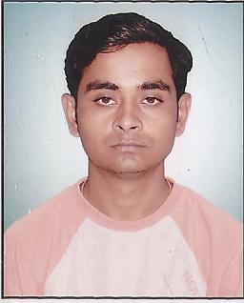
KHALEEL AHMAD

Address: Opp mail hospital
Sardar aara machine balrampur- 271201

________________________________________________________________________

Career Objective:

- I want to work in an organization where I can fulfill my dreams and make the name of
Organization bright.

Experience :

. Worked in APPOLO VALUE CARD 2014-16 As a Team Leader
. Worked in .Al rafie tour and travels oman 2016-17 As a Ticketing Agent

Educational Summary:

Degree | Year | Name of School | Subject
High School | 2001 | Jesus Marry School Balrampur | Science
Intermediate | 2003 | Jesus Marry School Balrampur | Art
B.A. | 2006 | MLK(PG) College Balrampur | Art

Personal Details:

Date of Birth | 08-07-1984
Nationality | Indian
Marital status | Unmarried
Permanent Address | S/O Mr. Naseer Ahamad Ansari  Near- Junior High School,Moh. Yateem Khana Dist.- Balrampur
Contact No. | 9532925520

Declaration: I hereby Declare that the above information are correct and true.

Date: (KHALEEL AHMAD)

