**Deekshith**

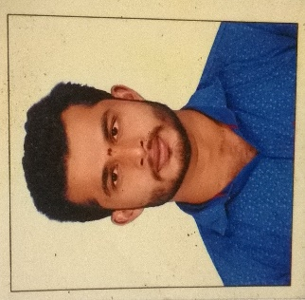**Permanent address**

NADYODI HOUSE

MUDANADUGODU VILLAGE

DHANDEGOLI POST

BANTWALA . MANGALORE

KARNATAKA .INDIA -574211

**Email**: deechu199@gmail.com

**Phone**:8971599662 ; Overseas no ;+ 22607030182

**PROFILE STATEMENT:**

As a graduate in Bachelor of Commerce with good marks under the UNIVERSITY OF MANGLORE looking to secure a position where my current analytical skill and knowledge effectively utilized and also help me to further develop these skill in a practical and fast spaced environment.

**EDUCATIONAL QUALIFICATIONS:**

|  |  |  |  |  |
| --- | --- | --- | --- | --- |
| **Qualification** | **Institution** | **University /**  **Board** | **Year** | **%** |
| **B.com** | Amrutha college  Padeel manglore | Manglore University | **2016** | **70.20%** |
| **PUC** | BA-Pre-University Thumbay | Karnataka state board | **2013** | **79.33%** |
| **SSLC** | Govt school vamadapadhav | Karnataka state board | **2010** | **67.2%** |

**TRAINING & CERTIFICATIONS:**

**1 months training about operation of foreign Accounting**

* **Peach tree (foreign accounting)**
* **Dac Easy ( foreign accounting)**
* **Tally ( indian accounting)**

**EXTRA CURRICULAR ACTIVITIES:**

* I have participated in cultural and sports events in our college.
* I participated RED CROSS in SSLC

**COMPUTER SKILLS:**

* Microsoft office
* E-mail writing
* Typing speed : 32 wpm

**WORK EXPERIENCE**

|  |  |  |  |
| --- | --- | --- | --- |
| **Company Name** | **Nature of work** | **Designation** | **Period of Service** |
| **J.K. Construction, Shakthinagar, Mangaluru** | **Accounts** | **Accountant** | **June, 2016 to March 2018** |
| **AXIS BANK** | **Clerical** | **Business Development officer** | **March , 2018 to October 2018** |

**STILL NOW I AM WORKING IN**

**COMPANY NAME** : TAN MONDIAL PVT LTD ( IMPORT EXPORT COMPANY )

**LOCATION :** ABHIDHJA , IVORY D COAST , WEST AFRICA

**ROLE :** ACCOUNTANT OFFICER

**PERSONAL INFORMATION**

Date of Birth : 14/06/1994

Gender : MALE

Language skills : Hindi, English, French,

Malyalam, KANNADA , TULU

**DECLARARTION**

**I hereby declare that the above mentioned details are true and correct to the best of my knowledge and belief.**

**Date:**

**Place: Manglore (DEEKSHITH)**