Curriculum Vitae

Mr. DINESH RAJA JAWARANI 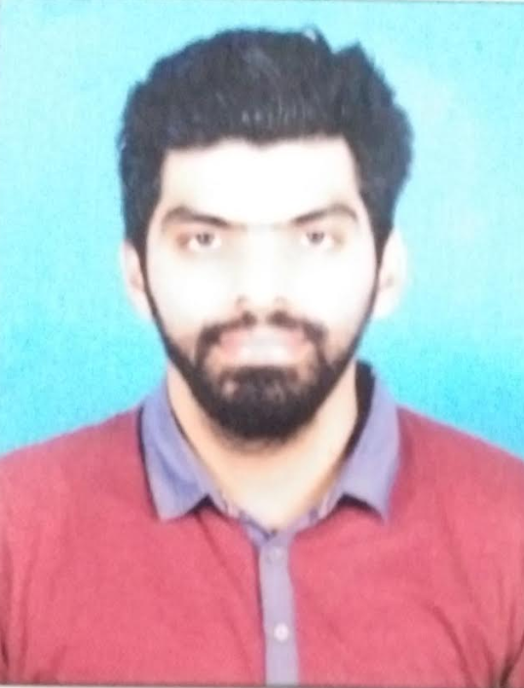
: dinesh.jawrani89@gmail.com
dinsjaw@yahoo.com

 : +91 8888-760-605

Career Objective
- To pursue a dynamic and challenging career with an organization of repute which gives value addition to the organization as well as offers opportunity to enhance professional skills while getting a high level of satisfaction and recognition.

Work Experience
- Presently Working with Quatrro Bussiness Support Solution Pvt Ltd. from September 2019 to till date as a Analyst. Restaurant financial statement department.
- Previously Working with Arya Toll Infra Ltd. from June 2015 to August 2019 as a Assistant Manager in Accounting and Finance.

- Previously associated with Heman Chheda & Co, Chartered Accountants for a period from Jan 2013 to May 2015 as Accounts, Audit & Tax executive.

- Current Work Exposure:

1. Accounting & finance process for US clients
.
2. The entire Record to report process including financials Statement month end deliveries.

3. Maintaining US GAAP reporting & MIS in excel format and formulation like vlookup, pivot table and running macros.

4. Email communication with team and clients.

5. Co-ordination with team for all strategic decisions making and finalizing.
Re-class and passing JE per details.

6. Recording and analyzing asset, liability, revenue and expense statement in excel format as well as Microsoft GP 13.

7. Maintaining GL code, preparing a trial balance and Bank reconciliation statement

8. Summarizes financial status by collecting information; preparing balance sheet, profit and loss, and other statements, budget forecasting and cash flow statement.

- Previous Work Exposure:

- Day to day banking and cash flow management
- Ledger scrutiny
- Finalization of yearly and quarterly accounts
- Preparation of MIS, Monthly Financial Reports,
- Monitoring of bank guarantees and letters of credit.
- Documentation of credit facilities
- Monthly and quarterly reports to lenders of working capital finance
- Compliances as per sanction letters of lenders
- Daily report of Toll collection and remittances
- TDS & Other statutory dues and Compliances
- Timely remittances to Toll Authorities
- GST reconciliation and co-ordination with GST Consultant
- Co-ordination with Statutory Auditors and other Consultants
- Reporting to company CFO & Managing Director

- Audits handled in the Previous firm:

- Statutory Audit and Tax Audit of Sudevi Chemicals
- Statutory Audit and Tax Audit of Lucky Hotel & Restaurants.
- Internal Audit of Gehimal H Karia.
- Internal Audit of S R Paper Pack
- Tax Audit of Travezia Tours & Travels Pvt Ltd

- Exposure across assignments:

- Conducting Internal Audit of the companies.
- Preparing and maintaining books of accounts.
- Filing of income tax returns of individuals and companies, and tax audit reports.
- Assisting clients in response to income tax department notices, sales tax notices.
- Vat Scrutiny and Filing Vat returns, assist clients in filing of Vat forms.
- Computation of Service tax liability of clients, assisting in application of PAN, TAN, ST.

Educational Qualifications

DEGREE/DIPLOMA | YEAR OF PASSING | Percentage | UNIVERSITY/BOARD
PGDM | 2019 | 1st Class | Wellingkar Institute of Management
TYBCOM | 2012 | 77% | Mumbai University
H.S.C. | 2009 | 58% | Mumbai Board.
S.S.C. | 2007 | 51% | Mumbai Board.

Computer Exposure
- Working knowledge of MS Excel, MS Word, MS Powerpoint, MS Outlook.
- Experienced in Accounting Tools i.e. Tally 7.2 & Tally ERP 9.0.

Strengths

- Excellent team member
- Ability to achieve deadlines.
- Ability to absorb pressures of cash flow management
- Willingness to work hard under demanding circumstances

Languages

- English, Hindi and Marathi.

Personal Details
Date of Birth : 25th September, 1991

Father’s Name : Raja C Jawarani

Marital Status : Single
Interests : Sports and Travelling.
PAN : ASJPJ0135A
Present Address : Sanam Apartment, 402 opp-Ruprells Hospital.
Ulhasnagar-421002

Declaration

I hereby declare the above mention details are true to the best of my knowledge and belief.

Date:
Place:

