**BIO-DATA**

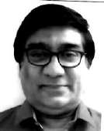

1. **Name of Applicant** : GAUTAM ROY
2. **Father’s Name** : LATE NARESH CHANDRA ROY
3. **Date of Birth**

(DD/MM/YYYY)

: 15.12.1955

1. **Gender** : Male
2. **Mailing Address (With Pin Code)**

: G6/104 SECTOR-D6,POCKET-D,GANGA APARTMENT TOWER NO-6VASANT KUNJ NEW DELHI-110070.

1. **Email ID & Contact No.** : [gautamroy71999@yahoo.co.in](mailto:gautamroy71999@yahoo.co.in)

(M) 9250017707

1. **Languages Known** : English, Hindi, Bengali.
2. **Educational Qualifications :**
   1. Passed All India Higher Secondary Examination in the year 1972 in second division from Central Board of Secondary Education, Kendriya Vidyalaya, Fort William, Kolkata.
   2. Passed B.Sc (Zoology Hons.) in the year 1975 in second class from Kolkata University, Bangabasi College, Kolkata.
   3. Passed M.Sc. in Museology (Museum Science & Administration), with special reference to Zoology, Botany, Geology, Geography and Anthropology in the year 1978 in first class from Kolkata University.
3. **Other Qualifications :**
   1. Passed Certificate Course in Forensic Science in the year 1981 in high second class from Delhi University.
   2. Passed Certificate Course in Hindi Probodh examination, three correspondence, in first class from Central Hindi Directorate, New Delhi
4. **Technical & Professional Qualifications and Training :**
   1. Passed the Certificate Course in Photography and Allied from School of Photography, Kolkata.
   2. Passed one week Certificate Course in Computer Maintenance from CMC, Delhi.
   3. Training in making of Dioroma, Models and other models for exhibition purposes from Birla Industrial and Technological Museum, Kolkata.
   4. Got appreciation from Director/CBI for organizing seminar in Cyber Law and the Police from CBI, New Delhi.
   5. Got appreciation from Joint Director/CBI for conducting first D.P. Kohli Memorial Lecture.
   6. Got appreciation from the Deputy Director/CBI for contributing photography in CBI Bulletin.
   7. Winning the third prize of the Eveready Better Photography Quiz Contest.
   8. Winning the first prize in the Fuji True to Life Photo Contest from M/s. Jindal Photo Films Limited.
   9. Won the first prize of Rs.10,000/- in the National Photo Contest organized by Photo Division, New Delhi.
   10. Won the first prize of Rs.5,000/- in the Photo Contest organized by Orissa Lalit Kala Academy, Bhubaneswar, also a National Award winner.
   11. Participated in the Role of Forensic Science in Criminal Investigation from Bundelkhand University, Jhansi.
   12. Participated in the course of Crime Scene and Forensic Evidence Collection from National Institute of Criminology and Forensic Science, New Delhi.
   13. Participated in the workshop on Color Photography from National Institute of Criminology and Forensic Science, New Delhi.
   14. Participated in the Forensic Evidence Collection and Digital Media from Federal Bureau of Investigation, Virgina, USA.
   15. Participated in Mobile Forensic Date Recovery from Certified Institute of Computer Response Team, New Delhi.
   16. Participated in Encase software from CBI Academy, Ghaziabad.
   17. Participated in Access Data Imager or Forensic Tool Kit Imager from CBI Academy, Ghaziabad.
   18. Participated in Mobile Forensic of Universal Forensic Extraction Device from Central Reserve Police Force, New Delhi.
   19. Participated in XRY Mobile Forensic extraction from Forensic Guru and CBI Academy, Ghaziabad and CERT-in.
   20. Participated in Cyber Law and Security organized by the DISCOM, ASOCHAM, DSCI and FORENSIC GURU.
5. **Experience :**
   1. Worked as Photo Assistant in National Archives of India, Jaipur from August, 1978 to 7th June, 1979. It includes micro photography of old documents, photographs, manuscripts, etc. through microfilm camera. Developing of 100 film role and studying of the negatives through reader.
   2. Worked as Scientific Assistant in Photo and Scientific Aids Division in CFSL, CBI, New Delhi from 8th June, 1979. Subsequently, promoted to Senior Scientific Assistant and then Senior Section Officer (SSO), Grade-II and lastly SSO, Grade-I.

Also given the charge of Head of the Department in Computer Forensic Division from 2011. It includes the Forensic Photography for eg. finger print photography, document photography, ultra violet and infra-red, micro & macro photography, photo micro and photo micro & macro, super imposition of skull, scene of crime photography, etc. All types of forensic photography in the investigation of crime.

Also done the cases of data recovery of digital media, i.e. external and internal hard disk, pendrives, DVDs, CDs, Tablets, Mobile phones, SIM cards, micro SD Cards and video footage of CCTV, photo comparision of question and specimen photographs recovered from CCTV, recovery of data from electronic voting machine, etc.

The undersigned have done five hundred cases of Digital Media regarding extraction and retrieval of data from hard disc, pendrive, micro sd cards, external hard disk and mobiles, etc.

The undersigned is working in this field for 36 years in Photo Division and Computer Forensic where I have visited 6000 crime scenes, two lakh negative and prints, 200 evidences in the Court of Law, 500 cases of Computer Forensic from 2011 and some cases of which are being convicted by the Court against my report. I am the only expert in CFSL, CBI, New Delhi who can recover data from the CCTV footage, also can compare the photograph and too retrieve data both logical and physical from the mobile.

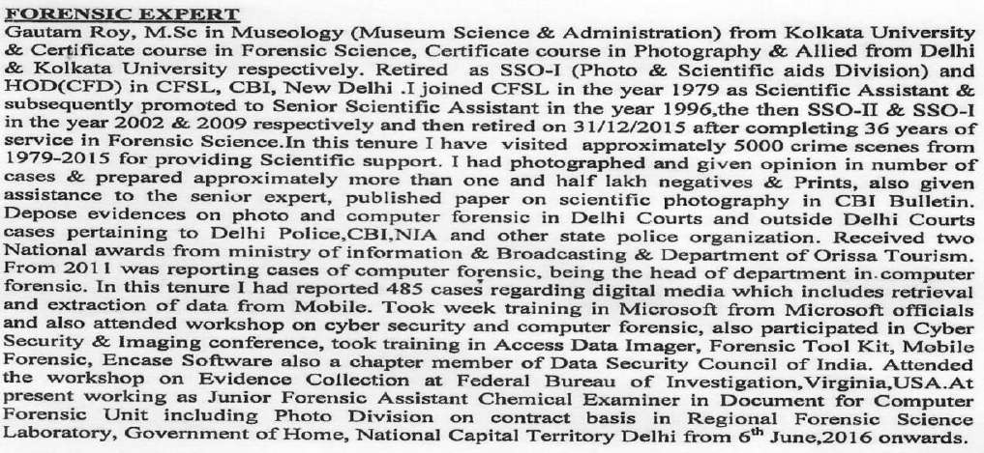

I, therefore, fervently pray you will be kind enough to give your sympathetic consideration which this application deserves and give me a job prayed for.

**Declaration :**

Certified that the information furnished above are true and correct to the best of my knowledge and belief and in case the same is found false or incorrect my candidature/appointment may be cancelled/terminated at any point of time.

Signature of the Applicant

**(Gautam Roy) HoD (CFD) & SSOI (Photo)**

**(RETIRED)**

**Date : 18/07/2020**

**Place : New Delhi**