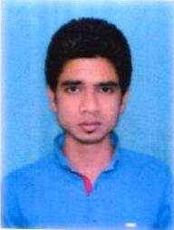  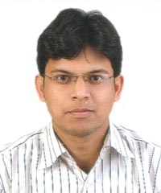  MANOJ KUMAR  Mobile: +91 8210041421  Email: manoj4jh@gmail.com  Address:  At- Bhuli E Block Sec-2 Q no-350  PO-Bhulinagar, PS-Bank More  Dist- Dhanbad (828105)  JHARKHAND  Personal Data:  Date of Birth : 27/08/1990  Father’s Name : Naresh Chauhan  Gender : Male.  Nationality : Indian.  Marital Status : Unmarried.  Languages known:  - English.  - Hindi  Strengths:  - Hard working.  - Confident.  - Punctual.  - Smart working. | Objective  To pursue a challenging and rewarding career by being constructive and innovative and to make myself competent enough for doing all my tasks independently as well as in a team in the organization so as to move ahead and add to the growth of the firm.  Key Skills  - Good Communication Skills.  - Can work effectively in team, as well as individually.  - Highly adapted to learn new views/ideas/technologies.  Academic Qualification  COURSE UNIVERSITY/BOARD DIVISION YEAR  B.a VBU Hazaribagh 2nd 2012  12th Sci JAC Ranchi 2nd 2007  10th JAC Ranchi 1st 2005  Extra Qualification  - DCA (Diploma in Computer Application)  Work Experience  - 1 Year training (Apprentice) completed from BCCL.  Declaration  I hereby declare that the above mentioned information is correct up to my knowledge and I bear the responsibility for the correctness of the above mentioned particulars.  Date:-  Place:- Signature

RESUME

