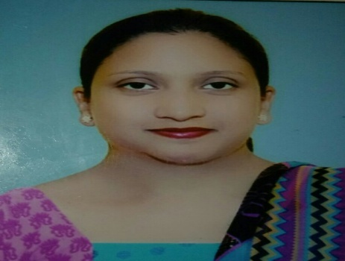**TIYASHA JANET WARNER**

Sheetlamai Mandir, Block -9**,**

Jabalpur, M P -482002.

Mobile no: 9109547384

Email : [tiyashadaniel084@gmail.com](mailto:tiyashadaniel084@gmail.com)

**Personal details:**

Date of birth 8th July 1984

Marital status : Married

Husband’s name : Mr. Pushpendra Warner

Permanent Address : 10 / A Muirabad, Allahabad, U.P 211002

**Professional Expertise :**

**B.Ed.** with teaching subjects – Geography and English.

Cleared **CTET** with 61%.

**Academic Qualification:**

|  |  |  |
| --- | --- | --- |
| Course | University | Year |
| B.A | Allahabad University | 2005 |
| B.Ed | Allahabad University | 2006 |
| M.A Geography | R.D.V.V Jabalpur | 2008 |
|  |  | 2012 |

**Project Work and Seminars:**

* Studied project on the **Badland Topography** of Rewa city.
* Attended **National Seminar** on Emotional Intelligence Nature and Nurture.
* Attended **Educational tour** to Uttaranchal.
* Attended **Educational tour** to Pachmadi.

Attended **National Seminar** on Environmental Hazards.

* Paper Presentation at **NAGI conference**.
* Attended **National workshop** on Play activities for Childhood period in different developmental areas.

**Educational Qualification:**

|  |  |  |
| --- | --- | --- |
| Year | Exam | Board |
| 2000 | X | I.C.S.E |
| 2002 | XII | I.S.C |

**Extra Curricular Activity:**

* Won various certificates in drawing competition.

* Won certificates in the games of volleyball.

* Attended the National basic Scout and Guide Program

* Attended Yoga Chetna Shivir.

**Teaching Experience :**

* Worked in Hawabagh College, as **Asst Prof in Dept of Geography** from 2008 to 2010.

* Worked in **Nachiketa Higher Secondary School**, Napier Town from 2010 to 2013.

* Worked in **St. Josephs Convent** ,Sadar ,Jabalpur, from 2013 to 2015.

* Worked as a **Principal Green Valley Public School,** Jabalpur since July 2015 to April 2019.

* Appointed as **Observer CBSE Board** for class 12th Examination, 2018.

**PLACE-**

**DATE- Tiyasha Janet Warner**