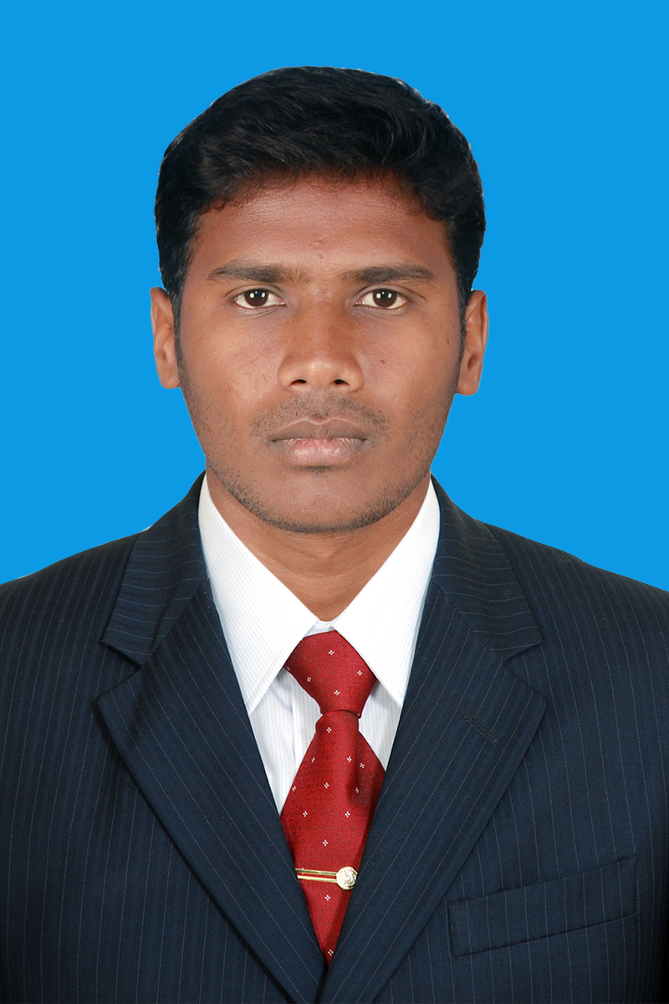
K.RAJESWARAN
1173,North Salaigramam
Salaigramam (PT),
Ilyangudi (T.K)
Sivagangai (D.T)-630710.
Contact No. : +91- 9790543638 E-Mail : rajshan086@gmail.com

OBJECTIVE

To work in a challenging environment demanding all my skills and efforts to explore and adapt myself in different fields and realize my potential where I get the opportunity for continuous learning.
ACADEMIC PROFICIENCY
Degree | Specialization | Name of the Institution | Year of Passing | University | Percentage of Marks/ CGPA
M.E | Structural Engineering | Vel Tech High Tech Dr.Rangarajan Dr.Sakunthala Engineering College. | 2015 | Anna University | 7.90
B.E | Civil Engineering | Kongu Engineering College, Erode | 2013 | Anna University | 6.98
H.S.C | -- | Govt. Higher Secondary School | 2009 | State Board | 82.4
SSLC | -- | Sacred Heart Higher Secondary School | 2007 | State Board | 71.2
SKILL SET

- Drafting Software : AutoCADD
- Analytical : STAAD.PRO

FIELD OF INTEREST

- Design of RC Elements & DRC BMS
- Design of Steel Structures
- Strength of Materials
- Structural Dynamics and Earthquake Engineering

PROJECT WORK

Academic Project | Experimental Study On Polypropylene Fiber Reinforcement Concrete With Mineral Admixtures | Vel Tech High Tech Dr.Rangarajan Dr.Sakunthala Engineering College – PG Level
Academic Project | Experimental Investigation Hollow Block Bricks | Kongu Engineering College, Perundurai – UG Level
Academic Project | Planning, Analysis, Designing and Estimation of a Hotel Building | Kongu Engineering College, Perundurai – UG Level
WORKING EXPERIENCE

- Worked as a Assistant Professor in the Department of Civil Engineering at M.P .Nachimuthu M.Jaganathan Engineering College, Chennimalai, Erode From 05-02-2016 to 31.06.2019( 3 Years 4 month).
- Worked as a Deputy Warden (student caretaker) in Boys Hostel M.P.Nachimuthu M.Jaganathan Engineering College, Chennimalai, Erode From 05-02-2016 to 31.06.2019( 3 Years 4 month).
- Worked as a Assistant Professor in the Department of Civil Engineering at Institute of Road and Transport Technology, Erode From 01.07.2019( 1 Years 10 month) to till now.
SUBJECTS HANDLED

- Strength Of Materials
- Railways, Airport and Harbour Engineering
- Structural Dynamics and Earthquake Engineering
- Environmental Science and Engineering
- Engineering Mechanics
- Prefabricated Structures
- Water Supply Engineering
- Wastewater Engineering
- Housing Planning and Management
- Maintenance and rehabilitation structures
RESPONSIBILITIES HANDLED

- Department Class Advisor & placement Incharge
- Department Time Table & Exam cell In-Charge
- Established 2 laboratories
TRAINING

- 30 days training on “Pier Construction, Portal Pier Construction, Erection Process” from URC company under senior civil engineer.
- Junior Engineer from Jun-14 to Jul-14 work with Chennai Metro Railway Station from URC

SPECIAL COURSES UNDERGONE

- Underwent a Certificated in STAAD.PRO
- Underwent a Certificated in AUTO CADD

CONFERENCES
- Exhibited a projected entitled as “ Partial Replacement of Red Soil Using Sludge In Bricks” at Kongu Engineering College in year of 2012.
- Exhibited a project entitled as “A Low Cost Workability Agent for Self Compacting Concrete from Waste Plastics” in 11th Open House Exhibition at Kongu Engineering College in year of 2013
EXTRA CURRICULAR ACTIVITIES

- Paper presentation of “Earthquake Resisting Structures “ at Vel Tech High Tech Dr.Rangarajan Dr.shakunthala Engineering college .
- Paper presentation of “ Experimental Study On Polypropylene Fibre Reinforcement Concrete With Mineral Admixtures” at Rajas Engineering College,Thirunalveli .
- Participated in Faculty Development Programme on “CE6302- Mechanics Of Solids” at Velalar College of Engineering and Technology.
- Participated in Academic Development and Training Programme on “ Engineering Mechanics” at SNS College of Technology.
- Participated in WORKSHOP on “ Design of Prestressed Concrete Members as per IS 1343: 2012 Code and Practical Aspects ” at Bannari Amman Institute of Technology.
PERSONALITY TRAITS

- An effective communicator with excellent relationship.
- Management skills and strong analytical skills.
- Problem solving and organizational abilities
PERSONAL PROFILE

Father’s Name : A.Karuppiah
Date of Birth : 26 -10- 1991
Languages Known : English, Tamil
Marital Status : Single
Address : 1173,North Salaigramam
Salaigramam (PT), Ilyangudi (T.K)
Sivagangai (D.T)-630710.

I do hereby declare that all the information provided above is true to the best of my knowledge.
DECLARATION

Place : Chennai Yours Truly,
Date : 13.12.2020 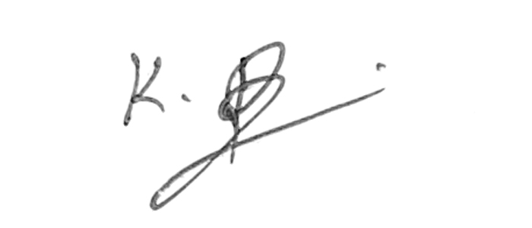
(K.Rajeswaran)

