SUBHRAJYOTI BOSE
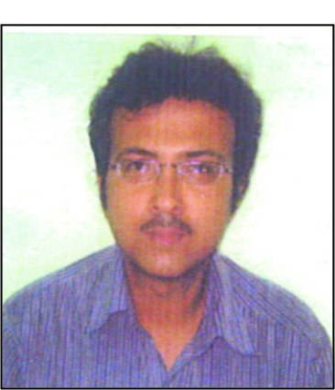

Address: 4B, Dharmatala Road
P.O. Tiljala, Kolkata-700039

Email: bosesj68@gmail.com / subhra68@hotmail.com
Phone No.: +91-9830733127 / 7980654930

Work Experience
- Organization: RGM International (India) Pvt. Ltd.
- Location: Kolkata
- Duration: June 2019 – Till date
- Description of the profile: Assistant Manager – Warehouse & Store Logistics
Stock handling - Inward & outward, Goods Receipt Note, Gate Entry, Issue Slip, Weekly report, requisition making
- Project Site : Afganisthan, DABS-15, DABS-16 Project

- Organization: Riverbank Developers Pvt. Ltd. (HILAND Group)
- Location: Kolkata
- Duration: April 2015 – March 2019
- Description of the profile: Document Controller – Design, Planning Department
Drawing log register, BBT Drawing register, Drawing print & site send, Payment log register, Document Control, Petty Cash Handling, Daily Attendance, Contractor Bill Certification, etc.
- Project Site : Calcutta Riverside – Hiland Greens I, Hiland Greens – II, Riverfront, Elgin, Bonochhaya Project, Cossipore Project, BBT Project

- Organization: SPECTRUM BUSINESS SOLUTION (A Subdivision of Masters Developement Management (I) Pvt. Ltd., Kolkata)
- Location: Kolkata
- Duration: September 2010 – March 2015
- Description of the profile: Executive – Admin Department
Site admin – Document Control, Gate Entry, Petty Cash Handling, Incoming & Outgoing Entry, Daily Attendance, Contractor Bill Certification, Good Receipt Note Entry, Challan & Issue Slip Entry, Internet etc.
- Project Site : Godrej Waterside, Infinity Magnacon IT Park, Godrej Genesis Project, Calcutta Riverside,
- Organization: COMPUTSET INTERNATIONAL
- Location: Kolkata
- Duration: March 2006 – August 2010
- Description of the profile: Computer Designer
Page layout, design, advertisement, document in Bengali, Hindi, English
Type with design in different job work in different software
Art work in Security Press

- Organization: S.S. Enterprise
- Location: Kolkata
- Duration: September 2005 – February 2006
- Description of the profile: Computer Operator
Computer type with design in different job work
Books in different languages type with setting jobs

ACADEMICS
DEGREE | INSTITUTION | BOARD/UNIVERSITY
B-Com | Calcutta University | Calcutta University
Higher Secondary | Jagad Bandhu Institution | WBCHSE
Secondary | Jagad Bandhu Institution | WBBSE

Strengths
- Software known as Corel draw, Pagemaker, Photoshop,
Microsoft Office, Miscrosoft Excel
- Typing in Bengali, English, Hindi
- Typing speed 50 w.p.m.
Interests and Hobbies
- Listening to music
- Watching Sports

Personal Details
- Date of Birth: 25th November, 1967
- Languages Known: Bengali, English, Hindi
I declare that the above information is true & correct to the best of my knowledge & belief.
Place: Kolkata
Date: Subhrajyoti Bose

