**CURRICULUM VITAE**

BHARATH M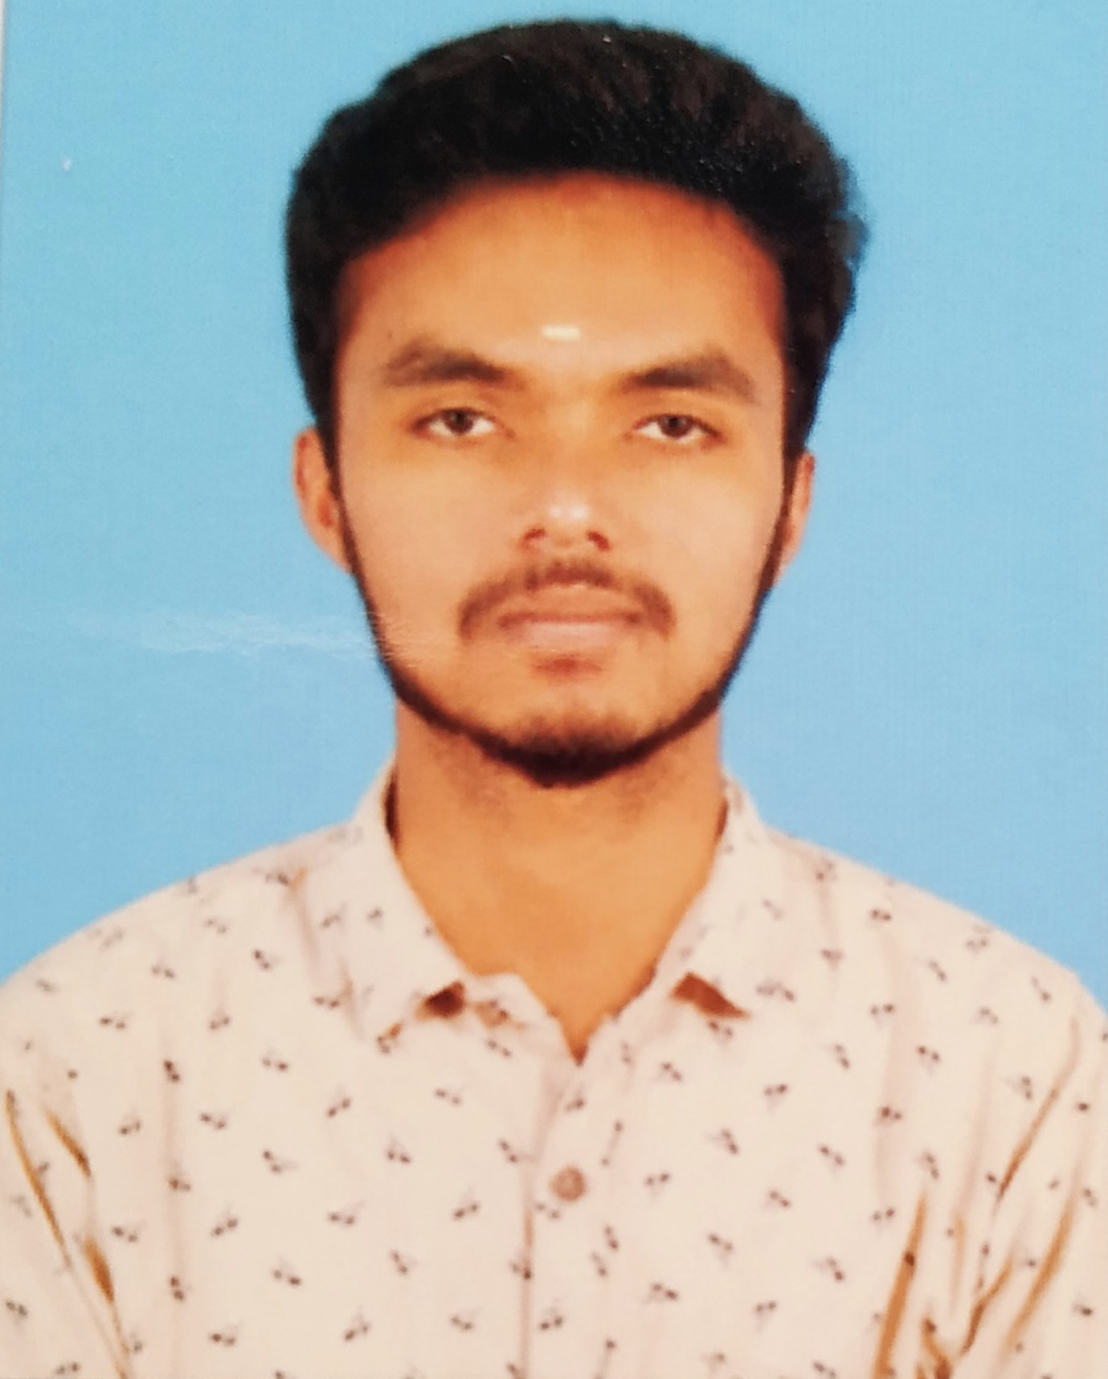

3/104-1 Rajiv Gandhi Nagar

Navadhi(vill) Hosur (tk),

Krishnagiri(Dt),

635110.

**Mobile No. :**+917339072596

**E-mail id. : bharathm2806@gmail.com**

**CAREER OBJECTIVE**

My goal is to associate with the company and its surroundings where I can utilize my skills and gain experience while I will give significant contribution to the development of the organization.

**ACADEMIC PROFILE**

**B.E. Computer Science and Engineering**

College : Excel Engineering College , Komarapalayam , Namakkal (Dt): Anna University

CGPA : 6.54( till 7thsem )

**H.S.C**

Seventh-Day-Adventist matr sec school,

Hosur-635110

March 2016,

Total aggregate –70**%**

**S.S.L.C**

Seventh-Day-Adventist matr sec school,

Hosur-635110

March2014,

Total aggregate-86%

**ACHIEVEMENTS**

* Participated in **“DEBUGING”** and won Frist prizein Intra College Symposium at KSR

Engineering college.

* Participate workshop In **IIT PONDICHERRY** in a topic of "**ETHICAL HACKING**".

**SPECIAL SKILLS**

* Independent and Smart working & flexible team player.
* Ability to work in multi-cultural and multi-functional team environment
* Capacity to solve any critical problem casually.

**LANGUAGES KNOWN**

* English ( Read,Write & Speak )
* Tamil ( Read,Write & Speak )
* Kannada ( Speak )
* Telugu ( Speak )

**AREAS OF INTEREST**

* Web Designing
* General Knowledge

**TRAININGS**

* Completed internship training " **WEB DESIGNING**" for 10 days at Infotech Solution, chennai.

**PERSONAL DATA**

FatherName :B.MURUGAN

DOB :28-06-1999

Gender : Male

Mother Tongue :Telugu

Nationality : Indian

Marital Status : Unmarried

**DECLARATION**

I hereby assure you that the information furnished above are true to best of my knowledge and belief.

Place:HOSUR

yours truly,

Date:

(BHARATH M)