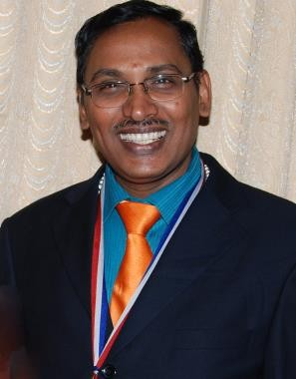KUNNAKUDI.V.SRINIVASAN

**M.Arch, F.I.I.A, F.I.V**

**First Floor, Aishwarya Apartments,**

**6a/18, Subbu Street, Thiruvanmiyur, CHENNAI- 600 041.**

**SOUTH INDIA**

**: +91 44 4262 9017 cell: +91 94440-69282.**

**+91 96000-59567.**

***Objective*** : **Architectural Design Faculty/ consultant**

## *Experience:* : : PRACTISING ARCHITECT SINCE 28 YRS IN WHICH ACADEMIC- 15YRS (OVERALL INCLUDING PART /FULL TIME)

***Education*** : **B.Arch** (July 1989) Mysore University

**M.Arch.** (May 2008)Sathyabama University,

***Council of Architecture No*** : **No: CA/90/13255**

***Additional qualification:*** Vaasthu and Feng-Shui consultant.

***Nationality*** : Indian

***Date of Birth, Age*** : 6th April 1964, 55 Years

### In Passport : VAIDYANATHAN SRINIVASAN

***Passport No*** : **K-0345303 –** issued at Chennai.

***Validity*** : **24-01-2022.**

***Fathers’ Name*** : **PADMASHREE.Dr. KUNNAKUDI VAIDYANATHAN,**

Renowned Carnatic Violinist cum Music Director.

***Chairman*** : **INSTITUTE OF INDIAN INTERIOR DESIGNERS- CHENNAI CHAPTER SINCE 2009 TILL DATE.**

***Fellow Member*** *:* **INDIAN INSTITUTE OF ARCHITECTS- TAMILNADU.**

## WORK EXPERIENCE on ARCHITECTURAL PRACTICE:

### Priniciple Architect:

*(21st Nov 2008 to till date)* **BAGYAAN ASSOCIATES, Chennai–600 028.**

* Reformed the total operation of clients’ handling and project management.
* Focusing more on the international updating in terms of software for handling and deliverance of projects in time.
* Ensuring the growth of the firm and looking forward to have more tie-ups internationally.
* Involved in various projects of Residential Interiors, Hospital Interiors and proposed multi storey building design consultancy as the current projects.

### Deputy General Manager –State Head-Architecture

*(11 Sep 2006 – 20th Nov 2008)* : **RELIANCE RETAIL LIMITED, INDIA**

* Identifying and report preparation of Feasibility of the Retail outlet, design and detailing of the outlets, Ware house designs, Town Centers and Corporate office.
* Anchor personnel responsibility for working drawings, detailing and tender floats. Supervision during the execution and release of GFC drawings.
* Successfully completed numerous prestigious projects in Chennai and south India.
* Headed the EPC division from state head office at Chennai, completed 96 outlets of Retail Reliance fresh outlets throughout Tamilnadu since September 2006.

### Chief Architect

*(15th Jul 1991 – Sep 2005)* : **BAGYAAN ASSOCIATES, Chennai–600 028.**

* Handled various kinds of projects from Concept to Completion of construction (Individual Residences, Bungalows, Cluster housings and Duplex houses.
* Residential Complex, commercial buildings from corporate office, shopping complex and community buildings.
* Involved in renovations of a Cinema Theatre.
* Developed strategies for strengthening Client – consultant relationship.
* Analyzed clients function to re-engineer business processes for performance improvements.
* Provided system integration across for effective CADD operative system with 3D studio.
* Handled and executed many corporate interior design projects in Turn – key basis.
* Successfully completed numerous prestigious projects in Chennai and south India.
* Residence, Bungalows, Institutions, FMCG factories and specialized in Retail outlets, shopping malls and more on Interior designs for Retail commercial outlets. Over all have covered more than 250 plus projects in Retail itself.

***Senior Architect*** *(March 1990 – July 1991):* **RAJENDRAN ASSOCIATES, Chennai – 18.**

* Undertook design and Planning for Residences and shopping complex.
* Preparation of Detailed working drawing on all services like electrical, plumbing and sanitation, HVAC and landscape drawings along with necessary details.
* Preparation of Perspective drawings in manual and in computer-aided design.

***Junior Architect*** *(April 1989 – March 1990)*: **KUMAR CONSULTANTS, Bangalore.**

* Dealt with star hotel maintenance from elevation features, provided addition and alterations, for better facia.
* Prepared schemes on Duplex houses, row houses for private organizations at Bangalore.
* Worked for Restaurant interiors including furnitures. Design and detailed drawings been prepared.

***Architect Trainee*** *(Sep 1988 – April 1989)* : **P.S.GOVIND RAO & CONSULTANTS,**

* Prepared model for a Commercial Complex.
* Prepared various layouts for individual Residences, Apartments and Commercial Blocks.
* Schemes for individual Bungalow with good amenities had been prepared.
  + Worked on various details of few projects like quantamizing the plans and to create the estimates and schedules with the proper specifications of materials, which was a great experience to learn and the interpretation of architectural language on project management were a milestone learning in those times.

## IN CONTINUATION TO PRACTICE HAVE LOTS OF PASSION TOWARDS ACADEMICS IN TEACHING LINE AND I EXTENDED SINCE LAST 15 YEARS AND BECAME NOW AS FULL TIME ASSIGNMENT

---contd

## ACADEMIC EXPERIENCE:

**DIRECTOR / DEAN – RVS SCHOOL OF ARCHITECTURE, DINDIGUL.**

*(14 SEP 2015 to TILL DATE)* **RVS SCHOOL OF ARCHITECTURE, DINDIGUL**

* Reformed the total operation of department and reorienting the administration.
* Focusing more on the external architects support towards student’s awareness programmes.
* Updating in terms of software for handling and practicing for students in Design related software.
* Ensuring the growth of the management and looking forward to have more tie-ups internationally.
* Involved in various external projects of our College premises involving our students and exposing them with the live projects.
* Recruiting qualitative staffs and refining the academic strength.
* Organized various workshops, symposiums, conferences in the college campus involving best practicing architects in the society. This exposure enhances the student’s awareness in the professional practice.

## DIRECTOR / DEAN – COIMBATORE ACADEMY OF ARCHITECTURE:

*(09 JUNE 2015 to 28th August 2015)* **COIMBATORE ACADEMY OF**

## ARCHITECTURE – JOTHIPURAM-KOVAI

* Been here as entrepreneur supporting the management from the time of its formation till the time of approval.
* The earlier experience in the teaching proved to achieve the different milestones in the academic area.
* Successful completion of initiation for the start of the new college been formulated and succeeded with the approval of council of architecture.
* During the tenure, I have been a instrumental to start and in due course due to various other reason they have to start only this year.

## Dean / Professor – School of Architecture

*(09 JUNE 2014 to 28th May 2015)* **McGAN’S OOTY SCHOOL OF**

## ARCHITECTURE – PERAR-OOTY.

* The instinct of leadership forced to take up the challenge in the area of known education.
* The earlier experience in the teaching proved to achieve the different milestones in the academic area.
* Successful completion of academic year and the student’s friendly approach made them to learn a lot and to perform in excellence.
* During the tenure, I have been a instrumental to start an course for the Draftsman, Site supervisor and Quantity surveyor as Para architectural course for the same university and chairman appreciated the perseverance of bringing the course to limelight.

### Director – Architecture Department

*(19th Nov 2012 to 28th March 2014)* **M.A.M SCHOOL OF ARCHITECTURE,**

## SIRUGANUR, TRICHY.

* Reformed the total operation of department and reorienting the administration.
* Focusing more on the external architects support towards students awareness programmes.
* Updating in terms of software for handling and practicing for students in Design related software.
* Ensuring the growth of the management and looking forward to have more tie-ups internationally.
* Involved in various external projects of our College premises involving our students and exposing them with the live projects.
* Recruiting qualitative staffs and refining the academic strength.
* Organized various workshops, symposiums, conferences in the college campus involving best practicing architects in the society. This exposure enhances the student’s awareness in the professional practice.

### Professor –Department of Architecture

*(Sep 2005 – Aug 2006)* **SATHYABAMA UNIVERSITY, CHENNAI, INDIA**

* The instinct of leadership forced to take up the challenge in the area of known education.
* The earlier experience in the teaching proved to achieve the different milestones in the academic area.
* Successful completion of academic year and the student’s friendly approach made them to learn a lot and to perform in excellence.
* During the tenure, I have been a instrumental to start an course for the Draftsman, Site supervisor and Quantity surveyor as Para architectural course for the same university and chairman appreciated the perseverance of bringing the course to limelight.

# PROFESSIONAL RESPONSIBILITIES:

## HELD POSITION IN OUR FRATERNITY ASSOCIATIONS:

**INDIAN INSTITUTE OF ARCHITECTS – TAMILNADU CHAPTER:**

## AS AN EXECUTIVE COMMITTEE MEMBER- SUB COMMITTEE

* **AS AN EDITOR FOR OUR NEWSLETTER FOR 2002-2008 with Monthly Edition Printing and Published and circulated to All the architects all over India.**

## INSTITUTE OF INDIAN INTERIOR DESIGNERS- CHENNAI CHAPTER

* **Being a member since 1999 have been part of varied activities of the IIID-CHENNAI CHAPTER.**

## Held position as CHENNAI REGIONAL CHAPTER CHAIRMAN since 2009-2014 for FIVE years.

* **Conducted varies Sponsor programmes, Excellence Award Programmes for professionals, Lecture demonstrations, Workshop for College Students, Symposiums, Inter college programmes and so on…**

# INTITUTIONS OF VALUERS- CHENNAI CHAPTER

* **As registered Member since 2000.**

# SOCIAL RESPONSIBILITIES:

Holding position as Trustee for a RAGA RESEARCH CENTRE, CHENNAI where the Music research for Carnatic Music and Hindustani done on Power of Ragas initiated by my father Dr.Padmashree Kunnakudi Vaidyanathan and the legendry continued with great support from the celebrities of Carnatic music. It also enhances varied chances to all the Young musicians. We also have 7000 sqft of RRC building facilitating the Programme hall of 2500 sqft where we conduct periodic programmes and other related activities of Carnatic music, also supported fairly by Government of Tamilnadu earlier.

Holding position as Trustee for THIRUVAIYARU THYAGABRAHMA TRUST in the name of SRI BANGALORE VIDYASUNDARI NAGARATHINAMMAL TRUST where we conduct yeartly thygabrahma mahotsavam and oter regular and allied programmes in terms of THYGABRAHMAM enchantment who is one of the Trimurthy deities of Carnatic Music

Keerthanas.

Held varied position in LIONS CLUB OF MADRAS CATHEDRAL from Board member to President level and to District chairman conducting varied programmes like school awareness, blood donation camp, Eye screening camp, Hygiene etiquette, Tree plantations and so on and still being a continuous member in my club since 1995 (20 years).

***Languages Known*** : English, Tamil, and Hindi & Kannada

***Computer Skills*** : Windows XP, AutoCAD 2000, Auto architect 3Dstudio and photoshop, MS-office ***Experience*** in preparing schemes, drawings and quotations using above softwares.

***Quality Management*** : Concentrating on up-keeping the quality while preparing necessary drawings and keen on tracking the execution of work.

### Special Projects:

* + Formulated the Course material for Diploma In ARCHITECTURE & conducted the D.Arch course affiliated to Newport University and the institute is **Natraj Institute of science &Technology** (1990-94)
  + Worked Conceptual design & Layout Planning of **Amusement park ‘Kishkinda”**

the first of its kind in India along with mock-up model of 146 acre project.

* + Worked as Associate Art Director for a Tamil feature film ‘Anjali”.
  + Served as Secretary for the National Event of Young Architects festival ’98 for Indian Institute of Architects – Tamilnadu chapter – February 1998.

### Extra curricular activities:

* + Portrait paintings on oil and canvas and abstract or on some concepts.
  + Musician playing the rhythms on instruments and rhythm pads for light music trope and violin for light music program.
  + Stage drama actor in college and schools, script writing for social plays.
  + Trained in personality development on Leadership quality to motivate the people to build their fortune better way. Conducted various workshops and seminars.
  + Conducted many social services through lionism, awarded as District chairman for the Blood donation in the district 324-A1. Conducted various camps in the colleges and created record to collect maximum blood units for the blood banks.
  + **Served as Editor, The Indian Institute of Architects, Tamilnadu Chapter.**

### Membership in:

* + **Registered Architect with Council of Architecture, NewDelhi. No: CA/90/13955.**
  + **Associate FELLOW member of the Indian Institute of Architects – Reg. No : F – 9109**

## Associate member of the Institute of Indian Interior Designers- Chennai Chapter. Chairman for Chennai Chapter for 2009-2013.

* + Registered Valuer from **The Institution of Valuers**, New Delhi.
  + **Lions club of Madras Cathedral** – Vice- President in the year 2000 – 2001. Prominent Lion member since 1988, involving in various societies oriented activities keeping service alone as a motto.

# Other positions:

Managing Trustee : Bangalore Nagarathnamal Trust, Chennai. @ THIRUVAIYARU….SRI THYAGABRAHMAM STHAN..

Vice-Chairman : Raga Research Centre, R.A. Puram, Chennai. .. (Carnatic Music Research organization...in support of Govt. of Tamilnadu)

## In General

**The Position**: As a practicing Architect, with good sound technical knowledge built up over a continued uninterrupted career within the building construction industry. I have several years experience envisaged that I have gained experience in most areas associated with the job. These areas includes carrying out detailed site measure surveys, preparing specifications, communicating with clients, contractors and other professionals etc. Apart from this, education being one more eye of my lifetime, would like to excel even in that and to prove, looking forward for the better exposure to prove my ability.

**The Role**: I control the day to day productivity and associated information for a diverse cross section of our system; To evaluate prioritize and monitor the performance: To monitor and improve the accuracy, technical content and presentations and all technical drawing information, including compiling and controlling the submissions and evaluations.

To improve and maintain the efficiency of our faculty/teammates; To work in close communication with the superiors, to whom the position is directly responsible; To work closely with faculty Team hand in hand to emerge the production activity qualitative and updating the in formations.

To disseminate and develop technical knowledge and experience to those less experienced staffs of the team, which, I never hesitated at any point of time, as I have understood that team work alone can work.

I can display good communication and inter personnel skills and would be on an equal footing with other staffs. To have a recognized staff structure, the genuine policy of equality, as each staff brings with them their own individual qualities and areas of experience. Hope I possess sufficient maturity, character and intelligence to integrate into this existing structure, which I declare to perform with my utmost confidence and to fulfill the best satisfaction to the management.

## Place: Chennai-600028. Date: 20–12–2019.

Signated by KVS

# [Ar.K.V.Sreenivasan]

### FEW SNAPS TO MARK…..

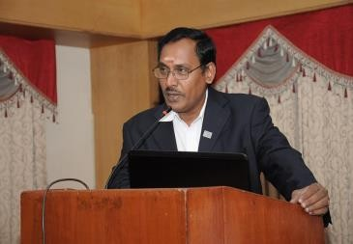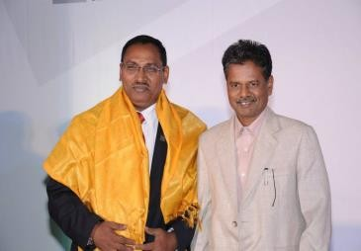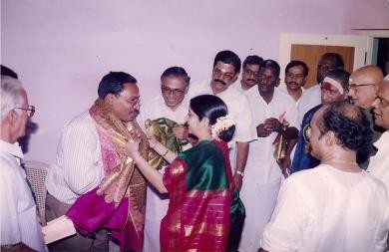

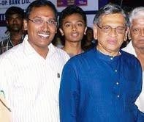 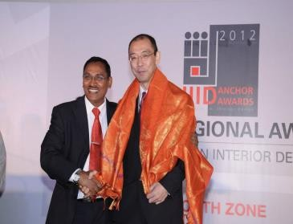 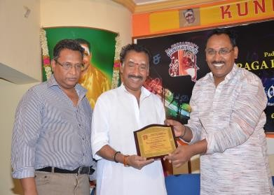

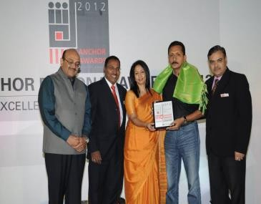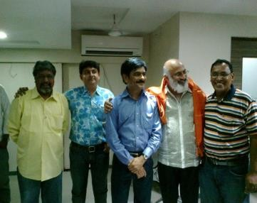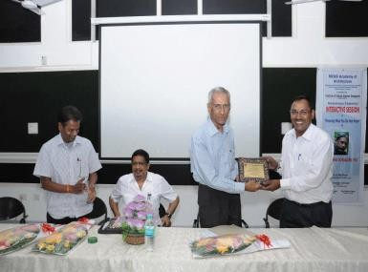

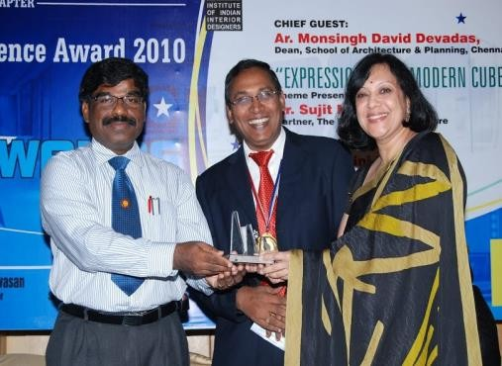 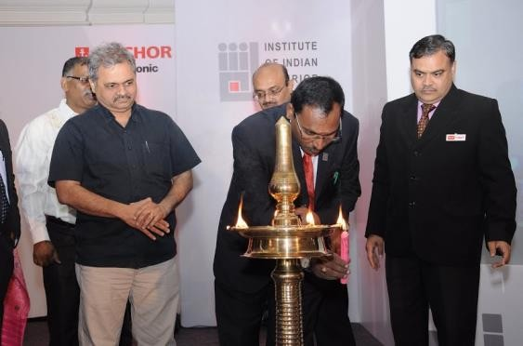

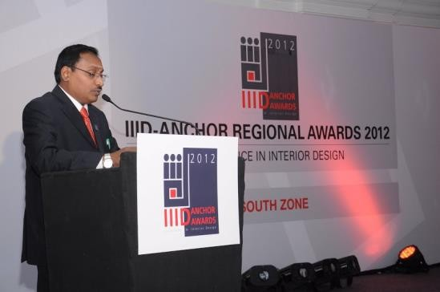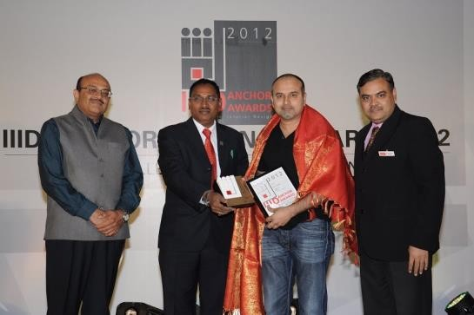

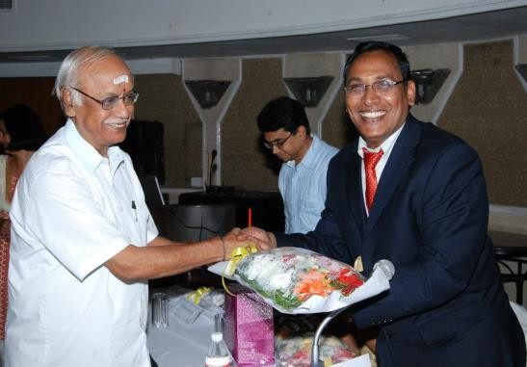 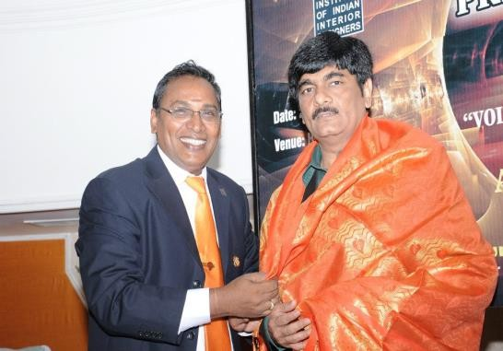

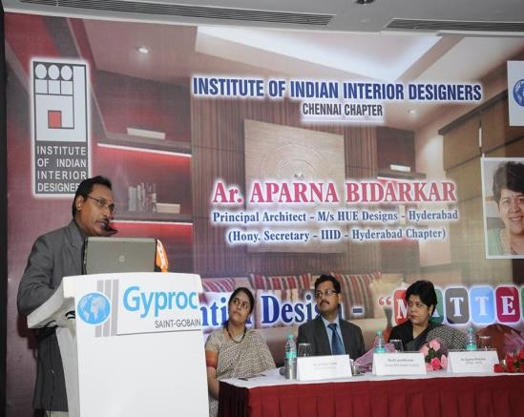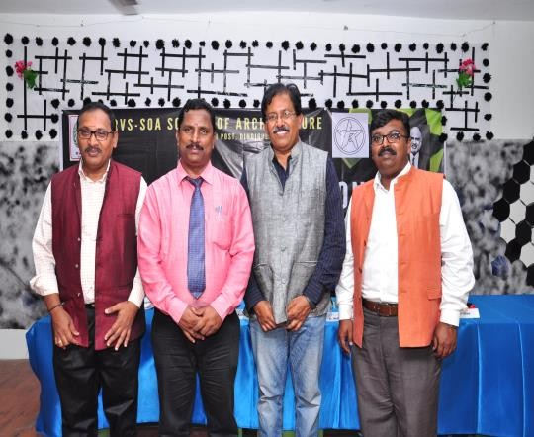

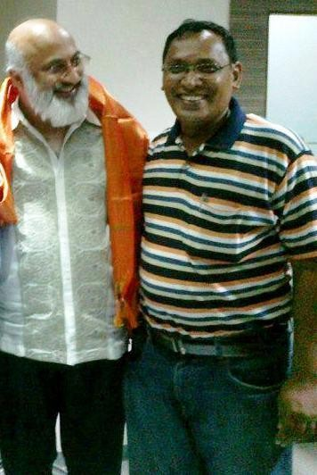 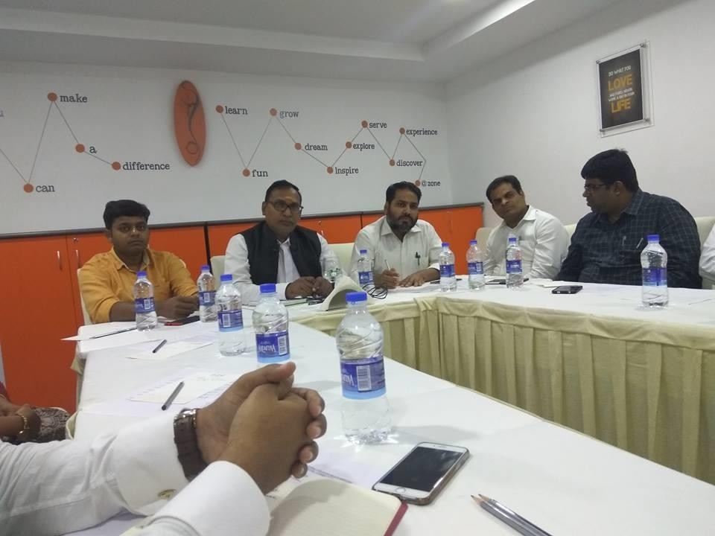

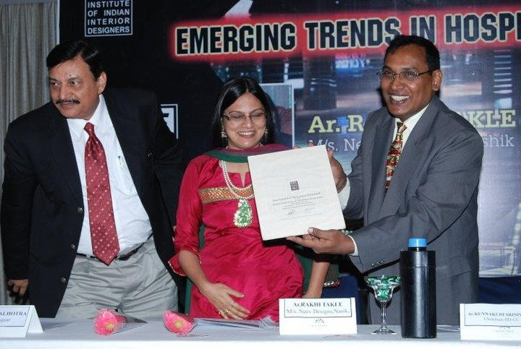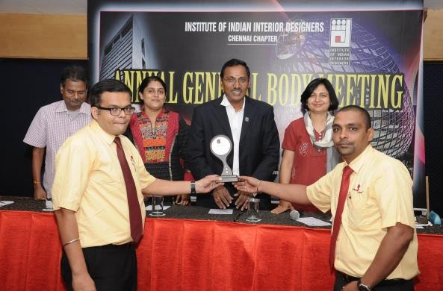

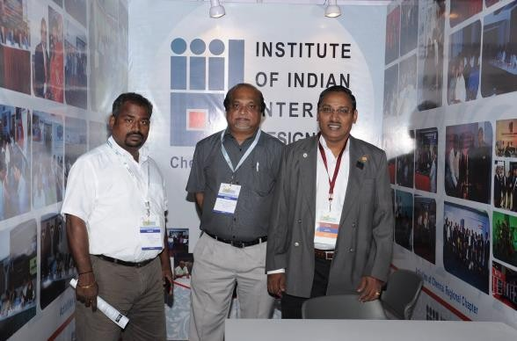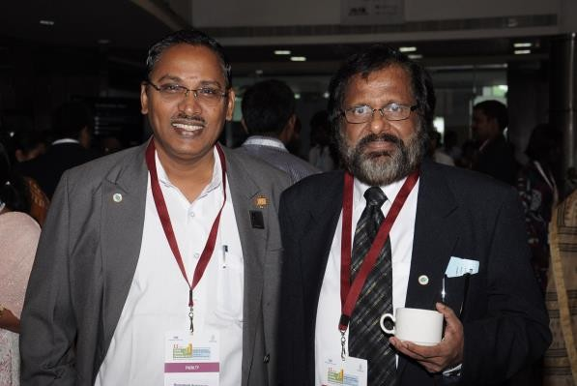

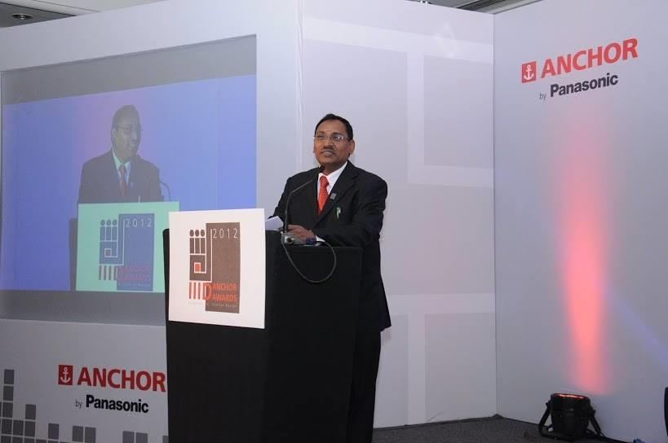 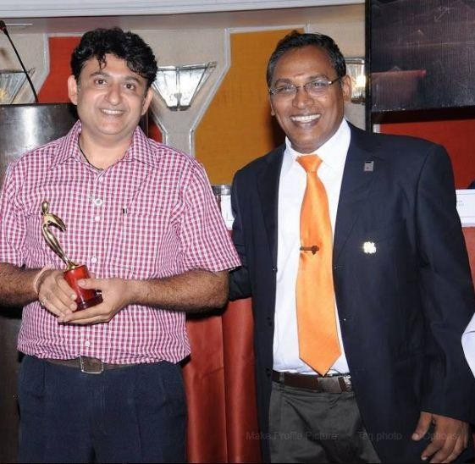

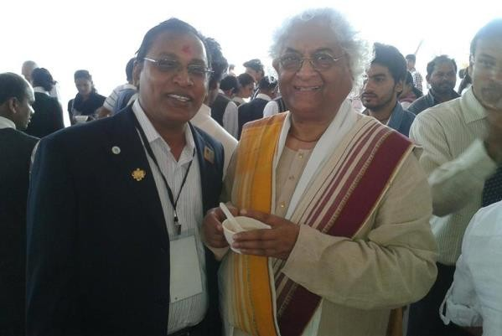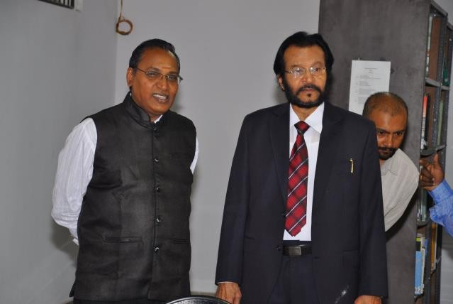

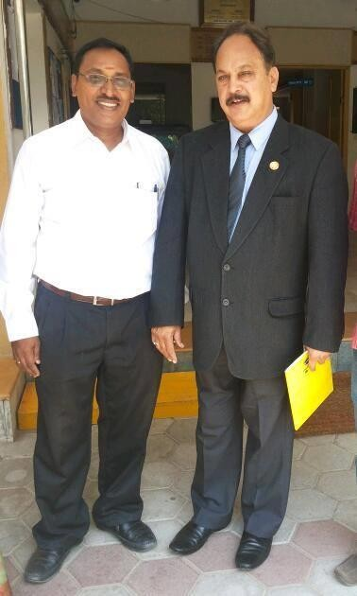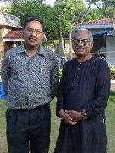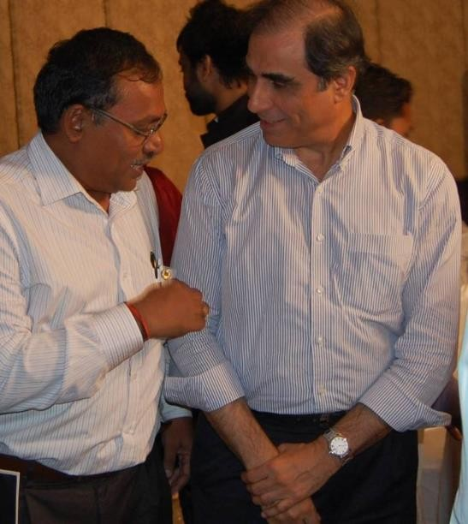

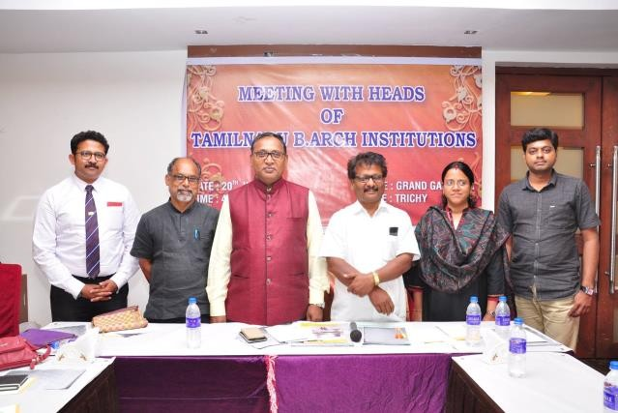 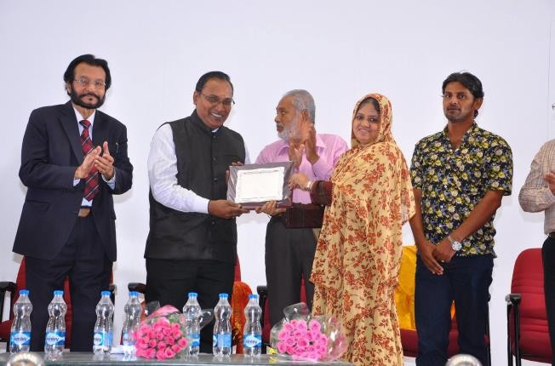

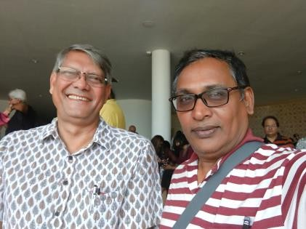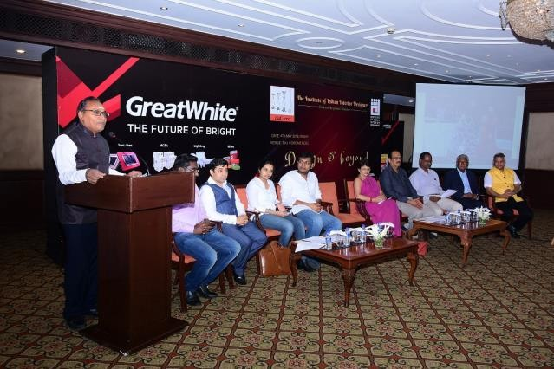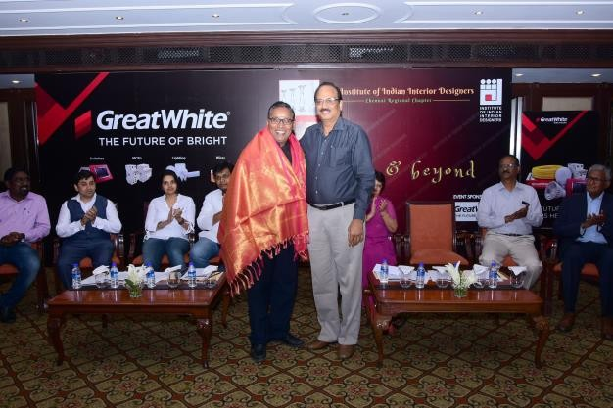

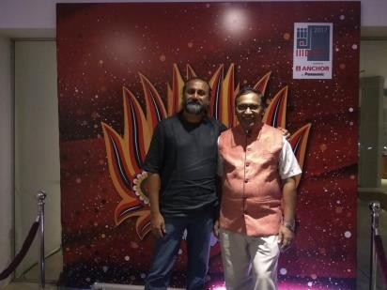

***and many more accolades to come…..- Thanking you – Ar.V.SRINIVASAN***