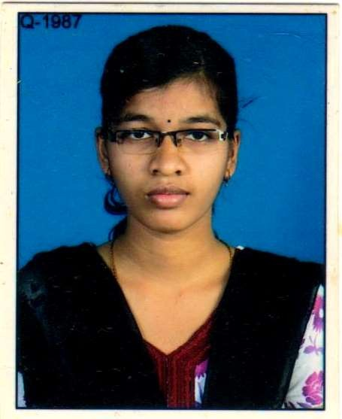§
BHARATI BEHERA
Email:bharatimaharana33@yahoo.com
Contact Address:
W/O: Pintu Moharana
Housing Board, Berhampur-760002 (Ganjam). Cell: -- 09178517850, 08763621785
CAREER OBJECTIVE:

To work with full dedication and sincerity and use my skills through careful observation and perseverance to achieve the goals of the organization I serve.

EDUCATIONAL QUALIFICATION:
EXAMINATIONS PASSED
YEAR OF PASSING
BOARD/ UNIVERSITY
% ACQUIRED/
GRADE
10th
2009
BSE, Cuttack
3rd Division

EXAMINATIONS PASSED | YEAR OF PASSING | BOARD/ UNIVERSITY | % ACQUIRED/  GRADE
10th | 2010  2012 | BSE, Cuttack | ^{2rd} Division
+2 Art’s | 2010  2012 | CHSE, BBSR | 2rd Division
+3 Art’s | 2015 | BERHAMPUR UNIVERSITY | 2nd Division

WORK EXPERIENCE:
+2 Com
2011
CHSE, BBSR
3rd Division

- Present employed with Sree Arnament, a mega gold jewelry mall at Berhampur, Odisha from Jan 2015 as Sales Executive

- Organization : RUBY EYE HOSPITAL Designation : Reception Appoint Girl. Experience : 1 Years 2 months

TECHNICAL SKILLS:
Diploma in Post Graduation Computer Application (PGDCA) with 75%. Typing speed with 35 wpm.
Diploma in Computer Hardware & Networking.
PERSONAL PROFILE:

Name : Bharati Behera Husband’s Name : Pintu Moharana Birth : 12th May 1994
Current Status : Intermediate

Gender : Female

Marital Status : Married

Nationality : Indian

Languages Known : English, Hindi and Oriya Hobbies : Book Reading
Self-Sketch : Hardworking, Punctual, Organized, Sociable, and Sincere

DECLARATION:

I hereby declare that the above mentioned particulars are true to the best of my knowledge and belief.
References will be provided as and when required.

Place: - Berhampur Bharati Behera

Date: Signature

