CURRICULUM VITAER

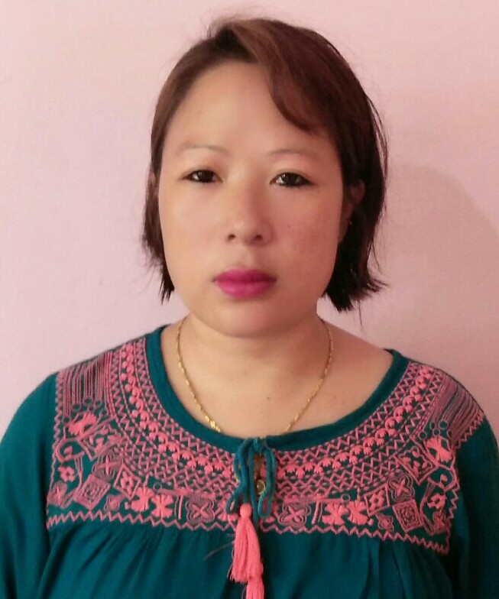
ESUMERE bjdgvubcbug7uggRERE
Profile:
Dynamic professional in Office management, clerical works, mail handling and computer based work with proven track record of supporting senior business figures in leading corporate and government organization.
Synopsis :
- NCVT-ITI COPA (Computer Operating and Programming Assistance)
- Typing speed of 40 wps
- One year diploma in MBA

PASSANG LHAMU SHERPA, E-mail-passchune@gmail.com Contact No.-7507662325

Career Summary
- Bharat Electronics Limited, Pune
Role – Assistance to General Manager (As an Apprenticeship trainee)
- Tech Mahindra, Pune
Role – Email processing associate

Key responsibilities
- Providing quality assistance to senior executive and General Manager to achieve organizational objectives.
- Accounting required stationeries and generate bills.
- Welcoming visitors and determine access to appropriate parties.
- Interact with clients when appropriate.
- Answering, clearing quires and directing calls to appropriate executives and departments, taking messages.
- Opening, sorting, and distributing correspondence, including email, faxes etc.
- Reading and analyzing submissions, letters, agendas, memos and determining significance; routing to appropriate personnel in a timely and in efficient manner.
- Maintaining inventory and office supplies.

Other Skills
- Good Communication skill.
- Operating System: Windows XP, 7 & 8.
- Office Suite : Microsoft Office (MS Word/Excel/PowerPoint)
- Good typing speed. (40/min)
- Soft Skills from Vishwakarma Institute of Management, Pune

Educational Qualification:
Qualification |  | Stream | Year | Remarks
Graduation |  | Arts | 2009
Personal Details:
Name: | Passang Lhamu Sherpa
Date of Birth: | 09 Jun 1983 (36 Years)
Local Address: | Salugara, Siliguri, West Bengal
Permanent Address: | Vill - Gairibas Factory Line, P/O - Gairibas, Dist- Kalimpong, West Bengal Pin -734502
Nationality: | Indian
Languages: | Hindi, English, Nepali,
Phone No: | 7507662325/8158926904
Email-id: | passchune@gmail.com
Declaration:

I assure that the above mentioned particulars are true to the best of my knowledge and belief.

Thanking you in anticipation.

Date: Passang Lhamu Sherpa

