CURRICULUM VITAE

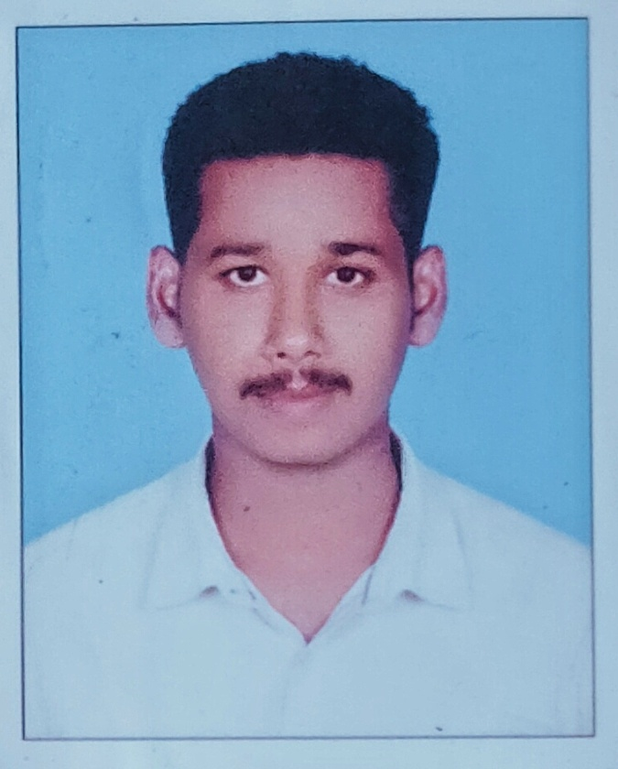MUHAMMED NIJIN. A

MOB : +91-9645019426

E-mail : [nijinsalam@gmail.com](mailto:nijinsalam@gmail.com)

Summary :

Profile : Male, 26 Single

Nationality : Indian

Total experience : 5 Years

Current position : Sales executive @ Bismi Electronics & Home appliances, Kollam

Right now would like to work for a company that is keen on hiring individuals who are smart & multi tasking talent, interested in a career one which will make best use of my existing skills and experience & also further my development

Educational Qualification :

\* INSTRUMENT MECHANIC TRADE NATIONAL COUNCIL FOR VOCATIOANAL TRAINING (NATIONAL TRADE CERTIFICATE, NCVT)

\* PLUS TWO(COMPUTER SCIENCE)

\* SSLC

Other Qualification:

Basic knowledge in MS Office & windows

Experience :

\*Sales Executive @ Bismi Home Appliances, Kollam (2021-till date)

\*Taxi Driver @ Saudi Arabia (2018-2020)

\*Junior Instrument technician @ KMML Titanium, Chavara (Apprentice Trainee) (2017)

Personal Details :

Father Name : Abdul Salam

Date of Birth : 03/11/1995

Nationality : Indian

Language Known : Malayalam, English, Hindi, Arabic

Driving Licence : Indian & Saudi Arabia LMV

Passport No. : N9103202 (MUHAMMED NIJIN.A)