(RESUME)

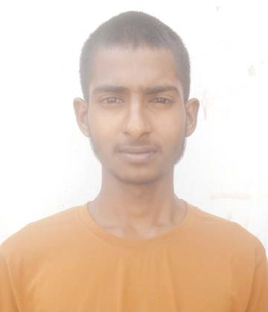  ROHIT  E-mail:-  Rohitindora86077@gmail.com  Contact No.  +919467253645  +918708008303  Address:  VPO Ramsara, Teh. & District Fatehabad  Personal Data:-  Father’s Name : Sh. Ramesh kumar  Marital Status : Unmarried  D/O/B : 30-04-2001  Hobbies:  Making new friends, Playing football, listing music  Language :  Hindi , English , Punjabi  Date :  Place : Ramsara, Fatehabad | CAREER OBJECTIVE  I wish to work for an organization that provides me enough challenges & give me responsibilities along with the opportunities to grow. I will be working with the best of my abilities & make myself an integral part of the organization.  EDUCATION QUALIFICATION  - Matric from C.B.S.E. in 2016 with 74%.  - 10+2 Arts from C.B.S.E. in 2018with 68%.  - B.Com in CDLU.  - ITI IN COPA.  HOBIES  - COMPUTER TYPING  STRENGTH  - A team player, working in effective coordination with other members and company clients.  - Good Interpersonal Skills.  - Willing to learn and listen.  - Good skills in management and communication.  - Ability to develop and follow through to success with optimal strategic plan.  (Rohit)

