RESUME

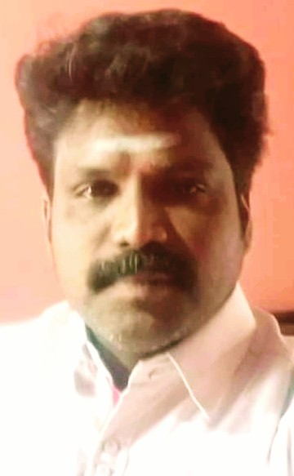
B.SENTHILMURUGAN
Cell: 06384836902.
Email.ID:senthilmuruganbharathi@gmail.com

CAREER OBJECTIVE:

To pursue a career which offers a high growth potential both to organization and the individual. To Successfully accomplish the set targets, Which improving the performance of the individual continuously and consistently.

TECHNICAL QUALIFICATION :

        - Diploma in Chemical Technology (1997 - 2000)
        - Pallavan Polytechnic, Kanchipuram.
        - Secured 79.6 % ( First Class With Honours )

EXPERIENCE PROFILE :

Present Company Name : Enzotech solution Pvt Ltd.,Chennai.
Period of Working : Dec 2018 To Till Date
Designation : Erection & Commisioning Engineer

Previous Company Name : Vision Water Technologies.,Chennai.
Period of Working : Nov 2016 To Dec 2018. Designation : Erection&Commisioning Engineer

Previous Comany Name : Aqua Engineers (India) Pvt Ltd.,Chennai
Period of Working : Feb 2015 To Nov 2016
Designation :. O&M Site Incharge(MBR,FBBR, RO)

Previous Comany Name : Anthem Bio -Sciences Pvt Ltd.,
Period of Working : Augest 2013 To Feb 2015
Designation : Jr. Executive(RO plant)

Previous Comany Name : Coromandel International Ltd., Chennai
Period of Working : January 2008 To March 2012
Designation : Plant Operator(DM plant,RO)

Previous Comany Name : Vinbros & Co, Pondicherry
Period of Working : May 2005 To January 2008
Designation : Plant Incharge(Wtp,Softener,DM,UF)

KNOW THE FIELD :

. Erection & Commissioning of STP Plant upto 300kld (mbbr also asp)
. Erection & Commissioning of ETP(ZLD-30KLD)
. Erection & Commissioning of WTP 2000 Dia PSF&ACF with OZONIZER
. Erection & Commissioning of RO Plant up to 10000lph
. Erection & Commissioning of STP UF plant 2000lph & 4000lph
. Erection & Commissioning of DM plant and SOFTNER plant(200cu.m-OBR)
. Re-wamping of wtp plant(changing vessel,media,activated carbon)
. Re-wamping of DM & SOFTNER plant(changing of resins ,vessel,stainers)
. Chemical cleaning and Membrane replacing of RO & UF plant
. O&M Incharge of WTP,STP(SBR,MBR,MBBR)
. O&M Incharge of RO(PASS&STAGE) and UF plant
. O&M Incharge of DM plant (OBR upto 300 cubic meter) & SOFTNER PLANT (OBR-200 cubic meter)
. Operating of Evaporator (Falling Flim & Forced Circulation with ATFD)

PERSONAL SKILLS :
Ability to complete task in stipulated time.
Grasping new concepts quickly and working hard on it to get knowledge on those concepts.

PERSONAL DETAILS :

Father’s Name : N.Barathi
Date of Birth : 06-05-1979
Sex : Male
Marital status : Married
Nationality : Indian
Religion : Hindu
Languages known : Tamil and English

Declaration
I, hereby declare that the information and facts furnished above are correct and true to the best of my knowledge and belief.
Thanking you.
Place : Your’s Faithfully
Date :
(B.SenthilMurugan)

