**CURRICULUM VITAE**

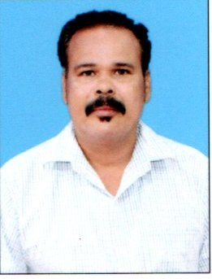**PERSONAL DETAILS**

**Name: PRADEEPT KUMAR ARUK**

**Father’s Name: Sj. KAMBHUDHAR ARUK**

**Date of Birth: 28th, May; 1976**

**Sex: Male**

**Religion: Hinduism**

**Nationality: Indian**

**Marital Status: Married**

**Linguistic Abilities: Odia, Hindi & English**

**Aadhaar No : 2135 1995 6742**

**PAN No : AOGPA4842J**

**Blood Group: B+ve**

**Identification Mark : Black mole on right side face.**

**Mobile Number: 8249022030 (Whatsapp)**

**Email ID: pradeept.aruk@gmail.com**

**JOB OBJECTIVES:** I want to work for the organization, where Innovative, Creative & Strategy are to be taken as important concern and from where I can learn something & contribute my positive performance towards the organization’s growth.

**ADDRESS**

**Present Address: C/O: Nanda Kumar Gupta**

**Seding Basti, Near Municipality Town Hall,**

**Ward No-04, Barbil, Keonjhar, Odisha-758035**

**Permanent Address: S/O: Mr. Kambhudhar Aruk**

**At: Bokada, PO: Godibandha, Via: Kanpur, Dist: Cuttack, Odisha - 754037**

**QUALIFICATION**

1. Educational

**Graduation in Arts from Utkal University in 1997**

1. Technical

**Computer Course in “PGDCA” with Accounting Course in “Tally ERP9”**

**WORK EXPERIENCE**

1. Back Office Assistant from “**BHASIN HOTA & CO**”, BHUBANESWAR, ODISHA (1998 to 2004)

(CHARTERED ACCOUNTANT FARM)

1. Accounts Assistant from “**UPLAND AUTOMOBILES**.”, JODA, KEONJHAR, ODISHA (2006 to 2010)

(TATA MOTORS AUTHORISED SERVICE STATION)

1. Accounts cum Store-in-Charge from “**UPLAND TRADE PVT LTD**”, JURUDI, KEONJHAR, ODISHA (2008 to 2010) (MRF AUTHORISED RETREADING FRANCHISEE)
2. Accountant from “**SUPERIOR MINERALS & EXPLORATION PVT LTD**”, BARBIL, KEONJHAR, ODISHA (2010 to 2018)  **(**MINES CONTRACTOR, ROIDA-1, IRON ORE MINES, MESCO)

**JOB EXPERIENCE**

Accounting, Daily Equipments Performance Reports, Monthly Equipments Performance Report, Store Inventory Analysis, Employees Provident Fund, Profession Tax, Labour License & Maintain Statutory Documents of Mines (Open Cast).

**DECLARATION**

**I do hereby declare that all the particulars furnished here are complete and correct to the best of my knowledge and belief.**

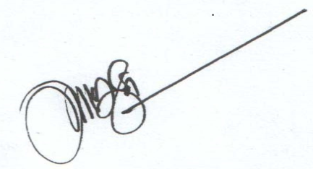

**PRADEEPT KUMAR ARUK**

Barbil, Keonjhar, Odisha

Date: