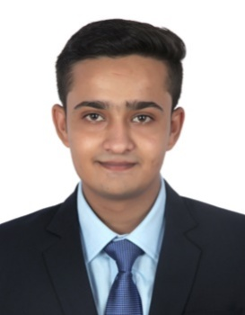**AMAN SINGH YADAV**

Email: [amanya1209@gmail.com](mailto:amanya1209@gmail.com)

Phone: 9193242534

Address: Front of block office,

Unchahar,Raebareli229404

Father’s Name : Mr. Narpat Singh Yadav

PROFILE

As an organized and creative individual, I love the challenges of working within a dynamic and fast paced working environment.

objectives

To use my Skills in Best Possible way for achieving company’s Goal.

Education and academics

* **Institute Name:**  I.H.M, JAIPUR (2016 – present)

**Degree:** B.Sc. in Hospitality and Hotel Administration

NCHMCT/IGNOU Affiliated

* **School Name:** D.A.V public school

**Qualification:** Intermediate (2015-2016)

85% CBSE Board, (Commerce)

* **School Name**: Chinmayavidyalaya

**Qualification:** 10th Standard (2013-2014)

8.2 CGPA, C.B.S.E Board

Skills

* Ability To Do Work Within And Lead A Team.
* Committed Towards The Work And Exploring New Areas Of Learning.
* Keen And Capable To Take Up New Responsibilities And Challenges And Also Fulfilling Them.

professional Experience

Worked as an industrial exposure hotel management trainee for 17 weeks at **THE OBEROI AMARVILAS, AGRA**A **FIVE STAR DELUXE** resort property, and learned how a hotel works and is ready to move as a fulltime hotel personal.

**Area Covered During Training**:- Front Office Operation, Kitchen Department, Housekeeping Operations and Food & Beverage Department.

* 1year and 1 month experience as a "FOOD AND BEVERAGE ASSISTANT" at "THE OBEROI AMARVILAS,AGRA"

hobbies, interest and other activities

* I like to travel and learn different cultures.
* I like to listen music when I am stressed.
* I like to play cricket.

KEY ACHIEVEMENTS And learning

* Represented State at National level in cricket
* Achieved A grade certificate at NCC
* Presented college at Jaipur Sports Meet
* Managing Outdoor Catering for I.H.M Jaipur Boys Hostel
* Things Require to Maintain Hospitality Standards
* Guest Interactions

DECLARATION

I hereby declare that the information is true of my knowledge.

Date: Place:

(**AMAN SINGH YADAV**)