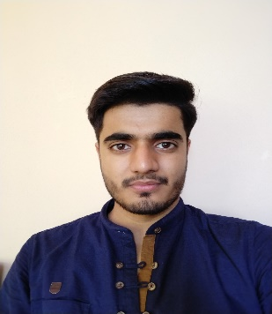**Career Objective:** To enhance my knowledge and apply my skills to the fullest so as to secure a challenging position in an organization. To be able to showcase my technical strength and utilize it for the company and personal growth.

Mayank

+91-9711274969

Email ID: [rajputmayank583@gmail.com](mailto:rajputmayank583@gmail.com)

# Education:

|  |  |  |  |
| --- | --- | --- | --- |
| **Degree** | **Year** | **University** | **%Marks/CGPA** |
| BTech – Mechanical Engineering | 2020 | JIMS Engineering Management Technical Campus, Greater Noida affiliated to GGSIPU, Delhi | **8.0** |
| Intermediate | 2016 | Kendriya Vidyalaya A.G.C.R colony, Delhi | **71.3** |
| Secondary school | 2014 | Kendriya Vidyalaya A.G.C.R colony, Delhi | **10.0** |

Skills:

* AutoCad
* SOLIDWORKS
* Catia
* Ms-Powerpoint

# Papers Published:

* Ms-Word
* Ms-Excel

## Digital Autolocking Handbrake Security System, Published in International Journal of Research Technology and Engineering, volume 9 issue 1 May-July 2020.

* + **Tools used:** Solidworks, Catia

## Different models of Reactors for Biodiesel Production, Published in Indian Journals, volume 10 issue 2, July-December 2019.

* + **Tools used**: Solidworks

# Certification Courses:

## Certified “AutoCad, Solidworks, Catia in 2D and 3D”.

# Internship:

* **Delhi Metro Rail Corporation**, Rolling Stock Department at Yamuna Bank Depot, June 2018-July 2018

# Extra-Curriculum:

* Participated in **3D printing workshop by CETPA**, Greater Noida.

# Area of Interest:

## Production Engineering

* **Automobile Sector**
* **Industrial Processes**
* **Mechanical Designing**

Personal Profile:

* Date of Birth: 18th September 1998
* Languages: English, Hindi
* Address: B-130, Brij Vihar, Ghaziabad, Uttar Pradesh, 201011