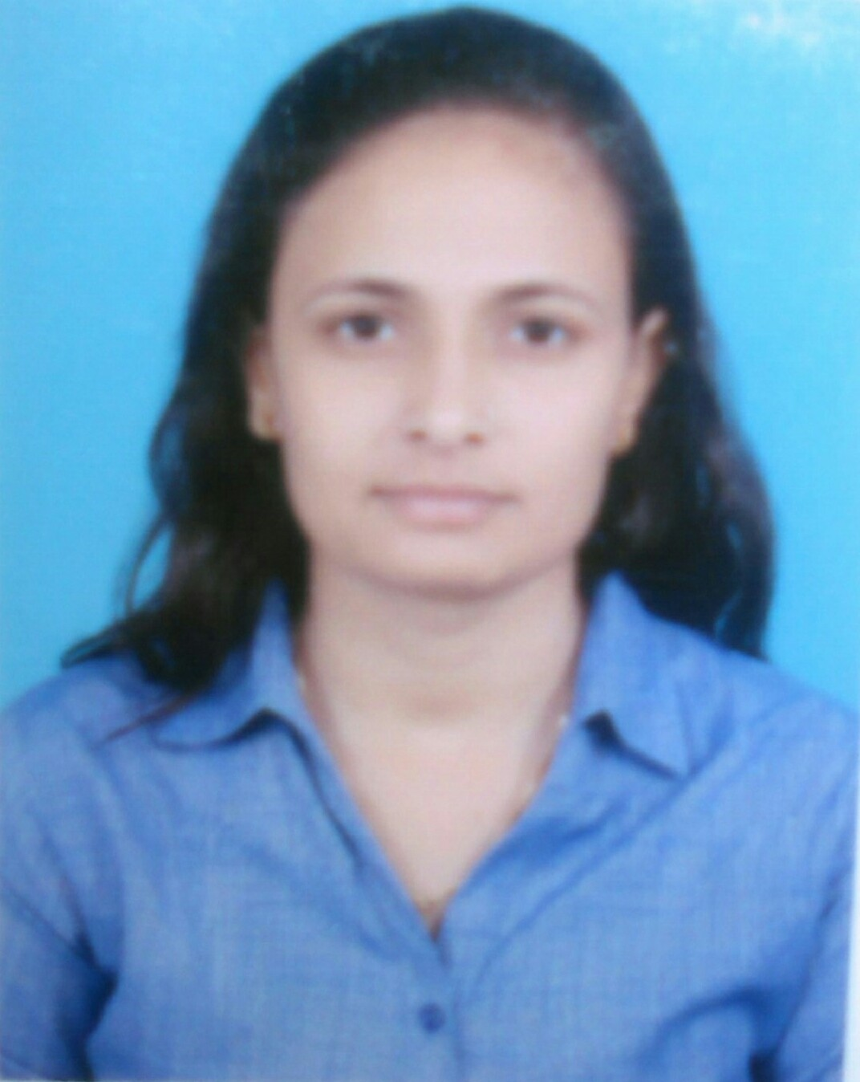
CHAUDHARY SAAKSHI
Contact No. : 7011495554
Email id –sakshirosechaudhary@ymail.com
Address: RZ-17A/230 J BLOCK WEST SAGARPUR
NEW DELHI PIN CODE – 110046

EXECUTIVE SUMMARY

A competent, result oriented HR Professional with proven success of over 5 years in Recruitment/Selection || On Boarding || Training/ Induction || Payroll ||Employee Engagement|| Policy Formulation || Performance Appraisal || Exit Management || General Human Resource ||MIS

Current Working:-

Company : APS Hydro Pvt Ltd.
Location : West Delhi (Corporate Office)
Designation : Sr. Executive HR
Profile : Recruitment +Admin
Duration : From Jan 2018 to till date

Job Responsibilities:-

Talent Acquisition:
- Responsible for man power planning and managing recruitment for all positions.
• Managed Entire recruitment cycle from sourcing, screening, selection, hiring, negotiation.
- Managing the New Employee Joining and On Boarding Processes - Handling the joining formalities of the new joiners and familiarizing them with the organization culture, structure, policies, facilities etc.
- Rolling out offers and various other letters

Employee Relation:
- Handling all the queries of the employees related to Salary, Leaves and Attendance, etc.
• Handling all issues related to time office & grievance.
• Explain the various policies, strategies and benefits to employees.
• Maintain All Documents Of all Employees, Employee handbook, assist with the preparation of training programs, including Welcome Day, new joiner induction.

Operation:
• Handling the Employees Database (Both in Soft Form and Files Management).
• Leaves and Attendance Management.
• Preparation of CTC Breakup.
• Confirmations, Performance Appraisals & Performance Management.
• Handling employees full & final settlement, exit interview process.
- 2nd Working experience:-

Company : Platinum Plaster India Ltd
Location : West Delhi (Corporate Office)
Designation : HR Executive
Duration : From Dec 2015 to Dec 2017

Job Responsibilities as HR Executive:-

- Complete recruitment & Selection process for PAN INDIA LEVEL.
- Handled the Profiles Of RSM,ASM,ADM for Pan India Level Basis
- Screening, Shortlisting, Scheduling, conducting interview of the candidate as per
the requirement.
- Sourcing CVs from various channels such as referencing, company’s own database, Job Portals i.e. Naukri, and networking tools such as LinkedIn & Indeed.
- Preparing the Offer letters & Appointment letters for the selected candidate
- Managing MIS Reports.
- Performance appraisal Management.
- Training and development.
- Process Increments, Arrears, Amounts.

Job Responsibilities as Sales Coordinator:-

- Coordinate sales team by managing schedules, filing important documents and communicating relevant information.
- Respond to complaints from customers and give after-sales support when requested
- Monitor the team’s progress, identify shortcomings and propose improvements

- 1st :- Working experience:-

Company : Era Infra Engineering Ltd.
Location : Noida Sector-62 (Head Office)
Designation : Jr. Executive HR
Profile : Recruitment
Duration : From Aug 2014 to Nov 15
Job Responsibilities:-

- Manpower Planning at Site level.
- Screening, Shortlisting, Scheduling, conducting interview of the candidate as per
the requirement.
- Completing Joining formalities of new Joining.
- Staff welfare.
- Maintaining of Leave Records
- Maintain database with all the information of the employees.
- Employee Benefits like Medical Insurance, ID cards, Encasement of Earned leaves.
- Day to day HR related operational activities.
- Booking for Vehicle, Train Tickets, Flight Tickets, Hotel, and Guest Houses.
- Coordination in opening Bank A/C’s with Union Bank to the newly Joined employees.

Handled Portals:-

- NAUKRI.COM
- INDEED
- LINKEDIN
- TIMESJOB

Academic Qualification:-

2014 PGDM (HR/Marketing) from Era Business School, Dwarka.
2011 BBA (HR) from C.C.S. University Meerut.
2007 Senior Secondary board of U.P. Board.
2005 Secondary board of U.P. Board.

Achievements & Awards:-

- Selected the best Intern HR in my batch during the two month summer internship in Era Infra Engineering Ltd. And got PPO.
- Member of management of Era-Bration Committee, Era Business School.

Computer Skills:-

. Operating Windows : Windows 8, Windows 7, Windows XP
MS Office Suite : MS Suite versions – 2010, 2007, 2003
(MS Word & Excel & Power Point)
Skill Set:-

- Team player & Good Learner
- Effective Communication skills,
- Dedication to work.
- Learning Attitude.

EXTRA CURRICULAR ACTIVITIES:-

- Playing Badminton
- Listening Music

PERSONAL DOSSIER:-

Name : Chaudhary Saakshi
Father’s Name : Mr. Brijpal Singh
Date of Birth : 01 JAN 1990
Language Proficiency : English, Hindi.

DECLARATION:-

“I do hereby declare that all statement made above are true and complete to the best of my knowledge and belief.”

Current CTC- Negotiable

Date……/……/……..

Place………………. (CHAUDHARY SAAKSHI)

