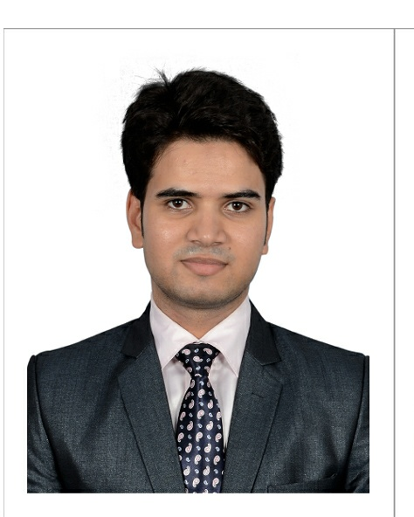

**MOHAMMAD SULTAN**

mohammad.sultan777@gmail.com

Mobile: - **+919677262500**

# 53/4, Shanmugarayan Street, Seven Wells, Chennai 600001.

***To work with passion to achieve my goals and to handle challenges while learning from my life experiences.***

**Work Experience**

* Worked for ***IndiGo Airlines*** as a Senior Exective AO&CS from ***July/2014 till July/2020***
* Worked in ***‘Rampur Distillery’*** for 6 Months (apprentice)-2012.
* Worked at ***local news channel*** for 4 months- feb to may 2013.

**EDUCATIONAL QUALIFICATIONS**

|  |  |  |  |
| --- | --- | --- | --- |
| **QUALIFICATION** | **NAME OF INSTITUTION** | **YEAR OF PASSING** | **GRADE ACHIEVED** |
| Diploma in Aviation Hospitality & Travel Management | Frankfinn Institute of airhostess Training. | 2013- 14 | *Merit* |
| 12th Grade | Raza Inter College, Rampur | 2012-13 | *First* |
| Electrical Diploma | Govt. I.T.I Rampur | 2010-2012 | *Distinction* |
| 10th Grade | Islah-e-quam Hr. Sec School. | 2009 | *Passed* |
|  | |  | |

**OTHER SKILLS**

* Swimming
* Computer basics(CCC)
* Video Editing

**AREA OF INTERESTS**

* ***Customer Service***
* ***“Flexible to work any time any weather conditions”***
* ***To work in team***

**PERSONAL PARTICULARS**

* **D.O.B.** : 31/July/1994
* **MARITAL STATUS :** Single.
* **GENDER** : Male
* **NATIONALITY** : Indian.
* **HOBBIES** : Playing guitar

**LANGUAGES KNOWN**

|  |  |  |  |
| --- | --- | --- | --- |
| **LANGUAGES** | **READ** | **WRITE** | **SPEAK** |
| English |  |  |  |
| Hindi |  |  |  |
| Urdu |  |  |  |
| Tamil |  |  |  |