**SUBAIDA ANSARI** 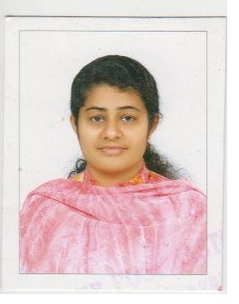

**KOTTACKAL HOUSE**

**PERUMBAIKKADU P O**

**KOTTAYAM-28**

**KERALA**

**PHONE 8943349717,9847477917**

**CAREER OBJECTIVE**

To invest all my efforts and talents in to building a strong career path through the organization where I am inducted and to bring the organization to new heights of success.

**PERSONAL STRENGTH**

* Possess a pleasing personality
* Self confident, Hard working, Energetic & Sincere
* Willing to learn & understand
* Ability to solve complex situation calmly

**PROFESSIONAL PROFILE**

**WINNERS PULIC SCHOOL :** Worked as a teacher cum office staff from 23.11.2003 to 20.10.2004

**MGF HYUNDAI Ltd.** Authorized Dealer for HYUNDAI,Kottayam, Kerala, India from 2007

Joined as a front office executive and soon promoted as a **Sr. Operating Officer** Now working as **Customer care Manager**

**Profile :**

* Prepare the Daily report of Five Branches
* Submit Monthly report to HMIL
* Submit Monthly business report to HO
* Helping service advisor in generating Repair Orders, closing and Billing
* Dealing Claim settlements petty cash and petrol expense(Service Department)
* Preparing monthly Service incentive
* Placing Printing Orders of Service Department
* Sending Service remainder cards to customers
* Co-ordinate staff welfare, ESIC and P F
* Handling true friendship- Organizing , service advisors to meet customers
* Arrange service campaign
* Customer complaint handling

**EDUCATIONAL QUALIFICATION**

BA (Economics) From Newman college Thodupuzha

MA (Sociology)

MBA completed (Sikkim Manipal University)

**TECHNICAL QUALIFICATION**

Post graduate diploma in computer application, DCA,DTP

**LANGUAGES KNOWN**

English,Hindi,Malayalam,Arabic

**PERSONAL DETAILS**

Sex : Female

Religion : Islam , Muslim

Nationality : Indian

Date of Birth : 02.05.1980

Husband’s Name : Ansari Kottackal

Father’s Name : Meeran Kutty

Place:

Date: