#### Devi Prasad mallick

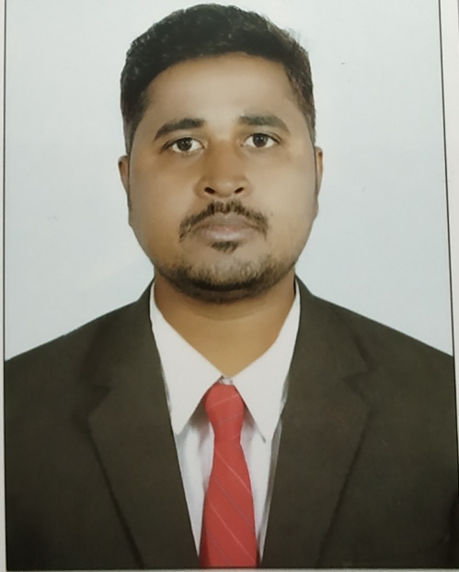

#### C/O :-Dharma Nanda Mallick

Present Address:-

At:- I.G.I.T Campus, Sarang

Dist:- Dhenkanal ,Odisha

Pin:- 759146

|  |  |
| --- | --- |
| Email:-  **devtutu@gmail.com** Contact No :-+919438489491 **Date of Birth:-**  12 - JAN - 1987  **Father name:-**  Mr. Dharma Nanda Mallick  **Fathers Occupation:-**  service | Objective  To achieve perfection in my work through the process of constant learning, hard work & vision combining with leadership contributing the best to the organization.  Profile  AsMech. Engineer with 6.5 Years Experience who can work on own initiatives or as a part of a team and can deliver responsibilities competently.  Education  Completed (**B.Tech in Mech. Engg.)** with **6.8 CGPA** from Odisha Tech. university BPUT.  Qualities   * Time Management. * Hard working and faithful. * Leadership. |

|  |
| --- |
| Technical Skills |

* Advance Diploma In CNC Programming from Central Tool Room & Training Centre, Bhubaneswar, Odisha,India
* AutoCAD- Good in 2D & 3D.
* Master Cam, Unigraphics.

Training:-

* Vocational training in NTPC Limited, TTPS Talcher Thermal, Angul. Odisha

Experience:-

* Working Reliance Life Insurance as a Sr. Agency Recruitment & Development Manager since 2019 December to continue

# **Working RULOANS as a Asst. Manager since 2019 may to December 2019.**

* Working SBI Life as a Advisor since 2018 to December 2019.
* Quality Control Engineer in Dongyue Bricks Engineering Pvt Ltd, Bhubaneswar Odisha from 2015 to 2017 October
* Workshop Manager in MechTech Engineers, Chennai from 03.12.2012 to 31.12.2014.

**Hobbies: -** Kick boxing, karate, spending time in Gym.

**Declaration:-**

I hereby declare that all the data furnished above is true to the best of my knowledge.

Date:

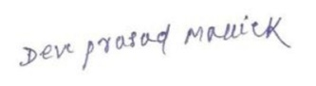

Place: Sarang **Signature**