**RESUME**

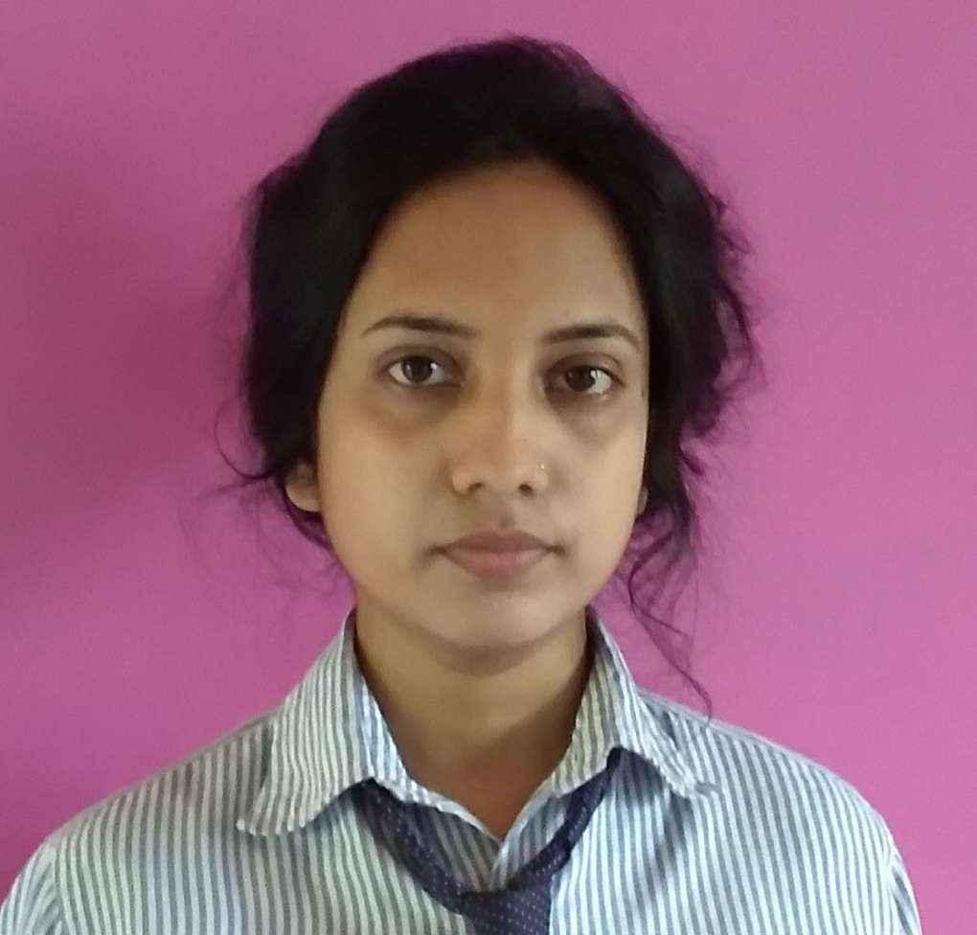

**PIYALI MONDAL**

**Mobile:** +91 8013456540**~ E-mail:** piyalimondal033@gmail.com

**Address: Buita**,Budge Budge,PO-Buita, Kolkata-700137

**PROFILE SUMMARY**

* **Computer Science & Technology with 2 years of** experience in varied **worked as Hardware & Nnetworking engineer at Rajiv Gandhi computer saksharata mission (RGCSM), Budge Budge**
* Successfully completed various Technical & Non-technical Academic Projects at BBIT.problem solving and coordination skills.

**WORKSHOP & TRAININGS ATTENDED**

* Attended workshop on campus of BBIT on Environment Savings with Digital Technology.

**TECHNICAL PROFICIENCY**

* C Programming, C++, Java, Advance JAVA,HTML, CSS, DBMS, Photoshop, graphics
* Working experience on platform of Windows 7,8,8.1,10, LINUX

**ACADEMIC CREDENTIALS**

* **10th** |Sarada Vidyapith for girls high School, WBBSE Board

|  |  |  |  |  |
| --- | --- | --- | --- | --- |
| **Exam** | **School** | **Board** | **Marks** | **Percentage** |
| Madhyamik | Sarada Vidyapith for girls' high school | WBBSC | 512 | 64% |

* **Diploma course in Computer Science & Technology** (Budge Budge Institute of Technology, Kolkata). conducted by the West Bengal council of technical & vocational Education & skill Development in may 2017 & was placed in 1st class.

|  |  |  |  |  |
| --- | --- | --- | --- | --- |
| **Course** | **Institute** | **Board** | **Marks(SGPA)** | **Overall Percentage** |
| Diploma | Budge Budge Institute Of Technology | WBSCTE | **8.2** | **74%** |

* **B.tech Course in Computer Science & Engineering at Budge Budge Institute Of Technology**

|  |  |  |  |  |  |
| --- | --- | --- | --- | --- | --- |
| **Course** | **Institute** | **Board** | **Marks(SGPA)** | **Marks(DGPA)** | **Overall Percentage** |
| **B.Tech** | Budge Budge Institute Of Technology | Makaut | **9.71** | **8.17** | **75%** |

* **Pursuing M.Tech Course in Computer Science & Engineering at Budge Budge Institute Of Technology**

**EXTRACURRICULAR ACTIVITIES**

* Attended the PASCHIM BANGA VIGYAN AVIKSHA and rank of 3rd position with certificate
* Certificate course in office Automation & internet(CCOAI)
* Attended the VIGYAN MODEL (seminar) and rank of 3rd position with certificate
* Participated the seminar & workshop on Internet of things (IOT) with certificate
* Painting

**PERSONAL DETAILS**

Name : Piyali Mondal

DOB : 07/01/1994

Address : Buita, Budge Budge, South 24 pgs, kol- 700137

Email : piyalimondal033@gmail.com

Ph No. : 8013456540