### Name of the Student:

DIMDEO UDHAORAO ZADE

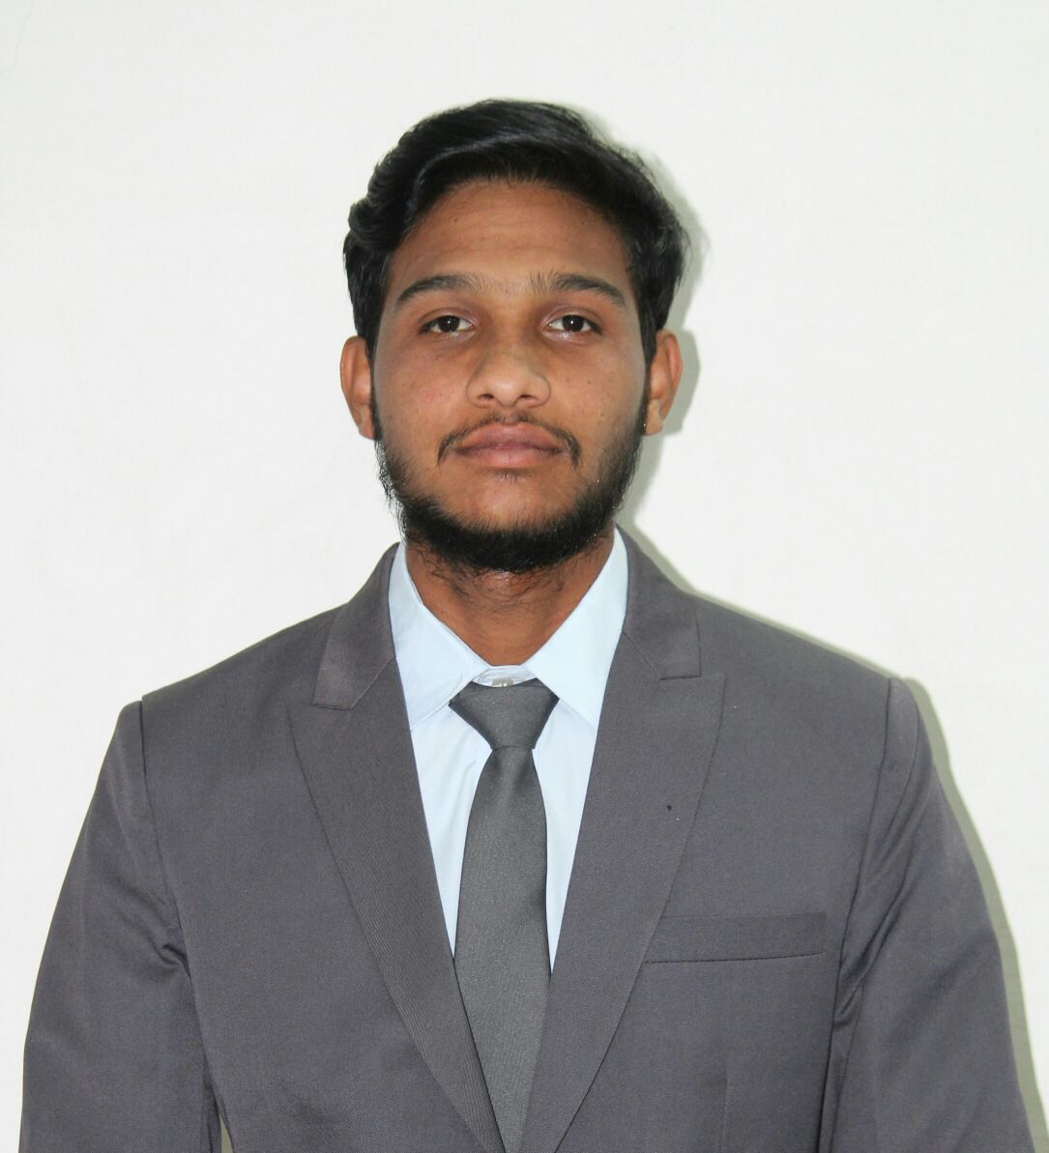

# 

**Career Objective:**

To serve the organization by making optimum utilization of my skills & knowledge in the field of finance and grow with the Organization.

|  |
| --- |
| **Personal Details:** |
| Gender: Male Marital Status: Single  Date of Birth: 30/03/1996 Language Proficiency: Marathi, Hindi ,English  Permanent Address: Near Forest Naka  Jay Bajrang Chowk Babupeth,Chandrapur-442401  Email ID: akshayzade96@gmail.com  Contact No: 9527915054 |

|  |
| --- |
| **Specialization (Major) :** |

Finance

|  |  |  |  |  |  |
| --- | --- | --- | --- | --- | --- |
| **EducationQualification:** | | | | | |
| **Course** | **Institute/College/School, Location** | | **University/Board** | **Percentage** | **Year of Passing** |
| MBA | | Sinhgad Institute Business Administration And Computer Application,Lonavala Pune. | SavitribaiPhule Pune University | 62.80 | 2019 |
| Graduation ( B.COM ) | | Sardar Patel. College, Chandrapur | Gondwana University, Gadhachiroli | 58.23 | 2017 |
| HSC | Sardar Patel. College, Chandrapur | | Nagpur board | 50.15 | 2014 |
| SSC | Paramount Convent High School,BabupethChandrapur | | Nagpur Board | 58.60 | 2012 |

|  |
| --- |
| **Technical Skills (Computer):** |

* MS-CIT
* TALLY

|  |
| --- |
| **SIP Project Details :** |

* **Name of Company/Institute) :** BANK OF MAHARASHTRA
* **Project Title :** A Study on Retail Banking of Bank of Maharashtra
* **Location :** Chandrapur

|  |
| --- |
| **Experience :** |

* **Name of Company/Institute)** : **HDB Financial Services**
* **Desination : Relationship Manager**
* **Location : Pune**
* **Experience : 08 months**

|  |
| --- |
| **Extra-Curricular Activities: Participations** |

* Participated in PHOTOGRAPHY Competition
* Participated in NATIONAL CONFERENCE held at SIBACA on the topic startup and new venture management opportunities and challenges under QIP SPPU
* Participated in RESUME COMPETITION
* Visit to Anand Orphanage, Lonavala, Pune
* Industry Visits: IAC Co., Lear Corporation
* Participated in GREENATHON HELD AT SIBACA
* Crtified in Edubridge (Business correspondence and Business facilitors)

**About me:- Core Competencies**

* Good command on Communication
* Skill both in Oral and written (English, Hindi and Marathi)
* Motivate to others
* Provides well thought out solution
* Able to learn quickly
* Dependable, analytical and Hardworking
* Can work well both independently and as a team
* Decision making, Leadership and Management skill

**Signature:-**

**Name of the Student: DimdeoUdhaoraoZade**