
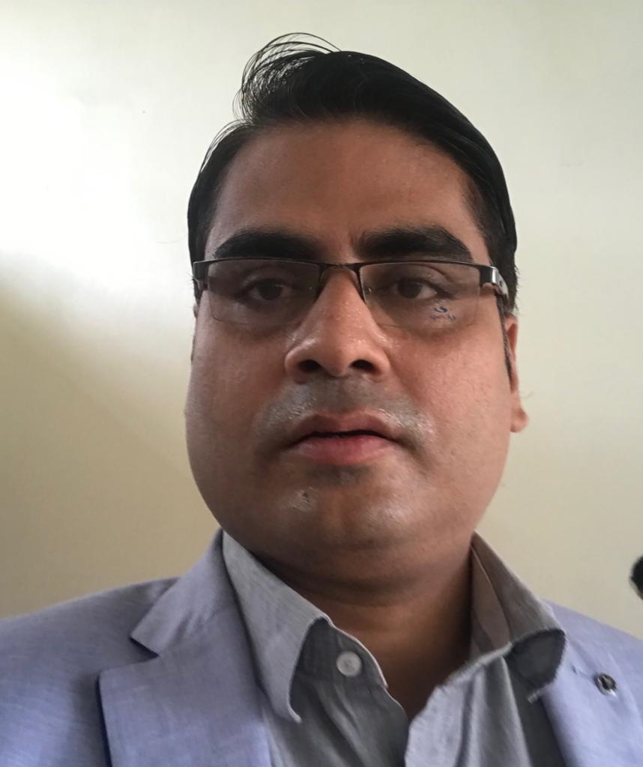
Goal-oriented professional targeting assignments in Centre Operations / Sales & Marketing with an organization of high repute

Location Preference: Overseas

Sanjeev Kumar Mishra
Career Summary  - Microsoft Certified Engineer with nearly 16 years of experience in Centre Operations and Training and Development  - Proficient in providing extensive training for new hires, preparing monthly assessment of center operations  - Functional expertise in managing the overall training operations with bottom line profitability by ensuring optimal utilization of resources for enhanced operational effectiveness within the budget  - Proactive in assessing the learning and development needs and effectively aligning programs / interventions with organizational objectives  - Gained exposure in drafting periodic reports, financial statements and records on center projects, progress, status or other special reports for management or outside agencies  - An effective communicator and team leader with proven team building and management capabilities  Education & Credentials  - MSC in Computer Science (Software) from Kurukshetra University, Haryana in 2005  - B.Sc. (Non-Med) from DAV College Amritsar, Punjab in 2002  Other Courses:  - GNIIT from NIIT, Amritsar, Punjab  - MCSE 2003 (Microsoft Certified System Engineer)  - ICDL (International Computer Driving License) | Contact  sanjkm@gmal.com +919955892930  Core Competencies  Learning & Development  Training Needs Assessment  Centre Operations  Team Management  Revenue Generation  Sales Review  Stock / Inventory Management  Reporting  Skill set  Motivator  Communicator  Change Agent  Collaborator  Analytical  Leader
Career Timeline

NIIT Computer Education, Ludhiana
New Horizons Computer Learning Center, Lusaka Zambia
APTECH Computer Education, Uganda

NIIT Computer Learning Center, Ghana
2018-2019
2011-2018
2006-2011
Punjab Technical University Study Center, Ludhiana
2005-2006
2002-2005
Professional Experience

May’18 – May’ 19

APTECH Computer Education, Uganda

May’18 – May ‘ 19 Principal/Centre Academic Head

Key Result Areas:

- The overall responsibility in the management of the school.
- Overlooking all academic, administrative and operational activities of the school, which is based
on agreed areas of responsibility or a delegated list of duties.
- Co-coordinating and implementing an appropriate curriculum having regard to the varying need,
experience, interests, aptitudes and stage of development of all the pupils in the school and
the resources available to the school.
- Maintaining a policy for pupil’s behavior and discipline and maintaining such rules and codes of conduct
for pupils as required for the maintenance of order and discipline within the school.
- The deployment and management of members of staff.
- To ensure that teachers adhere to the norms of Teachers Service, Regulations and handle
teachers disciplinary matters.
- Assist with the enrolment/assessment.
- Participate in preparation of monthly, quarterly and annual School Implementation Reports.
- Establish and maintain effective data management systems, such as student records, teacher
records, attendance, purchasing and maintenances procedures and routines.
- In meeting parents relating to disciplinary and other matters.

Previous Experience

May’11 – Apr’ 2018
NIIT Computer Learning Center, Ghana
May’11 – May’16 Center Manager
Jun’16 – Apr’ 18 Senior Manager

Key Result Areas:
- Planning Marketing activities for all centers in Ghana.
- Liaising with center external publics, particularly in relations to their advisory and financial support of center, including working in fundraising relating to memberships in center and sponsorships of center activities and related to the university and college development/capital campaign.
- Supervising daily center operations and coordinates center activities through assigned staff; prioritizes and delegates work activities.
- Preparing budget proposals and recommendations and establishing budget control system for controlling expenditures; controlling expenditures in accordance with budget allocations; recommends equipment and resources for the center.
- Designing, developing and recommending new programs, projects and activities relating to research, executive or student education.
- Evaluating center activities for effectiveness to develop improved methods; devising evaluation methodology and implementing; analyzing results and recommending and/or takes appropriate action.
Previous Experience

Apr’06 – Mar’11
New Horizons Computer Learning Center, Lusaka Zambia as Academic Head

Highlights:

- Trained Kasama Teacher’s Training College on ICDL.
- Ministry of Education on ICDL (International Diploma in Computer Driving License).
- Communications Authority of Zambia on ICDL (International Diploma in Computer Driving License)
- COMESA on Visual Basic.Net
- Finance Bank, Zamtel on Oracle 10g PL/SQL and DBA.
- Ministry of Finance on HTML, Flash, Dream weaver & FrontPage.
- Ministry of Education on SQL 2000 Database Design.
- Zambia Development Authority on MCSE 2003.
- Medical Store Limited on Microsoft Office 2003.
- American Embassy on Microsoft Office 2007.
- Ministry of Finance on Red Hat Linux and MySQL and Windows Vista.
- Celtel on Oracle 10g Pl/SQL.
- Zambia Accounting on Graphic Designing (Corel Draw & Photoshop).

Feb’ 05 – Feb’06
Punjab Technical University Study Center, Ludhiana, Punjab as Faculty/Lecturer

Sep’02 – Jan’05
NIIT Computer Education, Ludhiana, Punjab as Center Manager & Academic Head

IT Skills

- MS Dos, Unix, Linux, Windows 95/98/ME/00/XP/NT/03/08/Vista
- DHCP, DNS, WINS, TCP/IP
- MS Office 2003/2007, Visio
- Oracle 9i/10g, SQL Server 2000/2005
- LAN & WAN
- C, C++, VC++, Java, Html, Flash, FrontPage, Dream weaver
- Hardware, Networking, Application & OS issues
- Technologies like WINDOWS 2008 Server , Exchange Server, SQL Server, Oracle SQL, Oracle DBA, Oracle Developer, Microsoft Project Professional, Java, Visual Basic, Visual Basic.Net, CompTIA A+, CompTIA N+, Microsoft Exchange Server


Personal Details
Date of Birth: 28th November, 1979
Languages Known: English & Hindi
Passport No.: J7039341

