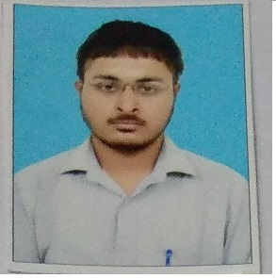 Address:-B-1, 308, Guru Nanak Pura, Mob: 8195973819
Civil lines, Ludhiana-141001, PUNJAB ALT:-8195994496

BIKRAMJEET SINGH
Email-id:-bjs1391@gmail.com

Objective:- To acquire a responsible position with the company offering opportunity which will develop my inner or outer skills, abilities knowledge.

EDUCATION:-
- Bachelor in Arts (2010-2013)
Major Arts and Humanities
University Punjab University C.H.D.

- Senior Secondary Education (2007-2008)
Major Arts and Humanities
Institution. R.S Model Senior Sec. School
Board Punjab School Education Board.

Professional
Education:-
- Course in Basics Application from NIIT (National Institution of Information Technology)

Computer Proficiency:-
- Introduction to Windows98,2000,XP from NIIT & Proficient in Windows various application like M.S Word, Microsoft Excel and full fledge internet proficiency.
Work Experience:-

- Join “Reliance communication” in 01-01-2014 (A reputed Revolution agency) as Collection Executive. (approx. 1 year exp)

- Selected in TATA MOTOR FINANCE as Collection Recovery Executive through agency name intellect support services Pvt Ltd on 24-01-2015. There my job profile is to recover debt collections of financed motor vehicles to clients by Tata Motors and also have experience of insurance of vehicles due to recovery job. (approx. Two &-half year exp)

- Selected PARAMOUNT HEALTH SERVICES (TPA) on 01-09-2017 to till 10-02-2020 as EXECUTIVE also doing cashless and re-imbursement investigations and Handling IBA claims and queries of corporate clients and also a co-ordinater between TPA and Hospital to do empanelment, when TPA asks. This is my Job Profile for institution.

- Recently joined Macro Global group of institutions as office boy from 1 March 2021 but due to previous experience I can handle as the duties of receptionist.

Interest:- Listening current affairs news, Learning new things.

Languages Known: - English, Punjabi, Hindi.

Extra Curricular Activities:- Get more and more knowledge by searching on
Internet.
Personal
Strengths:-
- Good command on English and good communication Skills Highly Motivated, Analytical Mind, Adaptable nature, Self-belief in acquiring goals and Having orthodoxy ideas to lead on Organization can work effectively in team as well as individually.
References: - Available on request.

Availability:- Immediate available.

Personal Details:- Name Bikramjeet Singh
Fathers Name S. Balwinder Singh
Parents Marital Divorced from my Birth
Status
Current Residence Nani House
Residence type Own
Earning persons Self
in house
D.O.B 23-03-1991
Nationality Indian
Health Sound
Marital Status Un-Married.



Bikramjeet Singh.

