Curriculum-Vitae
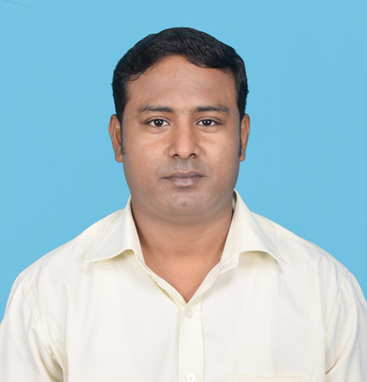

Raju Das
Mob: 9748283309
Email id- rajudas575@gmail.com

Objective:-

I aspire to acquire a challenging carrier in a growing organization where I can utilize my experience & skills for the growth of the organization.

Academic Status:-

Name of the exam | Name of the Board |  | Year of passed | Percentage
Secondary | W.B.C.R.O.S |  | 2007 | 40.37
Higher Secondary | W.B.C.R.O.S |  | 2010 | 45.6
B.A (In English Honors) |  | IGNOU | 2016 |  | 54.0

Technical Qualification:-

Name of the exam | Name of the Institute | Year of passed | Percentage
O-LEVEL ( Computer Applications ) | NIELIT(DOEACC) | 2013 | 59%

Computer skills:-
- MS – Office 2007-10, C, MySQL, Core PHP, java script, Html, Css, Software Installation, Software Troubleshooting Problems, Basic level network problems solving, Basic level hardware problem solving.

Passed Experience:-
I have worked with MindPoint Softsolutions PVT LTD at salt lake sector-1 in Kolkata-700061,
As a Jr. Web Developer from 1.09.2014 to February 2016.
Amity Infenity Infotech PVT LTD as a Jr. Web developer in salt-lake sector-2 Kolkata-700091.

Current Status :-
Now I am working with The Adtouch Advertising Pvt Ltd as a IT Administrator from 29.03.2017

Personal Profile:-
Father’sname: - Haripada Das
D.O.B :- 10th APRIL, 1986
Sex : - Male
MaritalStatus : - Single
Nationality : - Indian

Address:-
2nd FR, FL-B, Holding 52,
Dr. Meghnad Saha Road Subhash Udiyan
P.O- Panihati
P.S- Khardaha
Kolkata-700114.

Personal skills:-
- Comprehensive problem solving abilities and willingness to learn
- Goal oriented, highly focused & self-motivated
- Hard working ability in any condition,
- Maintain punctuality

Communication Skill:-
BENGALI (READ, WRITE, SPEAK)
ENGLISH (READ, WRITE, SPEAK)
HINDI (SPEAK)

Hobbies:-
Playing cricket and listening songs.

Declaration:-
I, hereby declare that all the information made above are true and correct to the best of my knowledge and belief.

Date:
Place: Kolkata ……………..
Signature

