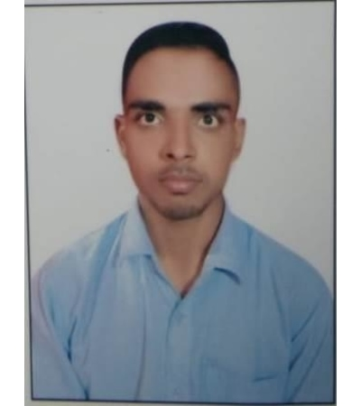*C:\Users\Administrator\Desktop\出生年月.pngC:\Users\Administrator\Desktop\dizhi.pngC:\Users\Administrator\Desktop\籍贯.pngC:\Users\Administrator\Desktop\邮件.pngC:\Users\Administrator\Desktop\政治面貌.pngC:\Users\Administrator\Desktop\求职意向.pngC:\Users\Administrator\Desktop\电话.pngC:\Users\Administrator\Desktop\图标\姓名.png*

MY resume

GR GROUP Online (GREAT day) HR Intern 2019-09-01-2020-09-01

Attended the training on civil engineering projects, human resource management

Assisted for employees recruiting, include collect recruit requirements, post the ad, site engineer resumes and arrange the interview etc, and obtained certain achievement. Position being offered included Algorith Engineer, Inter Indian Consulting, Engineer of civil

GR GROUP（Tianjin） PS Intern (GRg) 2019-09-15 to present

SITE engineer and other specific standards regarding restricted substances. Conduct Export Compliance self-review, including quarterly transactions review, self-review report completion；Denied party screening and

Optimistic, cheerful, positive and optimistic, honest and trustworthy, willing to help others;

study hard, in their own knowledge, but also covered in knowledge; responsible for practical,



Nane： Subham pal birth： 10/09/1997 tel : 9368888500 Current Address: 105-802/252 SHIV PURAM Mohkampur Delhi road Meerut

Materials civil engineering

eMAIL: meerutcantt.2018@gmail.com

Nationality: Indian

*Self Evaluation*

*Work experience*

*Education background*

10th HIGH SECONDARY SCHOOL UP BOARD ALLAHABAD 58.83 2013

12th INTERMEDIATE SCHOOL UP BOARD ALLAHABAD 60.00 2015

POLYTECHNIC AND DIPLOMA BOARD OF TECHNICAL EDUCATION LUCKNOW UP 65.58 2016-2019

（Basic Info）