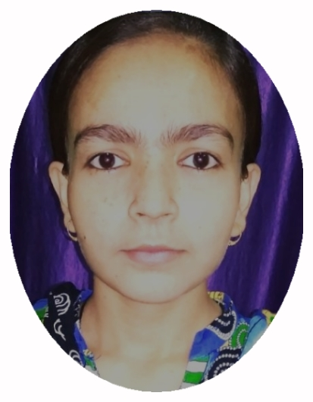

* M.A in Industrial Relation (L.S.W/P.M.I.R), from Darbhanga House Patna with 71.06%.
* B.C.A from Maulana Mazharul Haque Arabic and Persian University, Patna with 77.08%.
* Intermediate (Arts) from J.D. Women's College , Patna with 58.8%.
* Matriculation (C.B.S.E) from Scholars Abode Manghoopur with 72%.

**EDUCATION**

**EXPERIENCE**

**SEO Executive 16th March 2015 to 2nd Sept 2016**

* Writing content, creating websites, designing websites.

**Saima Jawed**

**PERSONAL INFORMATION**

* Date of [Birth](http://www.baidu.com/link?url=jsJgLG5aVost_f7ElDQQMhsI3RKn-4h0lJt9F3HLz7D_EVWqUXi7oo_gydjk4iz5OH5IrKXssZkPYZhziUujkaGCCmEPjHdGpzo4ZFqBRQ3) : 15 Jan 1995
* Nationality : Indian
* [Tel:970](Tel:625-000-000)8332221
* Email: saimjawed15@gmail.com

**INTERNSHIP/ ACTIVITIES**

* 1 months training on Recruitment & Selection from Bihar State Power (Holding) Co. Ltd.
* Seminar on the topic Understanding Labour & Human Rights From An Indian Perspective organised by Department of PMIR Patna University.
* One day seminar on the topic Sustainable Development Goals (SDG UNO), Social Justice and Cohesive Society organised by Kabir Ke Log in collaboration with A.N Sinha Institute of Social Studies, Patna.

**HOBBIES**

* Painting, sketching, Drawing

English

**CORE COMPETENCIES**

**SKILLS**

* Familiar with working of MSExcel, HTML.
* Quick learner, Self - Motivated and flexibility of working environment.
* Propound knowledge of Labour Law.

Power Point

[Microsoft](http://www.baidu.com/link?url=cLKCA0ldI6r6jzzmfJcdfrhzr7Oj2ahcuDp6iFiA9RoSs_GPiJrESObRUmm50-MN" \t "_blank) Excel

[Microsoft](http://www.baidu.com/link?url=cLKCA0ldI6r6jzzmfJcdfrhzr7Oj2ahcuDp6iFiA9RoSs_GPiJrESObRUmm50-MN" \t "_blank) Word