ANJAN MUDLI
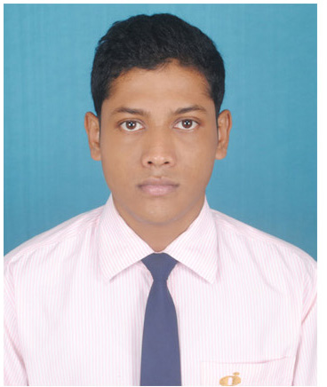

Address:
S/O- Chandi charan Mudli
Vill :- Deuli
P.O:- Sagareswar
Dist:- Purba Midnapur
State: - West Bengal
PIN: - 721446
Contact No: -9775931733
Email: - anjanmudli@gmail.com

Objective:-

To obtain a job within my chosen field that will challenge me and allow me to use my education, skills and past experiences in a way that is mutually beneficial to both myself and my employer and allow for future growth and advancement

Educational Qualification:-

Bachelor of Computer Application in (2014-2017) form Global Group Of Institutions under Maulana Abul Kalam Azad University Of Technology, West Bengal (Formerly known as West Bengal University Of Technology).

Academic Details:-

Name of the exam | Name Of the Board/ University | Name Of The School/College | Year Of Passing | Marks/ DGPA
BACHELOR OF  COMPUTER APPLICATION | M.A.K.A.U.T | GLOBAL GROUP OF INSTITUTIONS(337) | 2017 | 6.51%
higher secondary | W.B.C.H.S.E | GOBRA I.N.K.M HIGH SCHOOL | 2013 | 56.60%
MADHYAMIK | W.B.B.S.E | GOBRA I.N.K.M HIGH SCHOOL | 2011 | 67.25%

Communication Skill:-
Bengali (read, write, speak)
English (read, write, speak)
Hindi (read, write, speak)

Technical Skill:-
O.S- Windows XP, Windows 7, Windows 8, Windows 10,Unix
Language- C , C++, VB.
Database- SQL , Ms access.
Web Design- HTML, Photoshop
Documentation- MS word, PPT, Excel.
Name of the Institutions | Projects Name | Place | Duration
Mukesh Career Service | Online Examination System (Using PHP & MySQL) | Haldia | 4 months

MINOR PROJECT DETAILS:

Name of the Organization | Training Name | Place | Duration
TATA BUSINESS SUPORT SERVICES LIMITED &  TechReach | T-BEST (Tata Basic Employability Skills Training) | Haldia | 14 Days
TRAINING DETAILS:
EXPERIENCE:
Name of the Organization | Designation | Place | Duration
Patel Information Technology | XML Associate | Kolkata | 1 Year and 1 Month

Personal Profile:
FATHER’S NAME : CHANDI CHARAN MUDLI
MOTHER’S NAME : APARNA MUDLI
D.O.B : 05/03/95
Sex : MALE
Nationality : INDIAN
HOBBIES : Playing Cricket, Playing Chess,
Playing football, internet accessing
HEIGHT : 5ft.4 inch.

Key Strength:
- Easily adopt any kind of environment situation
- Decision making ability
- Quick motivating ability
- Confident

Extracurricular activity:

- Playing football, cricket, Chess.
- Typing speed.

Declaration:

I, hereby, solemnly declare that all the information made above are true and correct to the best of my knowledge and belief.

Date:-
Place:-



