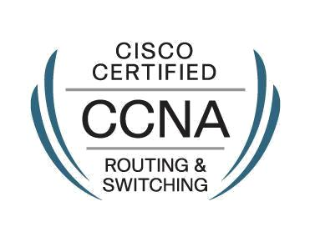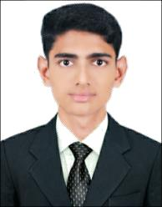**S.KOVALAN**

**Address:** No.6 Mettu Street,

Veema Nagar, Pondicherry-605009**.**

**Phone:** +91 9629634793

**E-mail:** skovalan90@gmail.com

Seeking a position in network engineering (**CSCO ID 13138644)** where my dedication, meeting goals, creativity and the ability to follow through can be utilize for the better growth and profit of the company.

**Education:**

* **M.C.A** Sri Manakula Vinayargar Engineering College is affiliated with Pondicherry University (2014) – **(70.57%)**
* **B.C.A** St. Joseph's College of Arts & Science the College is affiliated with Thiruvalluvar University (2011) – **(64.53 %)**

**Experience:**

* Currently Working with **Wipro InfoTech** as a Network Engineer fromApril -2015 till date.
* **Project Name**: **PSWAN**- (Pondicherry State Wide Area Network).
* **CLIENT:** Pondicherry-State Government **(IT Department**).

**Role & Responsibility:**

* Design, Implementations and Maintenance of Networks using Cisco routers ~ [**1800,** **1921, 800M Series ,4400 and ASR-1006**] and Switches ~ [**CE 500, 2960, 3650, 4507**].
* Commissioning of new links from Service providers and terminated with (**G.703, V.35**) Modems.
* Design, Implemented and Configure the Routing Protocol with **OSPF.**
* Configuration of Switches with **VLAN** and Inter-Switch Communication to Meet Specified Network Requirements.
* Configuration **Cisco IP phones**
* Monitoring the Servers, Routers, Switches through NMS Tools **Nagios** and **Whatsup** **Gold**.
* Troubleshooting the **LAN** and **WAN** Network.
* Monitoring the Bandwidth Utilization in the **MRTG** Graph and Maintain the Asset.

**Knowledge and Skills:**

**Cisco Certified Network Associate (CCNA):**

* Knowledge in **OSI Model, TCP/IP Model, IP addressing**, **LAN and, Routing Protocols.**
* Routing Protocol (**OSPF, RIP, EIGRP, BGP**) and Routed Protocol (**TCP/IP**).
* Configurations Knowledge in Router Concepts – **Inter-VLAN, ACL, NAT.**
* Configurations Knowledge in Switch Concepts – **VLAN, VTP, STP, RSTP, PORT-Security.**
* Configurations Knowledge Redundancy Protocols -- **HSRP, VRRP, GLRP**
* **Password Recovery** from Cisco Router.
* LAN Cable Structuring
* Good Troubleshooting Skills with Respect to Configurations and Hardware.
* Antivirus and Windows Updating.

**Languages:**

** ** Tamil **–** Native Language

English **–** Speak /Read/Write

|  |  |  |  |  |  |
| --- | --- | --- | --- | --- | --- |
| **Personal Particulars:** | |  | |  | |
| Date of Birth | | : Aug 08, 1990 | |
| Gender | | : Male | |
| Father’s Name | | : Mr. Semacottayan .R | |
| Nationality | | : Indian | |
| Marital Status | | : Married | |

**Declaration:**

I declare that the information and facts stated herein above are true and correct to the best of my knowledge and belief.

**(S.Kovalan)**