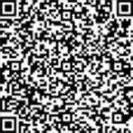
RAM KUMAR

About Me
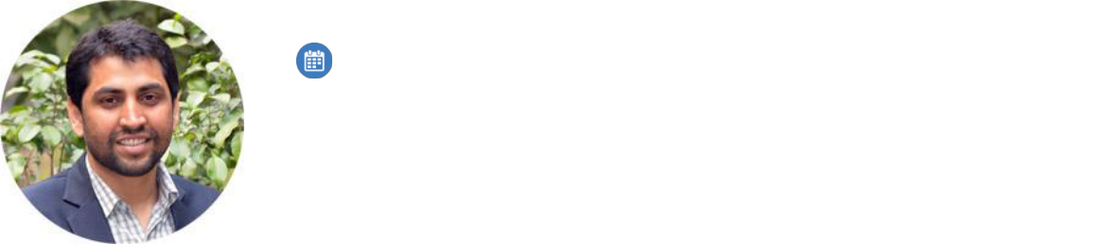

6 Years experience

+91.0000000000

October 28, 1982

shri.babuji@shriresume.com

Mumbai, Maharashtra

Linkedin.com/in/ramkumar

Marketing and Sales Professional

Lorem ipsum dolor sit amet, consectetur adipiscing elit. Integer nec odio. Praesent libero. Sed cursus ante dapi-bus diam. Sed nisi. Nulla quis sem at nibh elementum imperdiet. Duis sagittis ipsum. Praesent mauris. Fusce nec tellus sed augue semper porta. Mauris massa. Vestibulum lacinia arcu eget nulla. Class aptent taciti sociosqu ad litora torquent per conubia nostra, per inceptos himenaeos.

Education

Masters, Business Administration
Symbiosis Institute of Management Studies
AICTE & UGC Board
Pune, Maharashtra

Graduated, July 2010
Marks 59%
Division 2

Bachelor, Technology
Deccan College of Engineering & Technology
Osmania University Board
Hyderabad, Telangana

Graduated, July 2008
Marks 64%
Division 1

10+2
DPS Bokaro

CBSE Board

New Delhi, Delhi


Graduated, July 2004
Marks 81%

Division 1

Professional Qualifications and Affiliations

- Lorem ipsum dolor sit amet, consectetuer adipiscing elit lorem ipsum dolor sit.

- Lorem ipsum dolor sit amet, consectetuer adipiscing elit lorem ipsum dolor sit.

- Lorem ipsum dolor sit amet, consectetuer adipiscing elit lorem ipsum dolor sit.

- Lorem ipsum dolor sit amet, consectetuer adipiscing elit lorem ipsum dolor sit.

Career Highlights

Lorem ipsum dolor sit amet, consectetuer adipiscing elit. Aenean commodo ligula eget dolor. Aenean massa. Cum sociis natoque penatibus et magnis dis parturient montes, nascetur ridiculus mus. Donec quam felis, ultricies Lorem ipsum dolor sit amet, consectetuer adipiscing elit. Aenean commodo ligula eget dolor. Aenean massa. Cum sociis natoque penatibus et magnis dis parturient montes, nascetur ridiculus mus.

- Lorem ipsum dolor sit amet, consectetuer adipiscing elit lorem ipsum dolor sit.

- Lorem ipsum dolor sit amet, consectetuer adipiscing elit lorem ipsum dolor sit.

- Lorem ipsum dolor sit amet, consectetuer adipiscing elit lorem ipsum dolor sit.

- Lorem ipsum dolor sit amet, consectetuer adipiscing elit lorem ipsum dolor sit.

Skills

•

•


Lorem ipsum

Ipsum dolor

•

•

Nulla quis sem

Lorem ipsum

•

Integer nec odio

Work Experience

April 2014 – Current
Sales Manager
Solvent Solutions Pvt Ltd
Kolkata, West Bangal

Lorem ipsum dolor sit amet, consectetuer adipiscing elit. Aenean commodo ligula eget dolor. Aenean massa. Cum sociis natoque penatibus et magnis dis parturient montes, nascetur ridiculus mus. Donec quam felis, ultricies Lorem ipsum dolor sit amet, consectetuer adipiscing elit. Aenean commodo ligula eget dolor. Aenean massa. Cum sociis natoque penatibus et magnis dis parturient montes, nascetur ridiculus mus.

- Lorem ipsum dolor sit amet, consectetuer adipiscing elit lorem ipsum dolor sit.

- Lorem ipsum dolor sit amet, consectetuer adipiscing elit lorem ipsum dolor sit.

- Lorem ipsum dolor sit amet, consectetuer adipiscing elit lorem ipsum dolor sit.

- Lorem ipsum dolor sit amet, consectetuer adipiscing elit lorem ipsum dolor sit.

October 2011 – March 2014
Team Leader
Serena Global Pvt Ltd
Gurgaon, Delhi-NCR

Lorem ipsum dolor sit amet, consectetuer adipiscing elit. Aenean commodo ligula eget dolor. Aenean massa. Cum sociis natoque penatibus et magnis dis parturient montes, nascetur ridiculus mus. Donec quam felis, ultricies Lorem ipsum dolor sit amet, consectetuer adipiscing elit. Aenean commodo ligula eget dolor. Aenean massa. Cum sociis natoque penatibus et magnis dis parturient montes, nascetur ridiculus mus.

- Lorem ipsum dolor sit amet, consectetuer adipiscing elit lorem ipsum dolor sit.

- Lorem ipsum dolor sit amet, consectetuer adipiscing elit lorem ipsum dolor sit.

- Lorem ipsum dolor sit amet, consectetuer adipiscing elit lorem ipsum dolor sit.

- Lorem ipsum dolor sit amet, consectetuer adipiscing elit lorem ipsum dolor sit.

August 2009 – October 2011
Sales Assistant
Tamcoj Technologies

Pimpri-Pune, Maharashtra

Lorem ipsum dolor sit amet, consectetuer adipiscing elit. Aenean commodo ligula eget dolor. Aenean massa. Cum sociis natoque penatibus et magnis dis parturient montes, nascetur ridiculus mus. Donec quam felis, ultricies Lorem ipsum dolor sit amet, consectetuer adipiscing elit. Aenean commodo ligula eget dolor. Aenean massa. Cum sociis natoque penatibus et magnis dis parturient montes, nascetur ridiculus mus.

- Lorem ipsum dolor sit amet, consectetuer adipiscing elit lorem ipsum dolor sit.

- Lorem ipsum dolor sit amet, consectetuer adipiscing elit lorem ipsum dolor sit.

- Lorem ipsum dolor sit amet, consectetuer adipiscing elit lorem ipsum dolor sit.


Computer Proficiency

- Word 2010

- Excel 2010

- Power Point 2010

Languages

- Hindi

- English

Personal Interests

•

•

Lorem ipsum dolor sit amet Lorem ipsum dolor

•

•

Lorem ipsum dolor sit

Lorem ipsum

- Lorem ipsum dolor sit

Personal Details

Father’s Name: | Mr. Abhijeet Kumar | Marital Status: | Single
Birthday: | October 28, 1982 | Nationality: | Indian
Gender: | Male

Declaration

I, Ram Kumar, hereby declare that the information contained herein is true and correct to the best of my knowledge and belief.

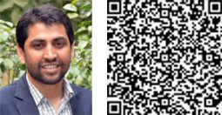

____________________________ Ram Kumar

Mumbai, Maharashtra
March 1, 2015

